**ANSWERS**

**QUE 2.VPC Network to communicate between 2 vm instances present in different network**

**Steps :**

**1.create two vpc network and add firewall rules**

**Vpc network in us region**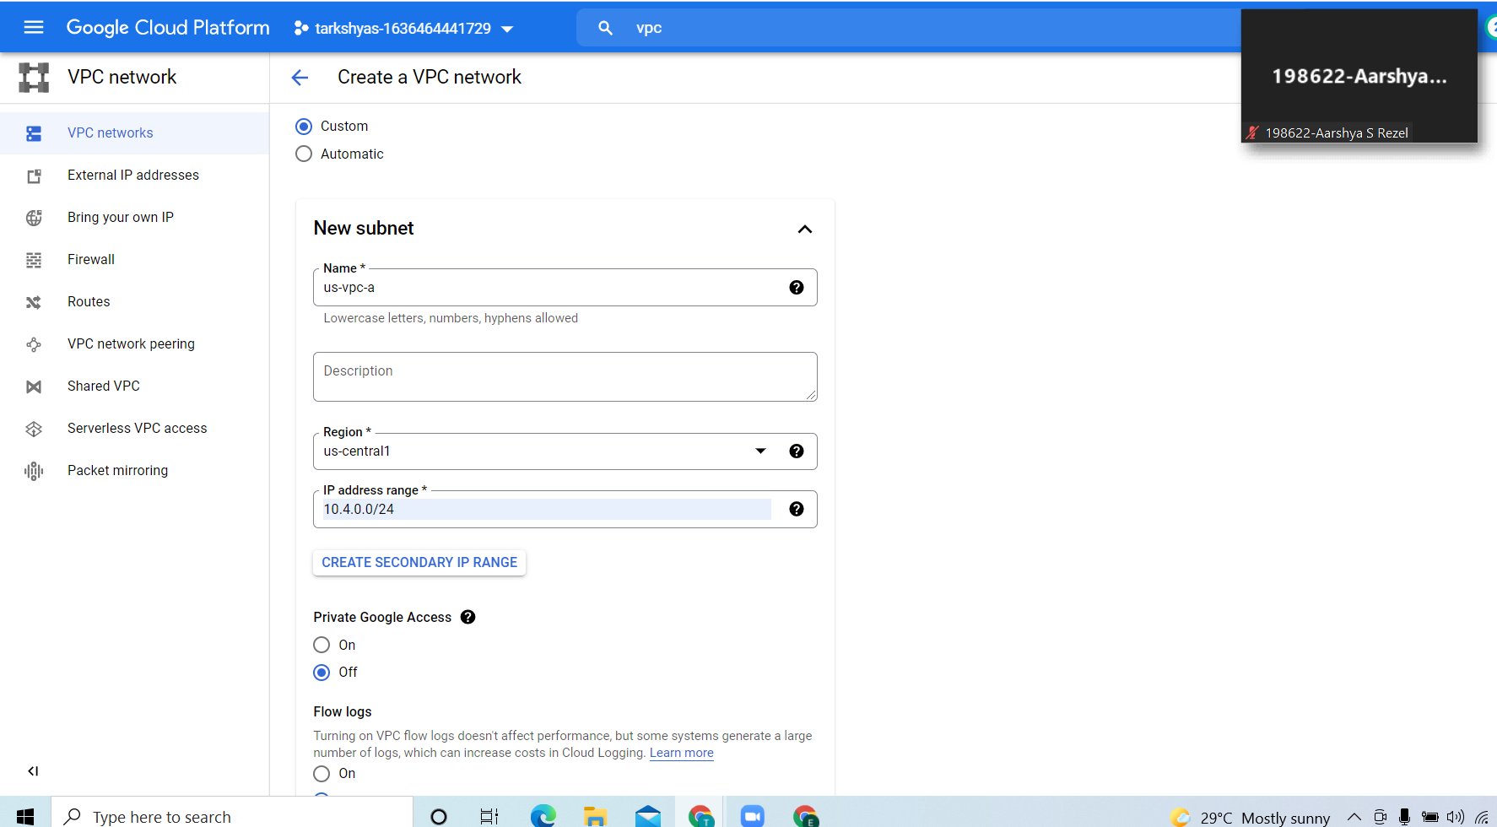

**Vpc network in Asia region:**

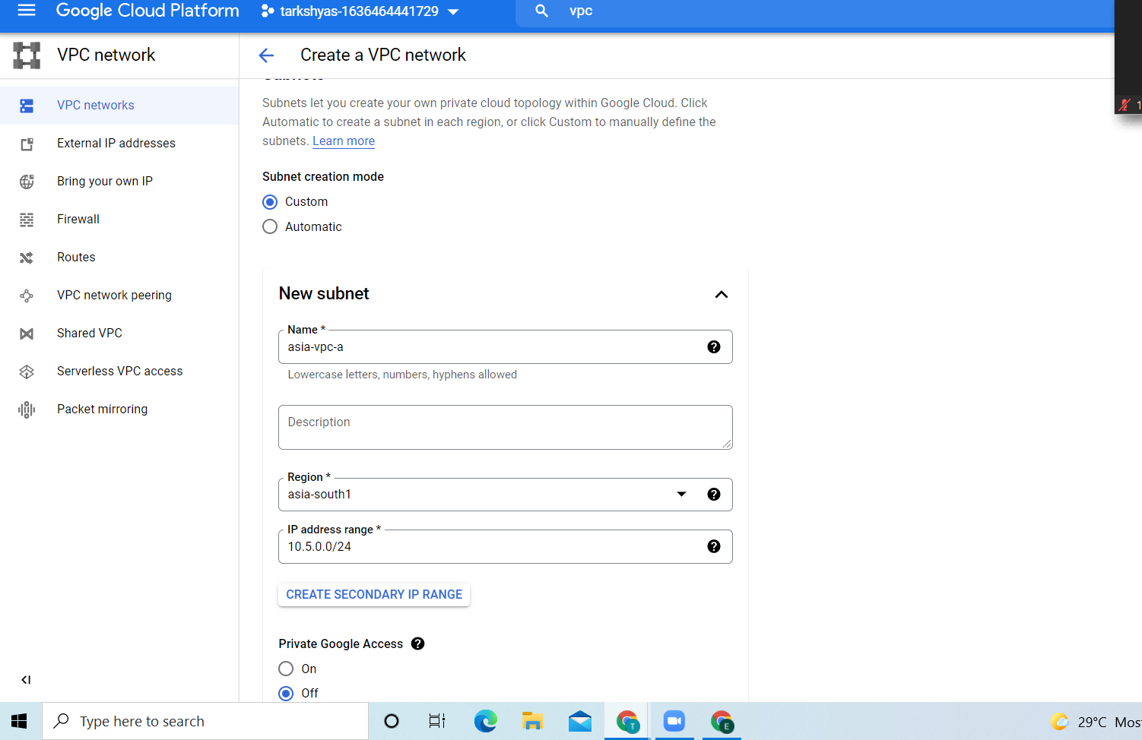

**Adding firewall rules:**

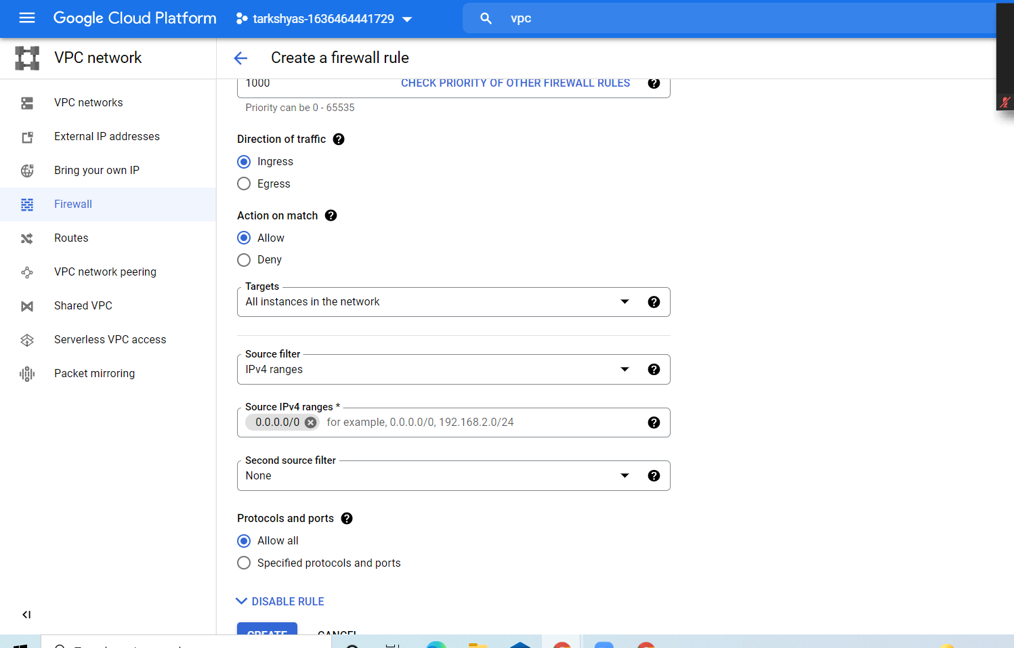

**2. create two vm instance and change the network as follows (for both vm)**

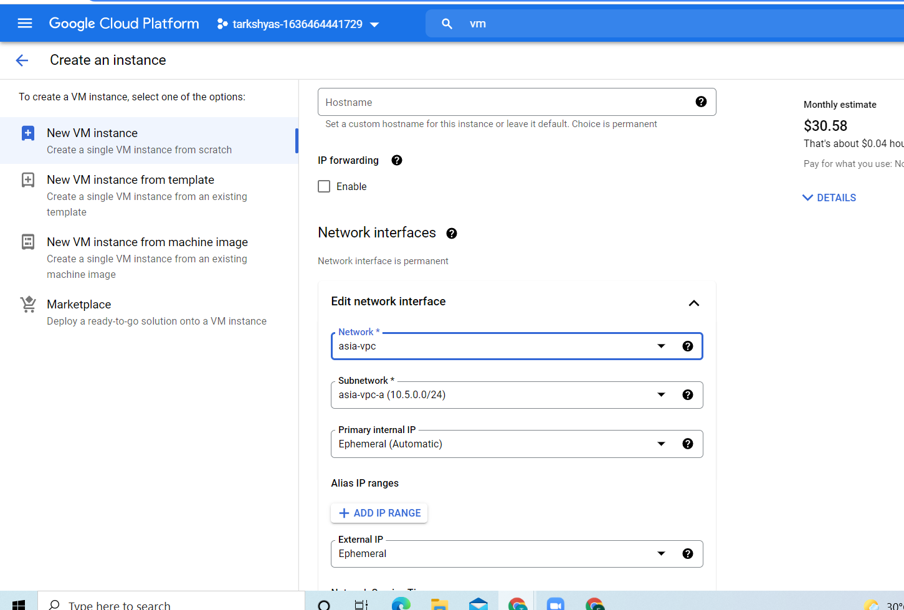

**Thus create two vm in two different regions**

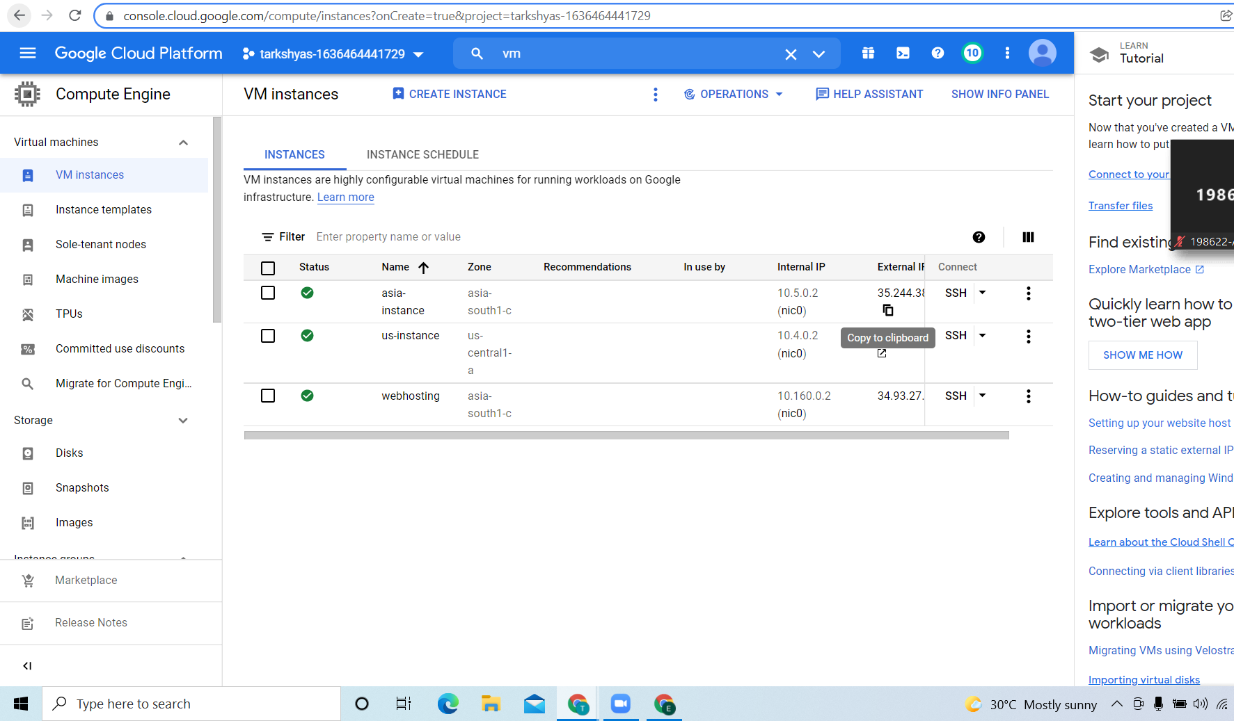

**3.in order to connect to vm’s we need vpn network so goto hybrid connectivity then click on create vpn and then do the steps as follows**

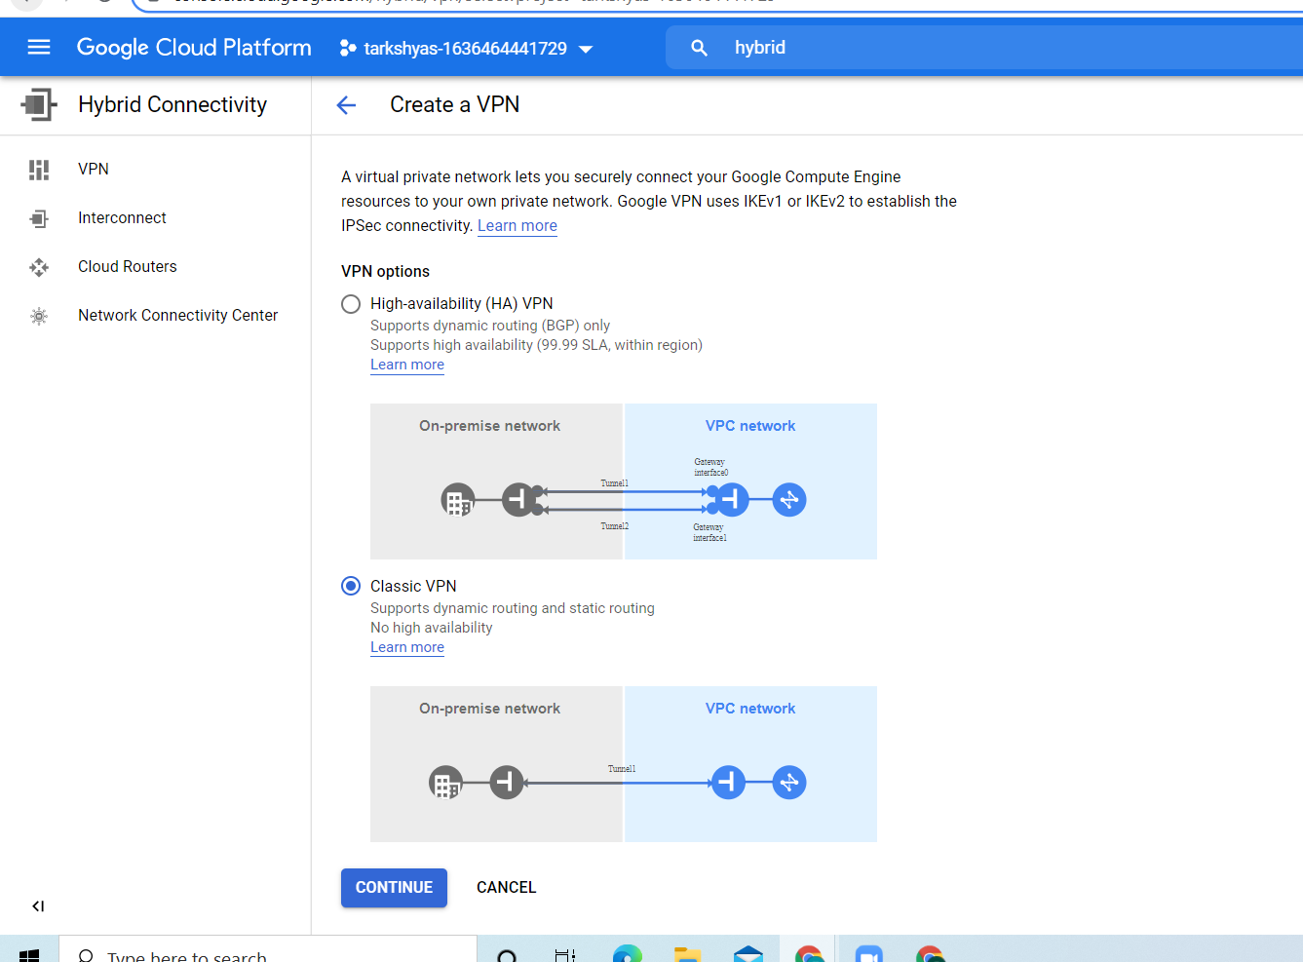

**Then give the name for vpn ,select the region and give the reserved ip address**

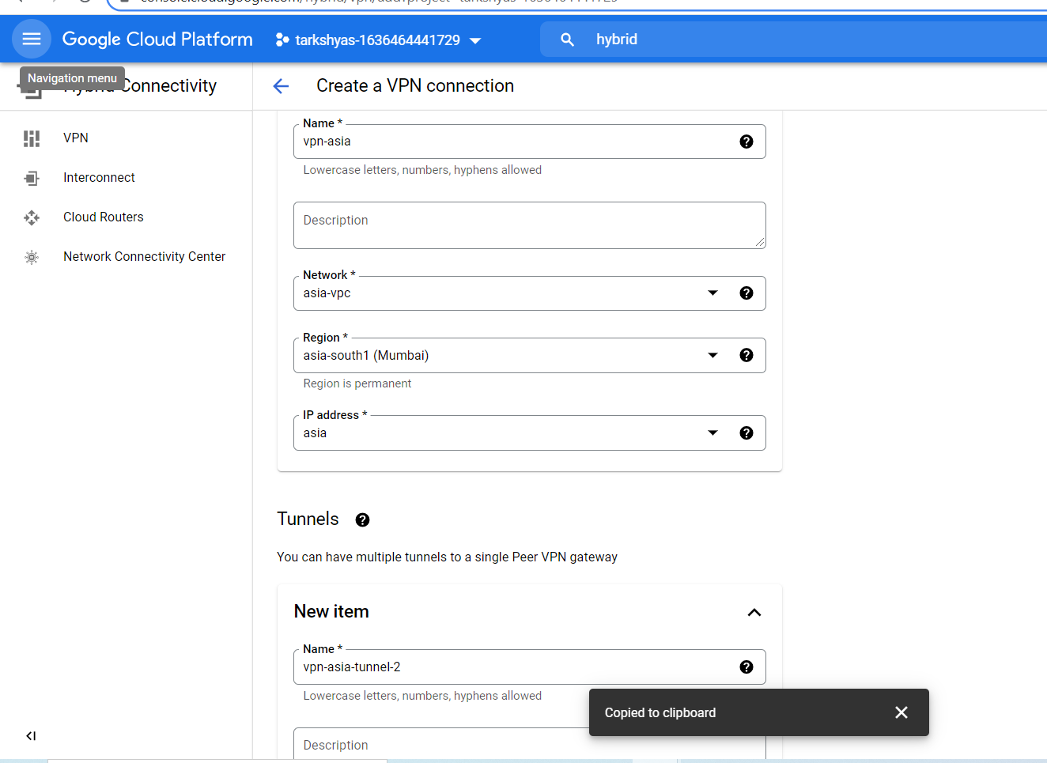

**For tunnels,the remote peer ip should be the reserved ip of other network and after that create and copy the key**

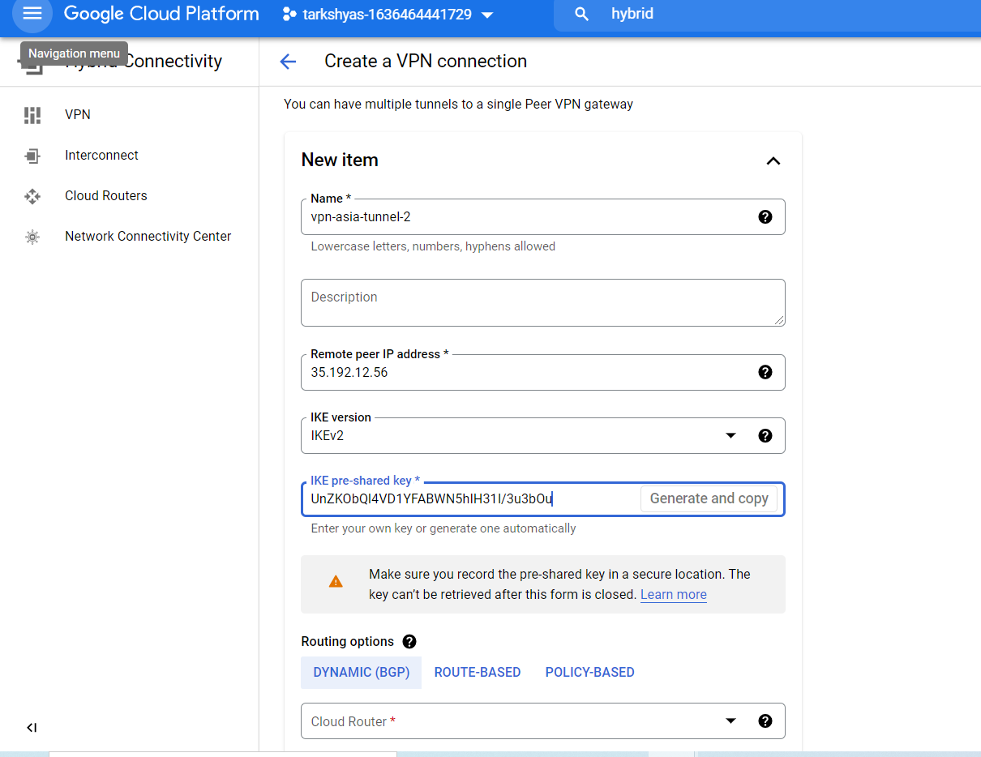

**we have 3 routing options 1.dynamic based,2.route-based 3.policy-based here we choose dynamic based. So we need cloud router creation of cloud router is as follows**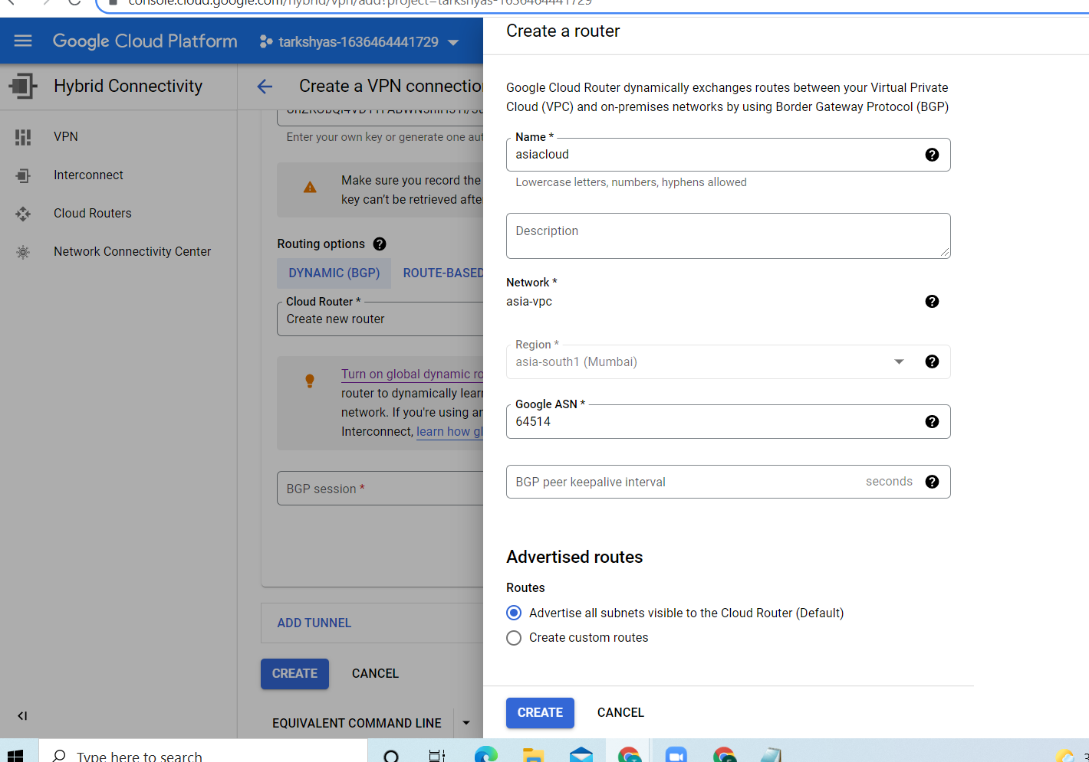

**next we need bgp session**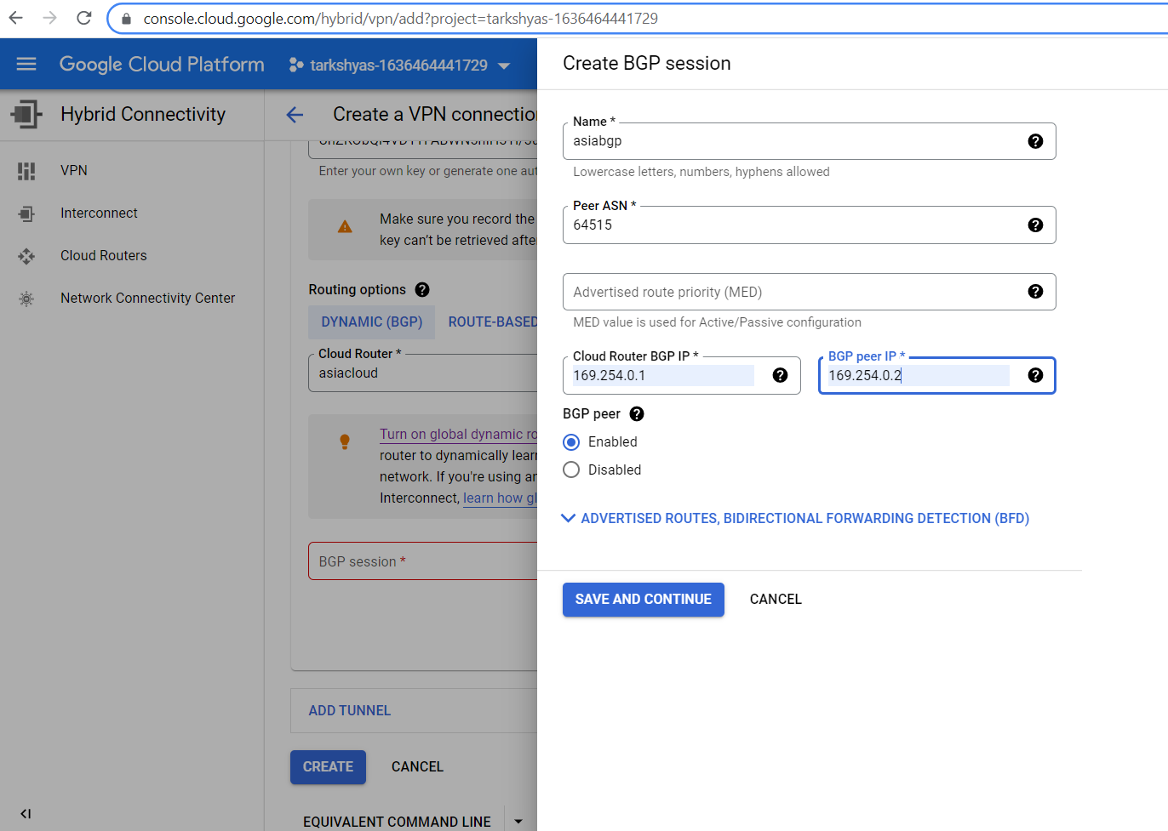

**Similarly we can do the same steps for making the other vpn tunnels**

**Vpn tunnels and vpn gateway**

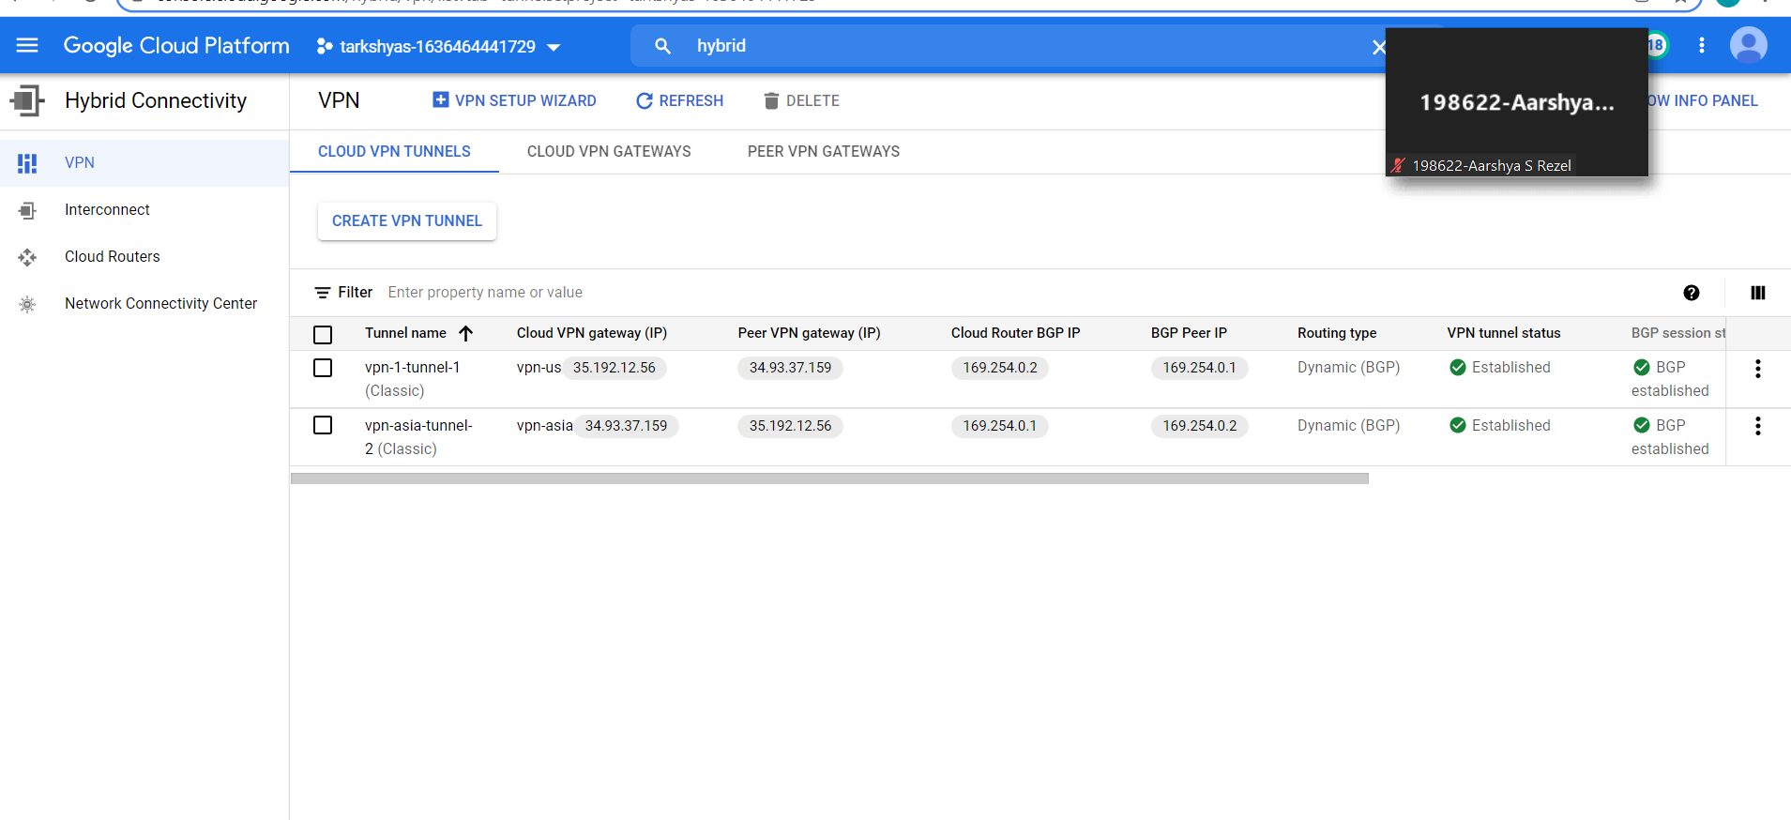

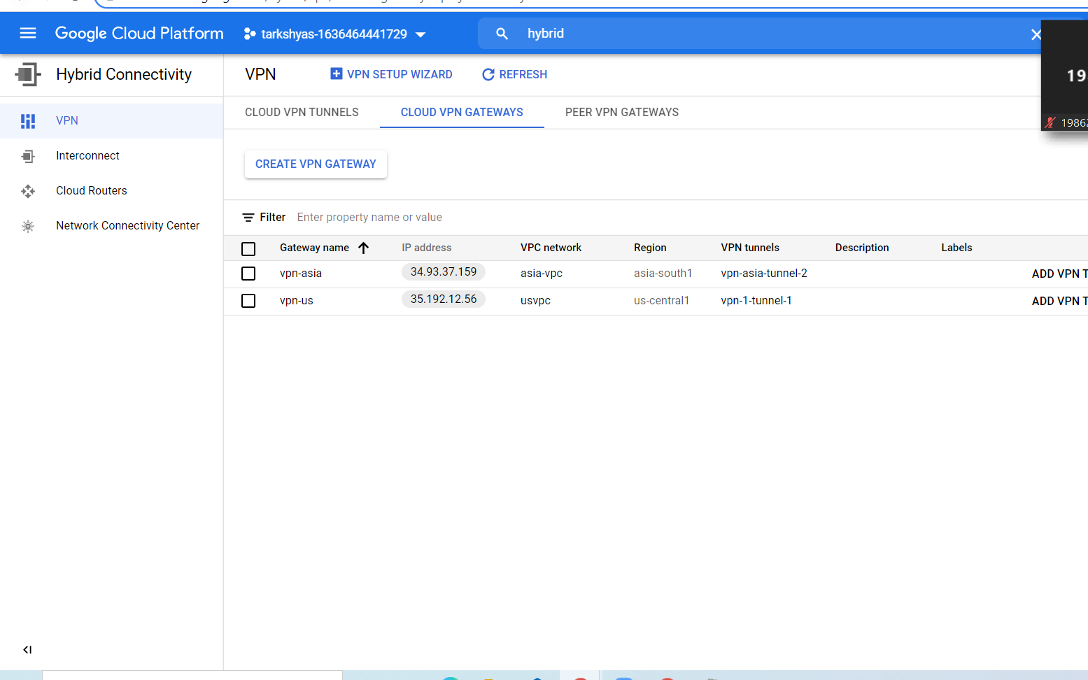

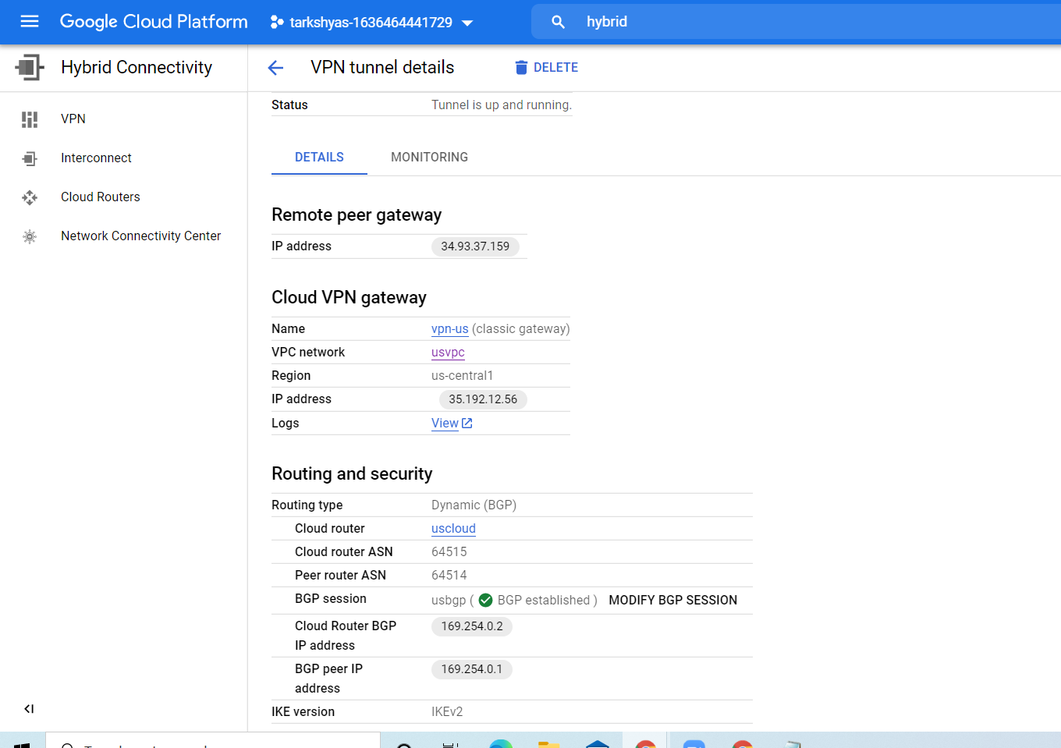

**Us tunnel details**

**Asia tunnel details:**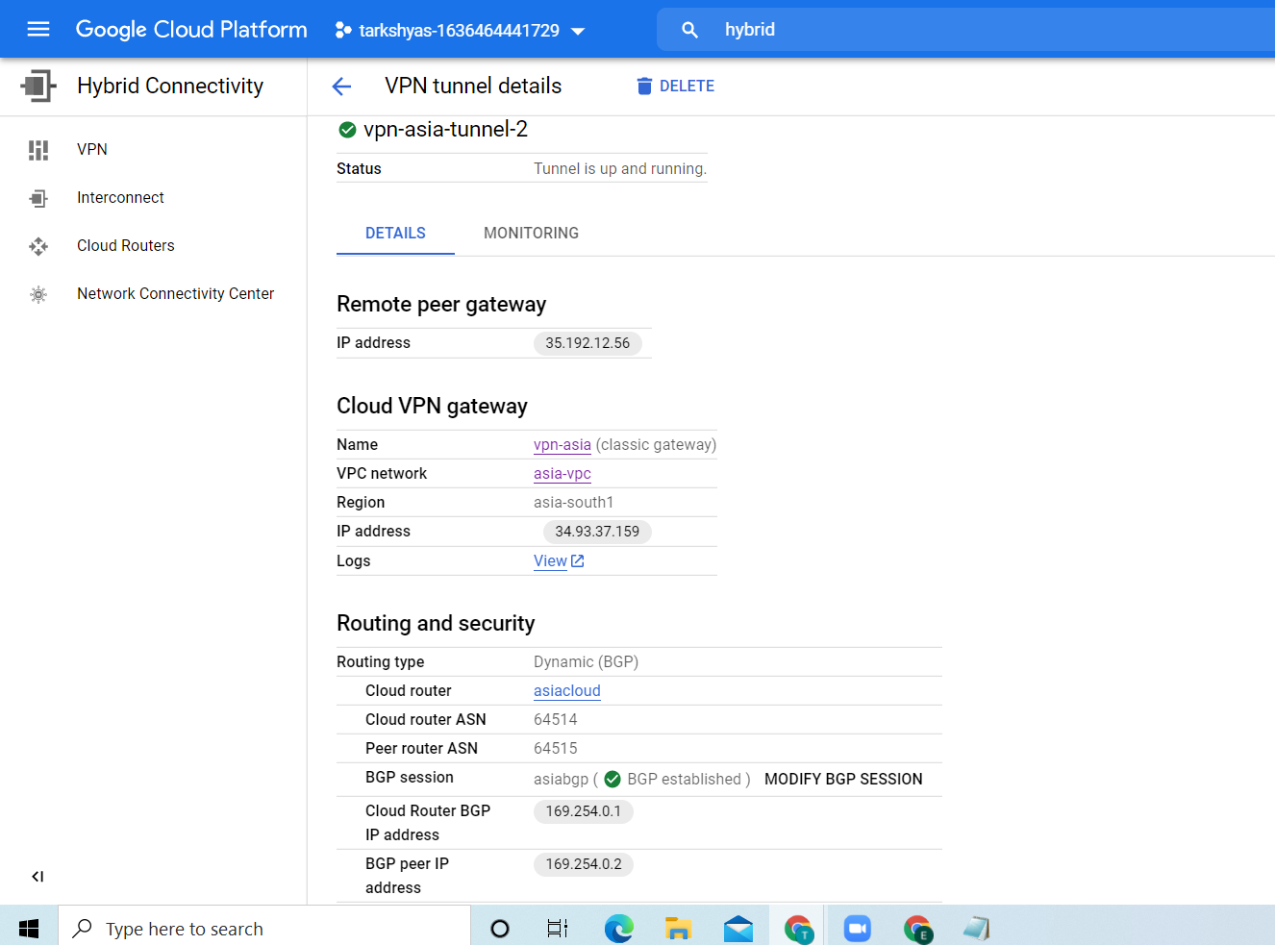

**After creation of vpn we can communicate with the two vm’s** 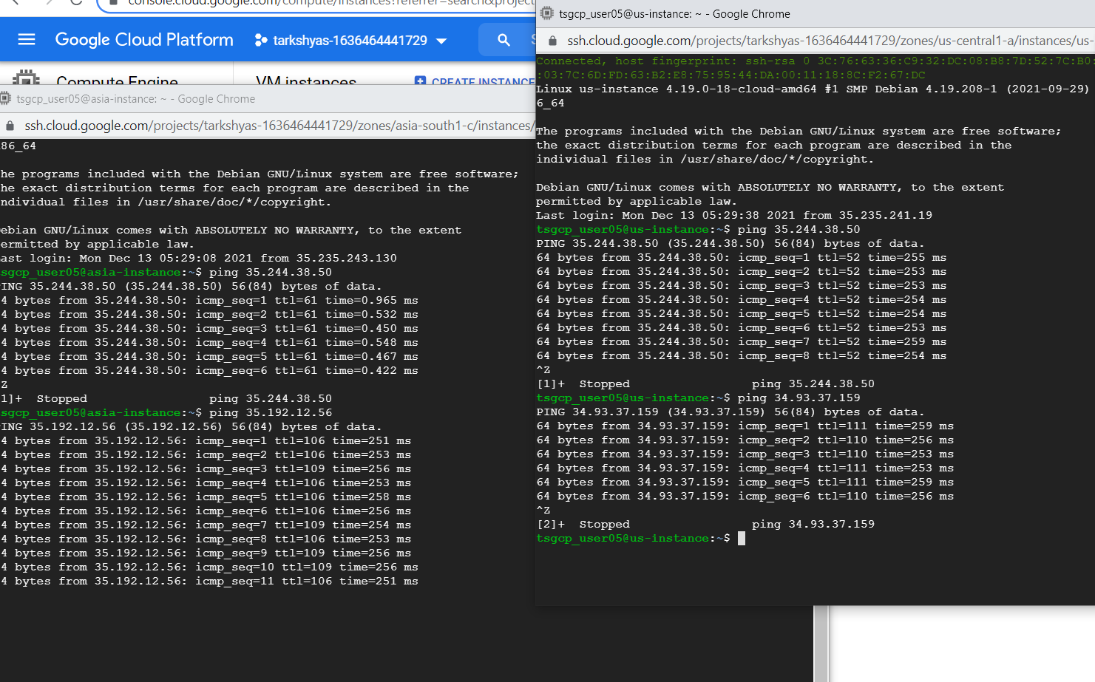

**QUE 6. CLOUD RUN**

**In order to host a website using cloud run we need containers so in order to create the container follow the steps :**

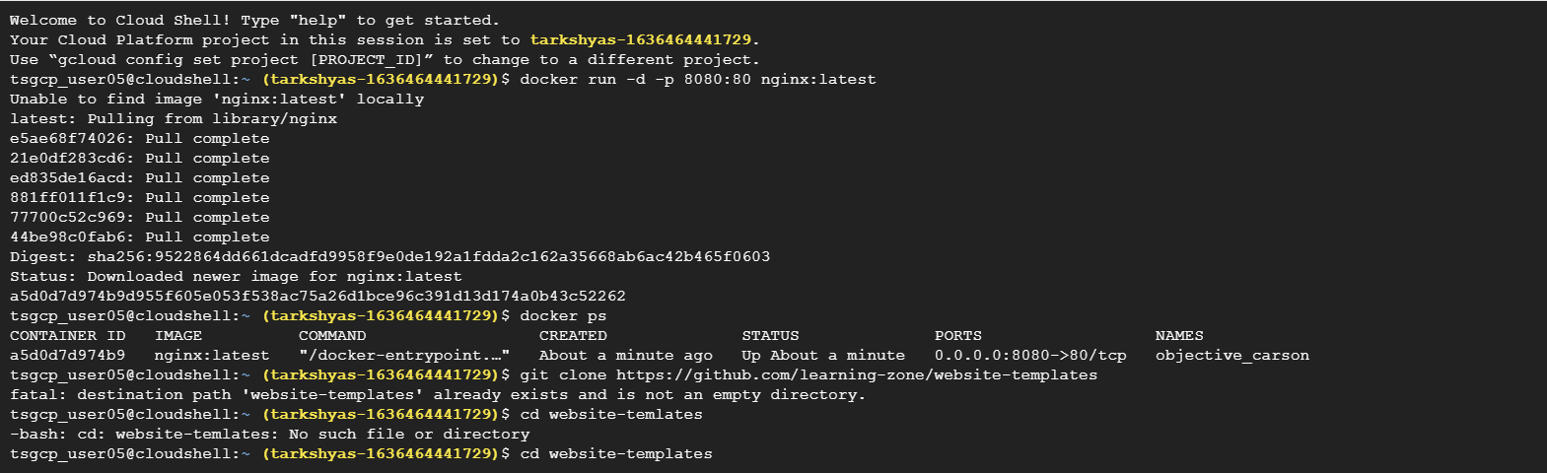

**First start the docker using 1.docker run –d –p 8080:80 nginx:latest**

**2.docker ps (for getting the status of docker)**

**3. git clone command : git clone** [**https://github.com/learning-zone/website-templates**](https://github.com/learning-zone/website-templates)

**Then change the directory as follows:**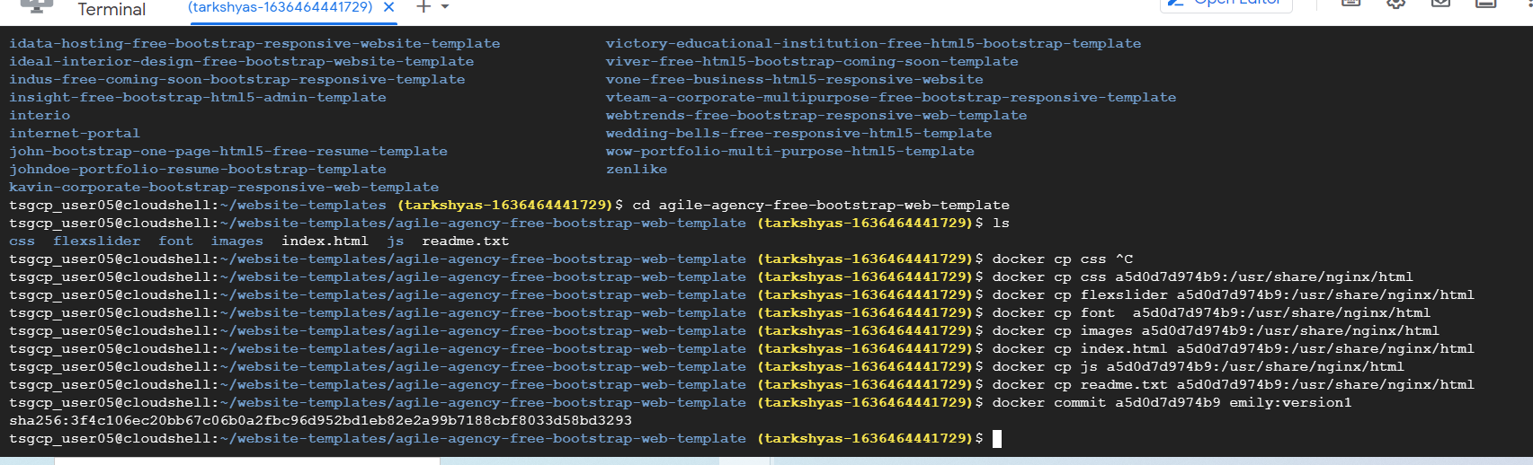

**Then list all the file inside that directory and copy each and every files using docker cp filename containerid :/usr/share/nginx/html**

**then commit the files using docker commit containerid name:version**

**then we can view the site using preview option in shell**

**after that we need to tag and push the container**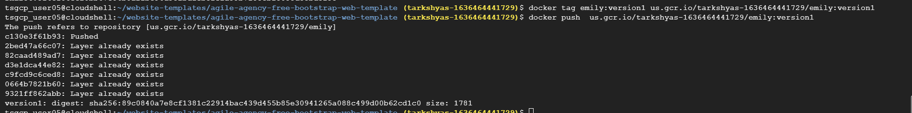

**container registry**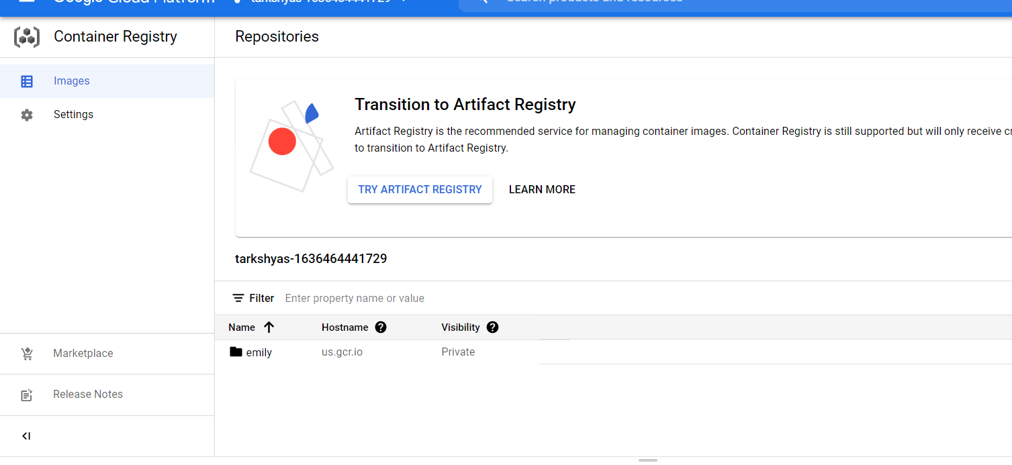

**the nextstep is to create cloud run service**

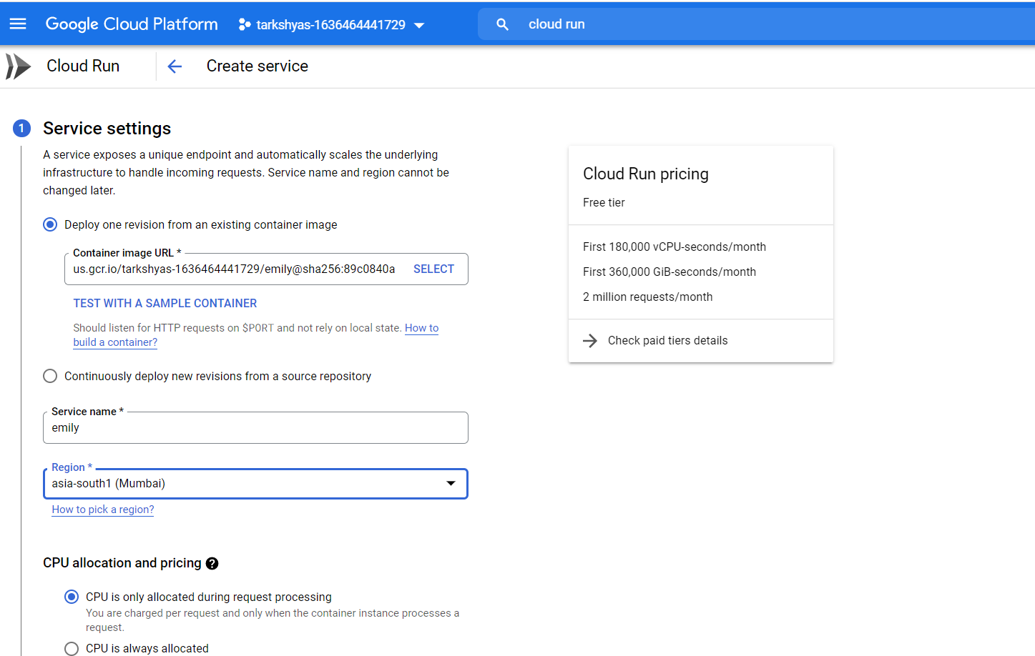

**Here select the path of the image .another option is from resource repository .we can clone github directly by using this second option.**

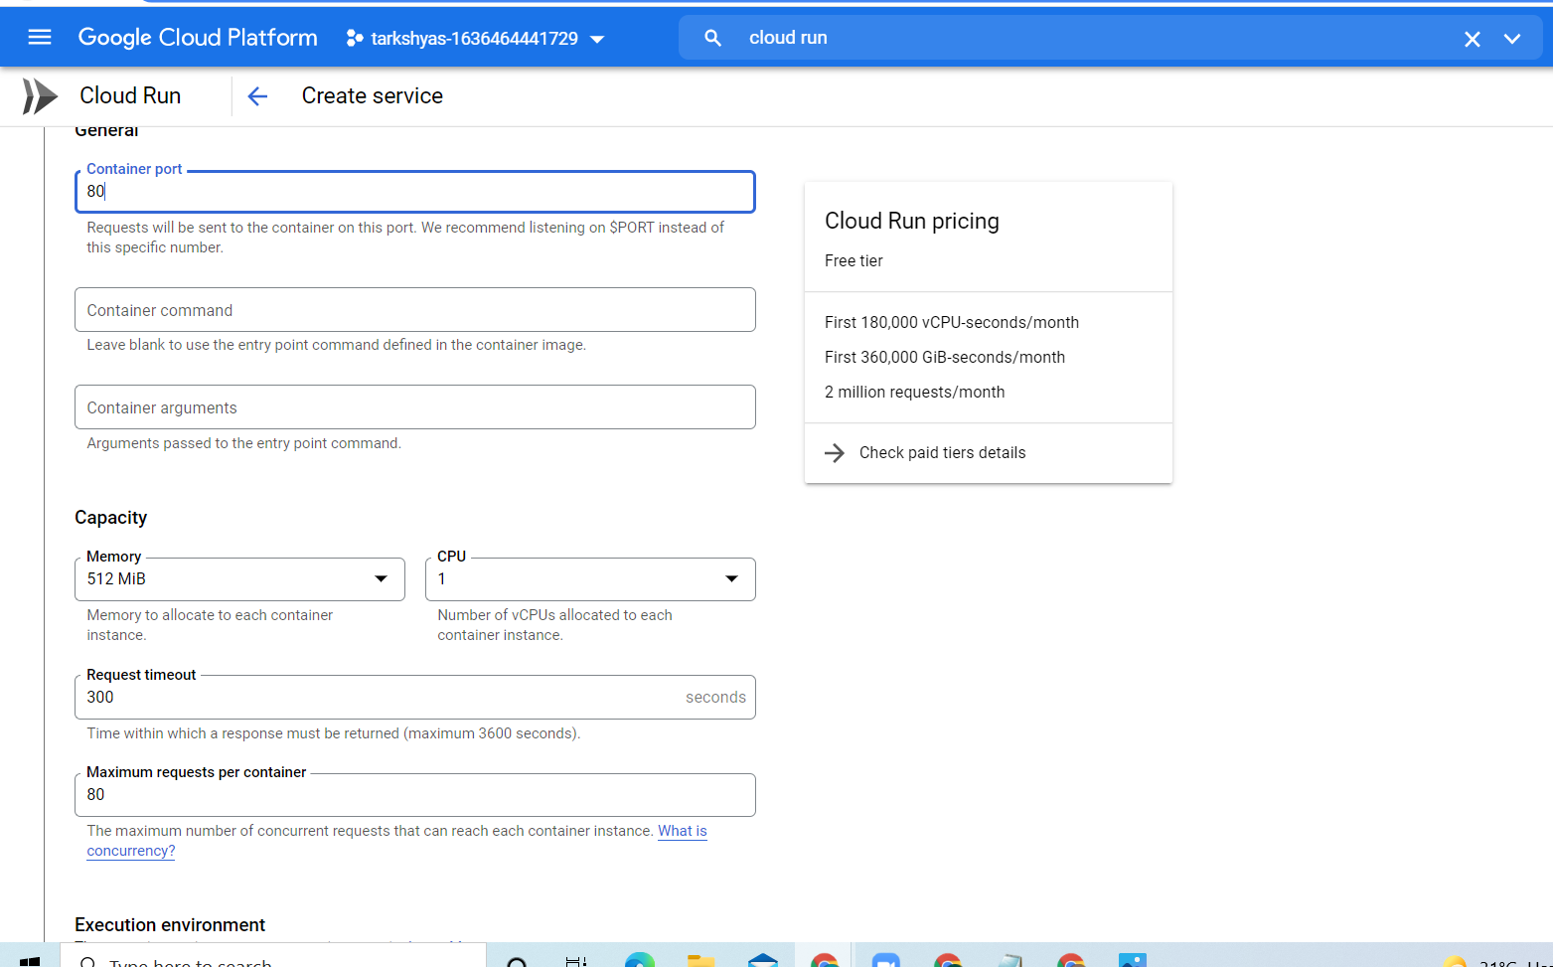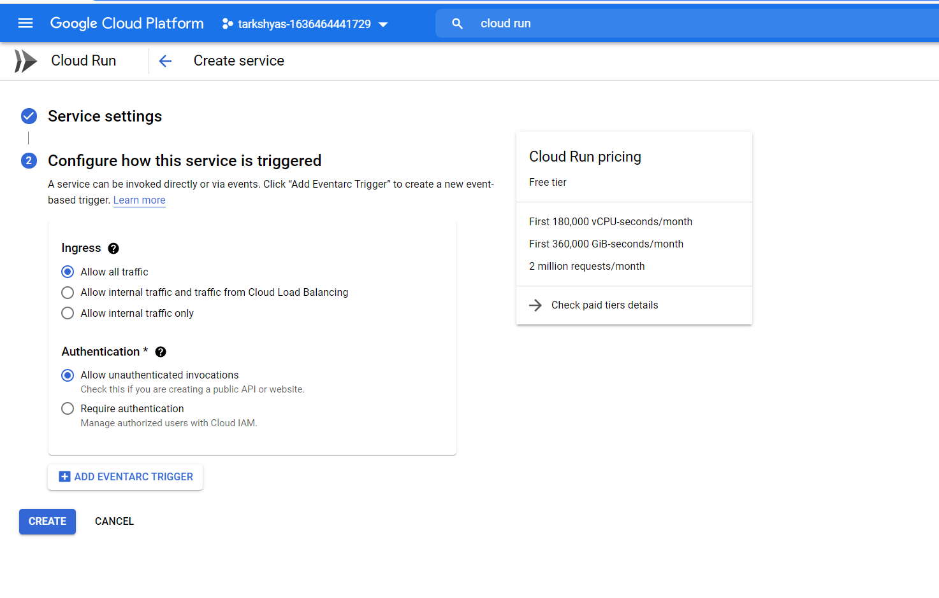

**After doing all the steps we will get a page as follows:**

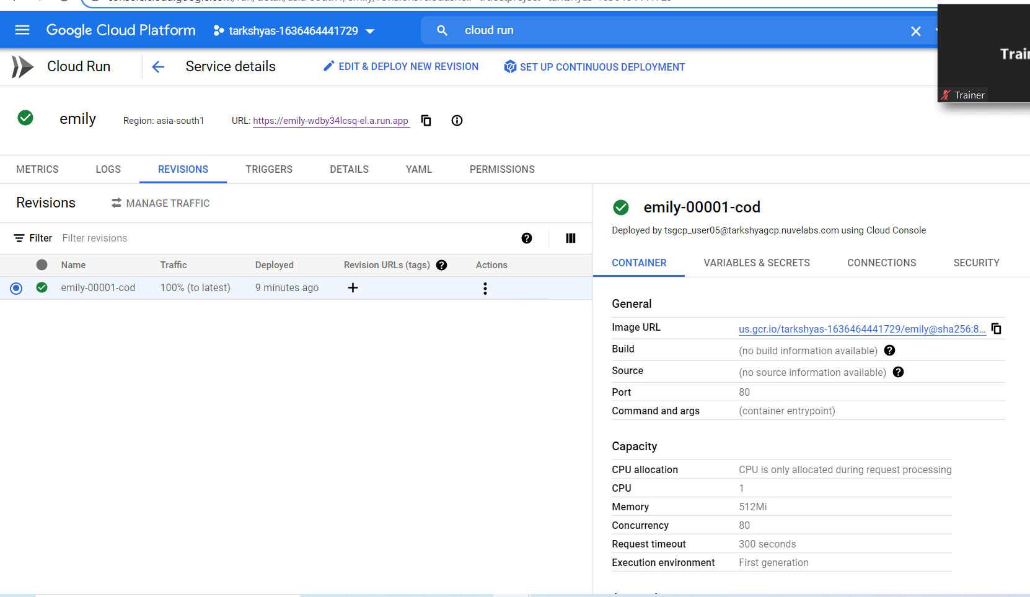

**The click on the url .then we will get our website**

**The hosted website :**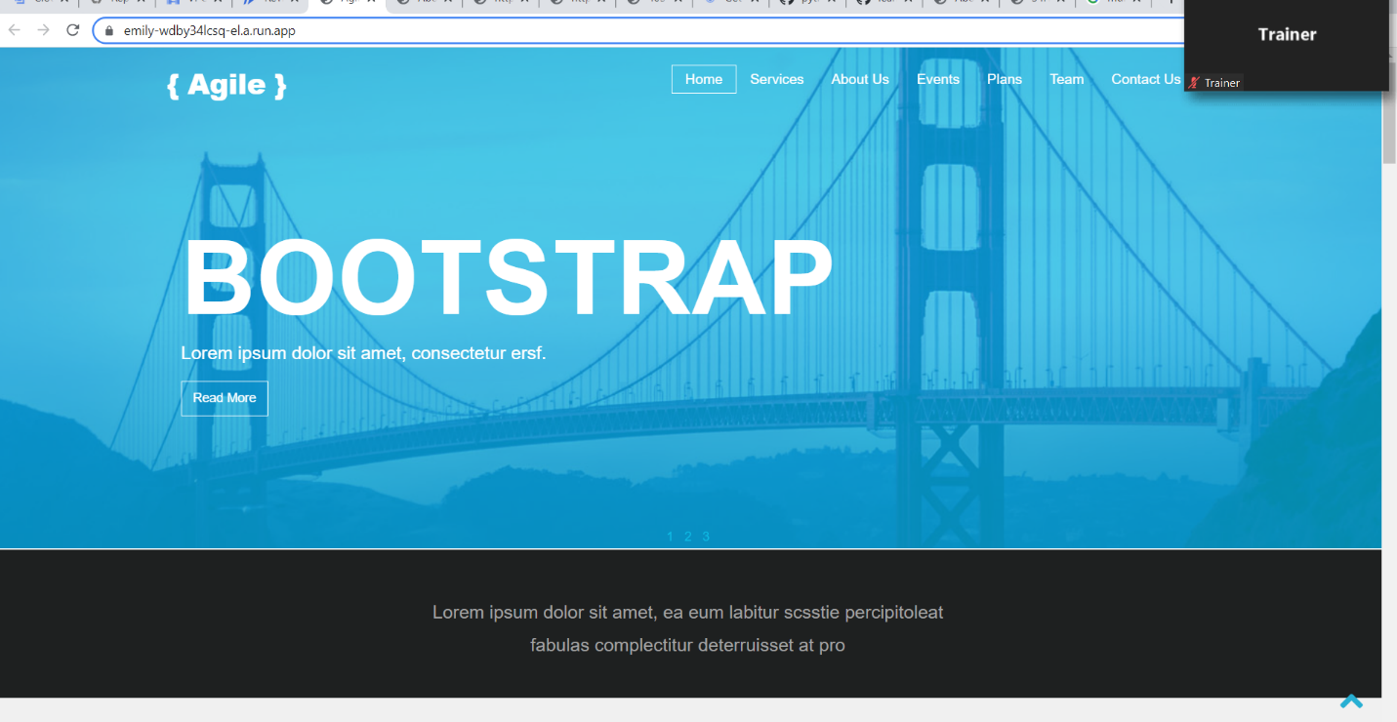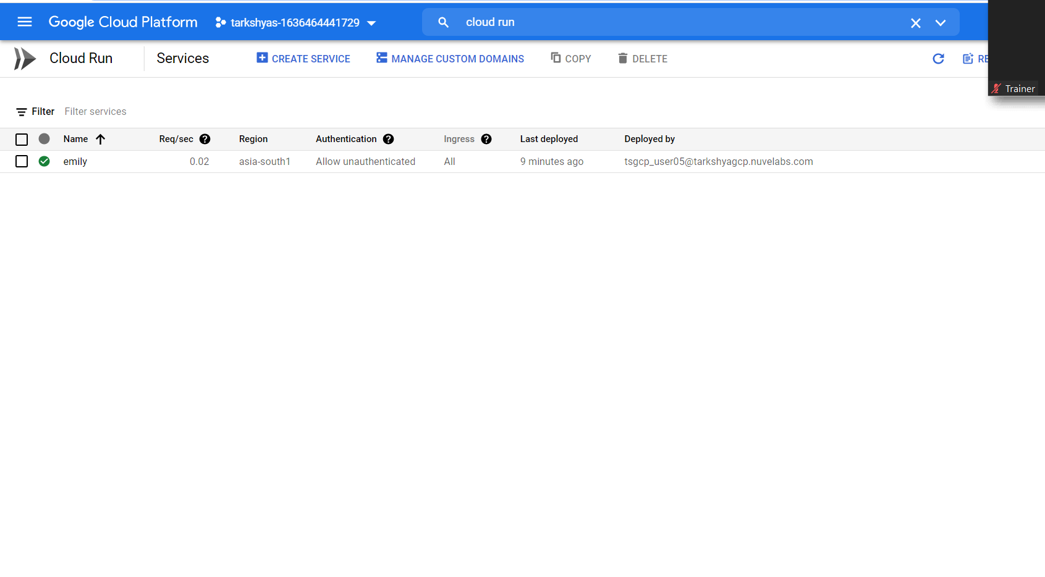

**QUE 7. VPC PEERING**

**VPC peering helps to communication of 2 vm**

**First create two vpc network then add firewall rules as follows:**



**Vpc network for us and asia region**

**Adding firewall rules**

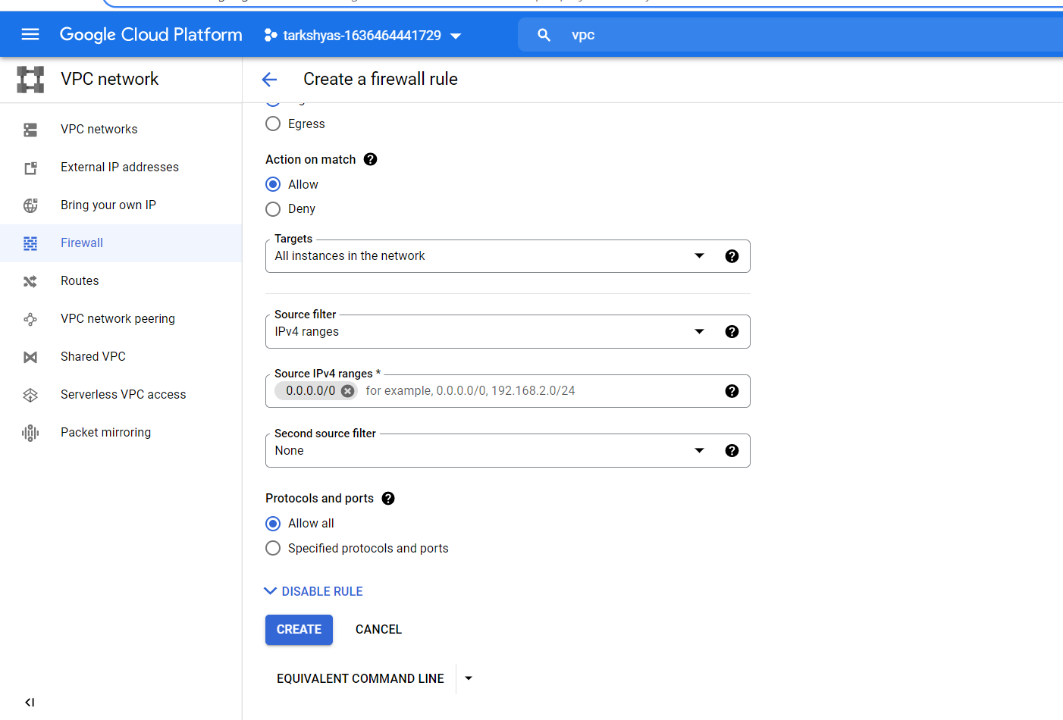

**Then create two vm**

**Select the appropriate network for vm instance**



**The created vm’s :**



**Vpc peering:**

**Peering of asia is as follows:**

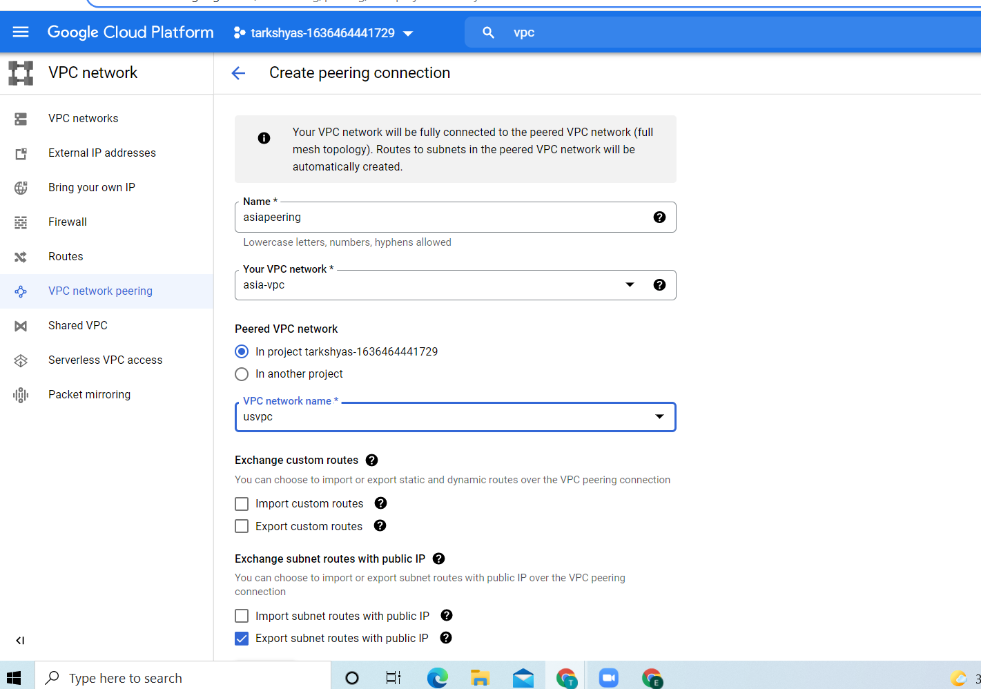

**Peering of us**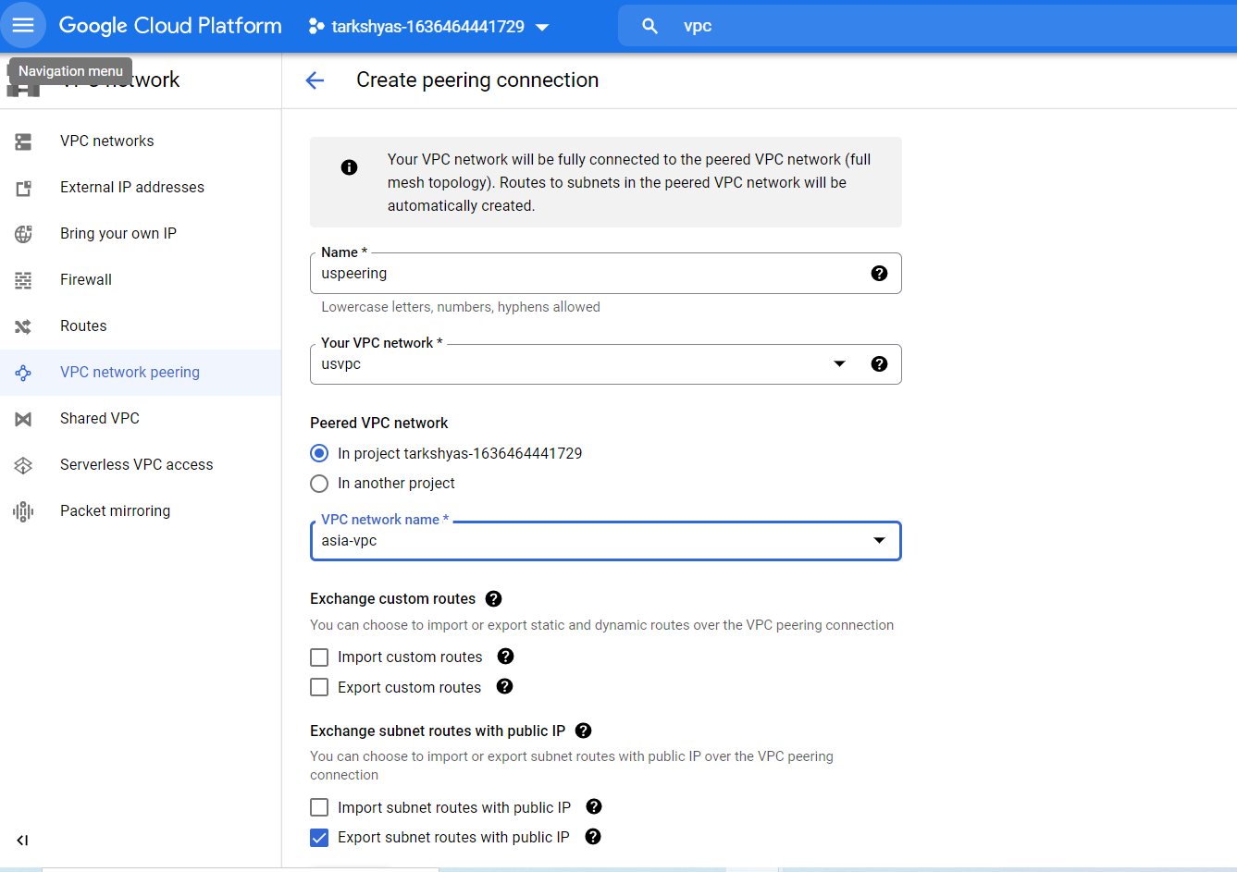

**Vpc peering completed:**

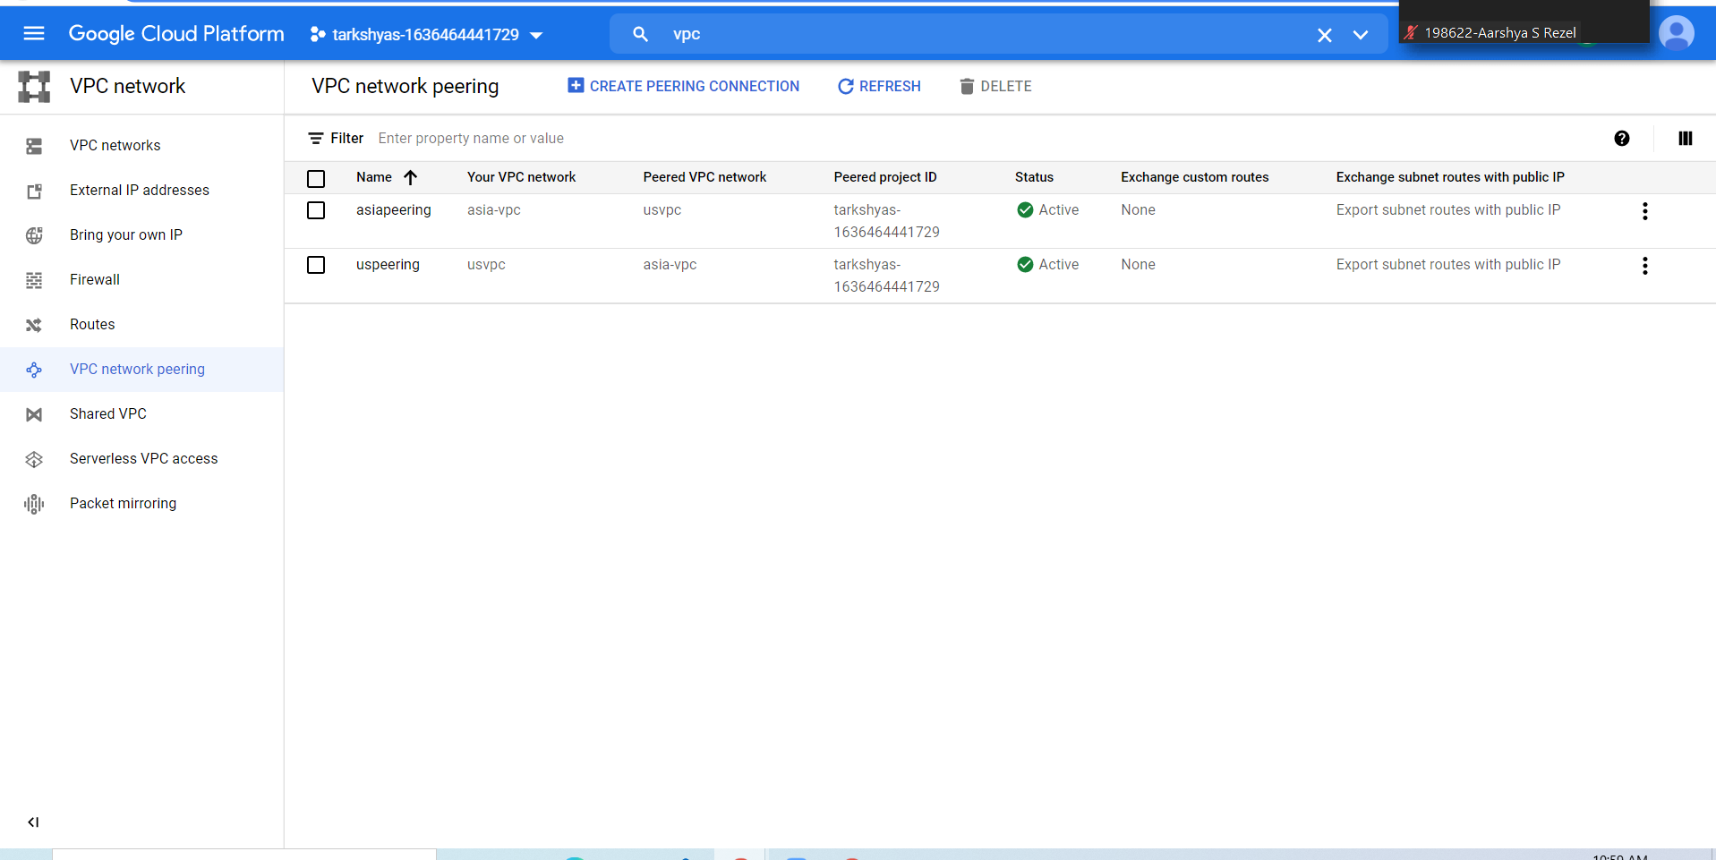

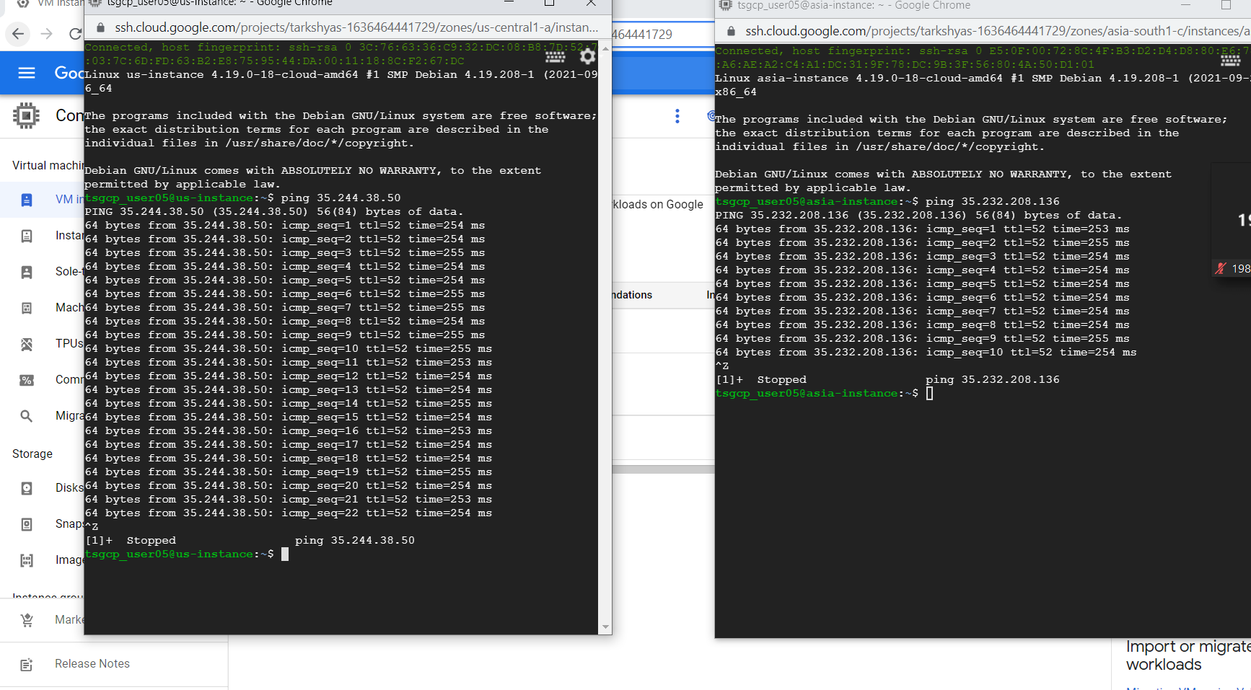

**QUE 10. KUBERNETES**

**In order to host a website using cloud run we need containers so in order to create the container follow the steps :**

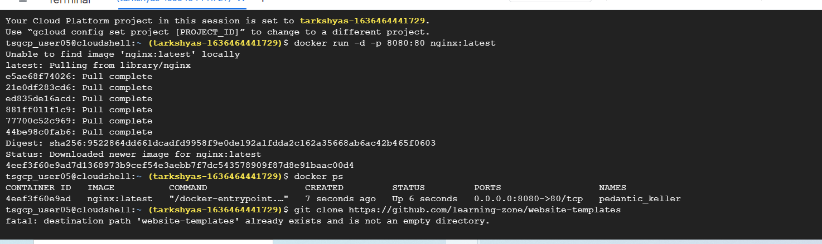

**First start the docker using 1.docker run –d –p 8080:80 nginx:latest**

**2.docker ps (for getting the status of docker)**

**3. git clone command : git clone** [**https://github.com/learning-zone/website-templates/above-educational-bootstrap-responsive-template**](https://github.com/learning-zone/website-templates/above-educational-bootstrap-responsive-template)

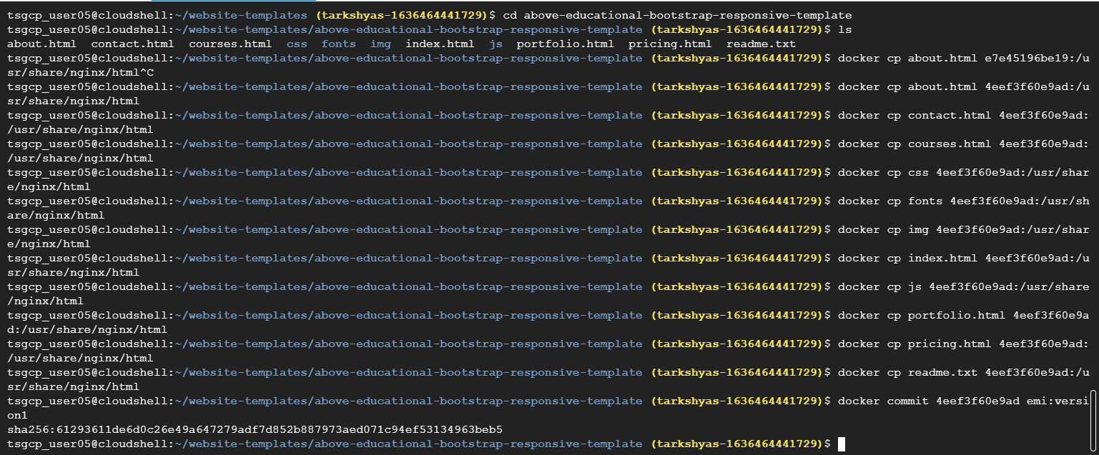

**Then list all the file inside that directory and copy each and every files using docker cp filename containerid :/usr/share/nginx/html**

**then commit the files using docker commit containerid name:version**

**then we can view the site using preview option in shell**

**after that we need to tag and push the container**

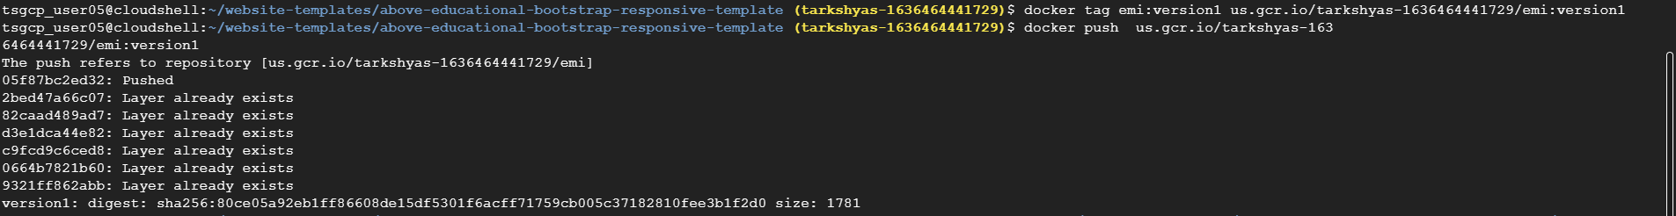

**After that we can see the website using preview option from the cloud shell**

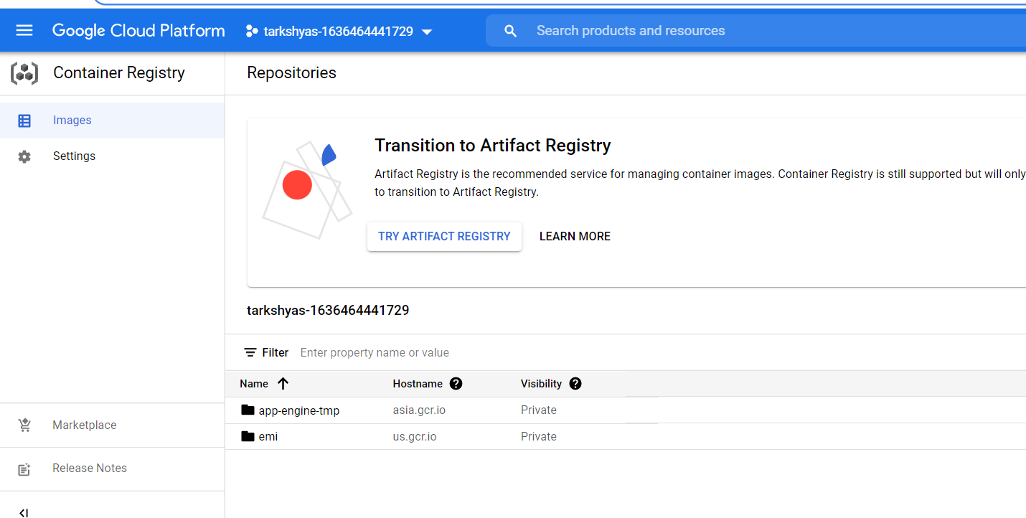

**After this create kubernetes engine:**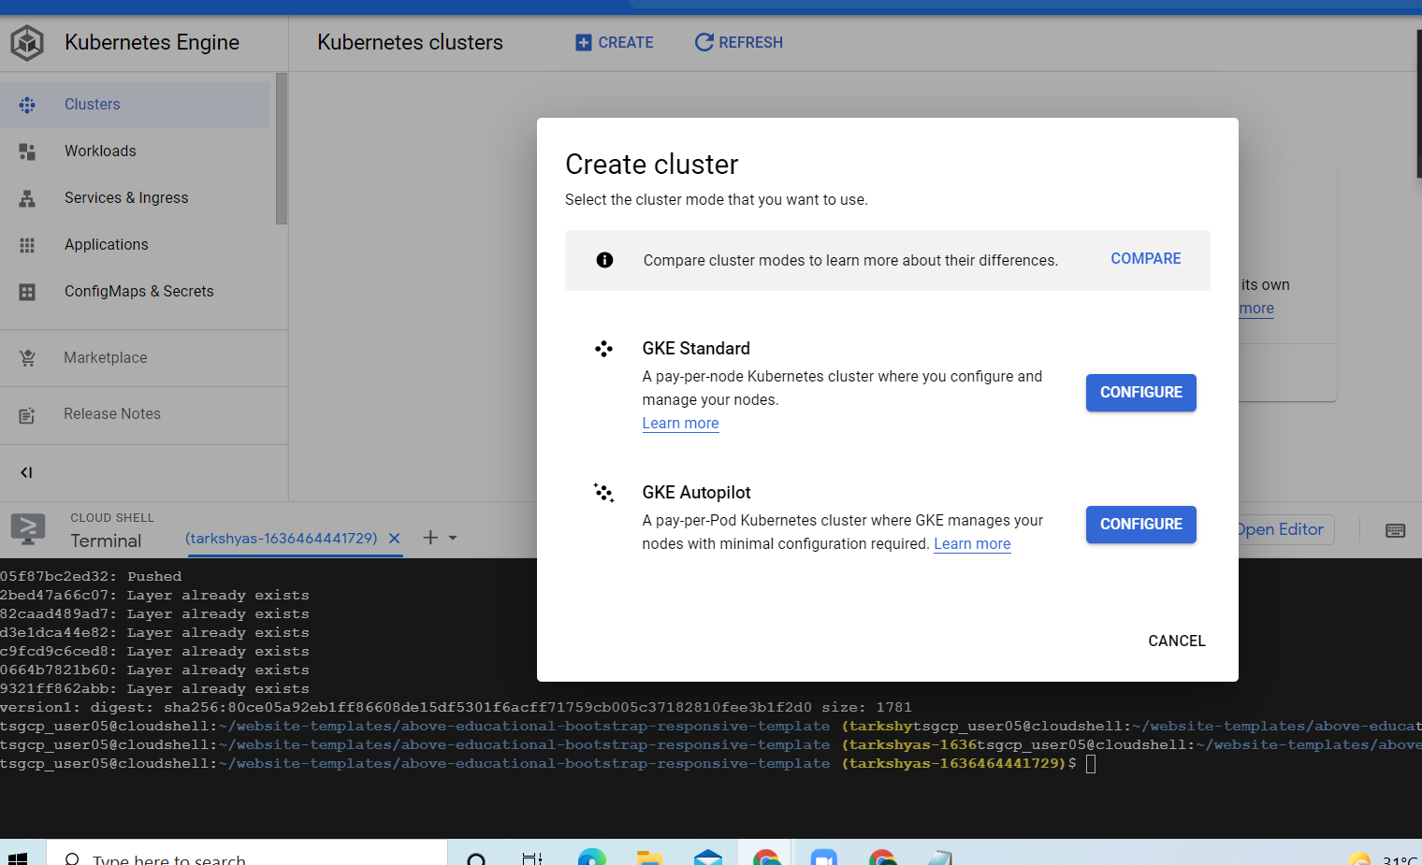

**Select GKE standard**

**After creating the cluster we need to connect the cluster with shell .do the steps as follows:**

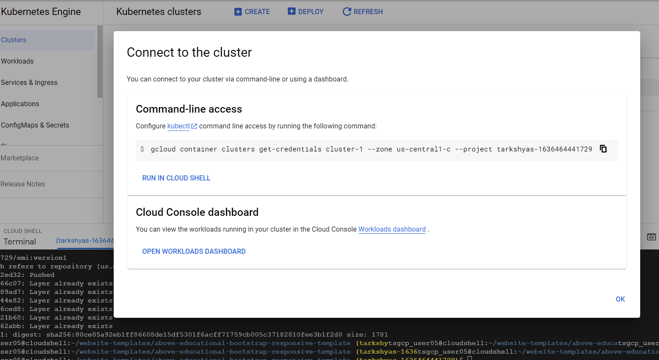

**Copy and paste this command in shell**

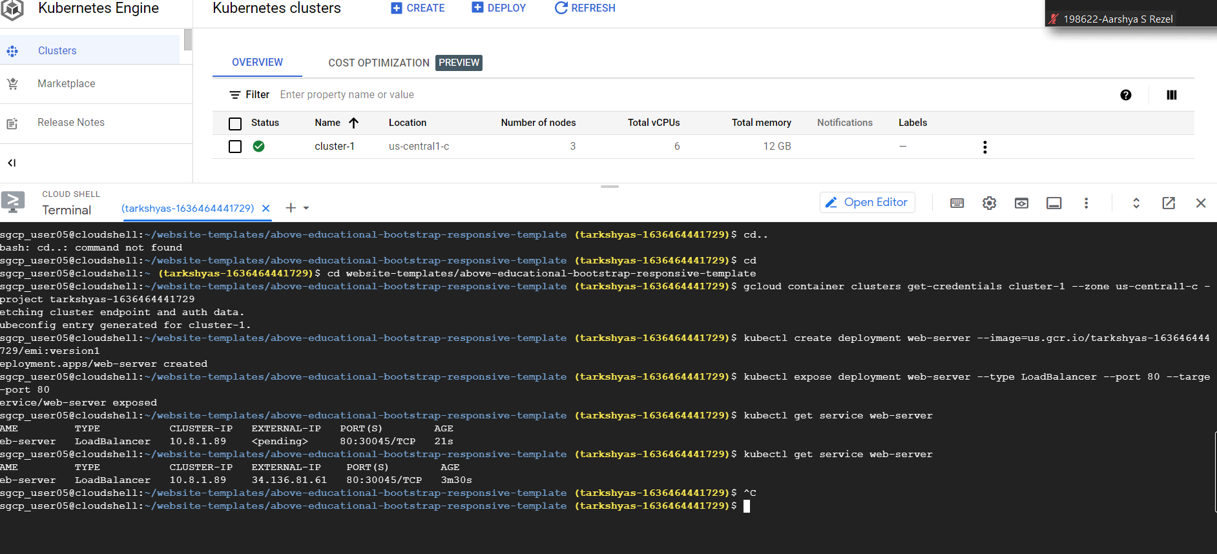

**After pasting connection command we have to use two commands for creating and exposing service**

**The commands are mentioned in the above screenshots**

**kubectl get service web-server is used for the external ip**

**the final output :**



**QUE 9. LOAD BALANCER**

**Steps:**

**1.create instance template**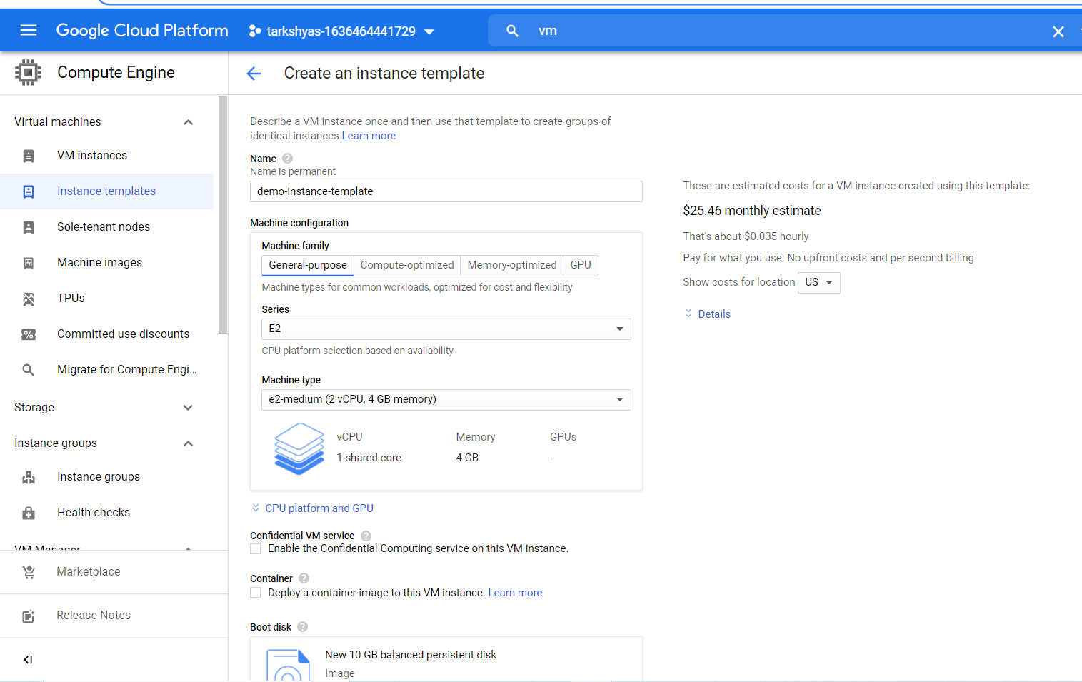

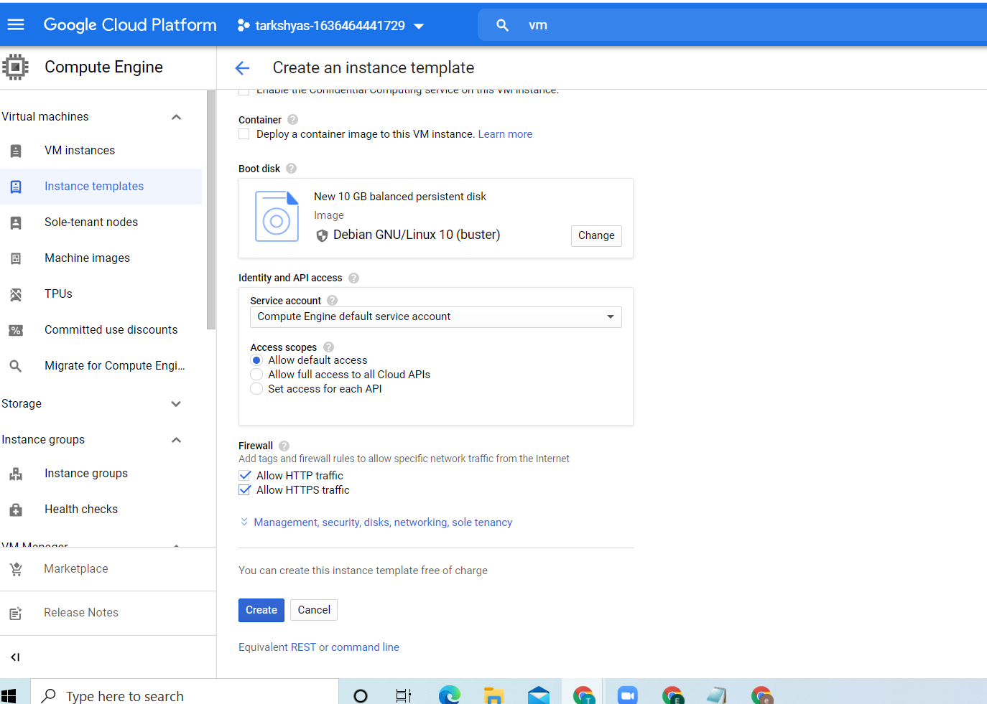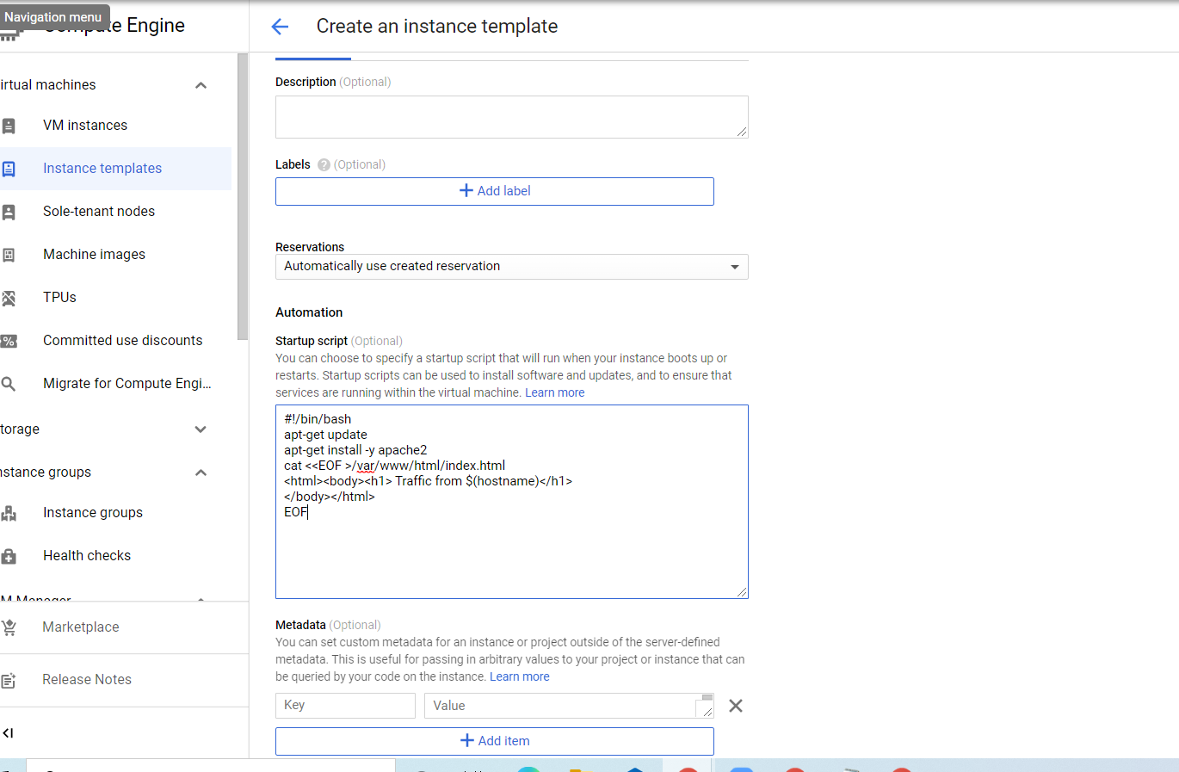

**Use the automation script mentioned in the above screenshot**

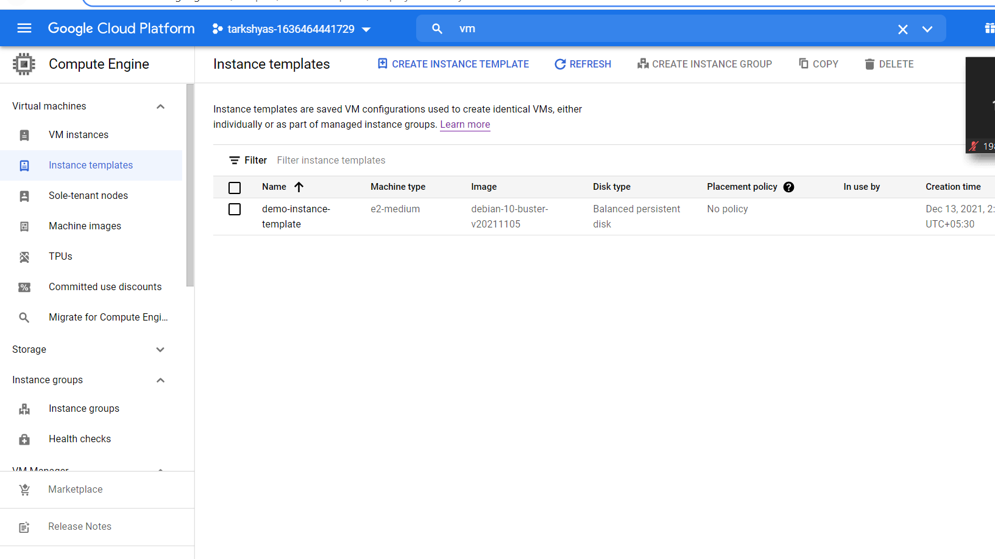

**2.create instance group and health check**

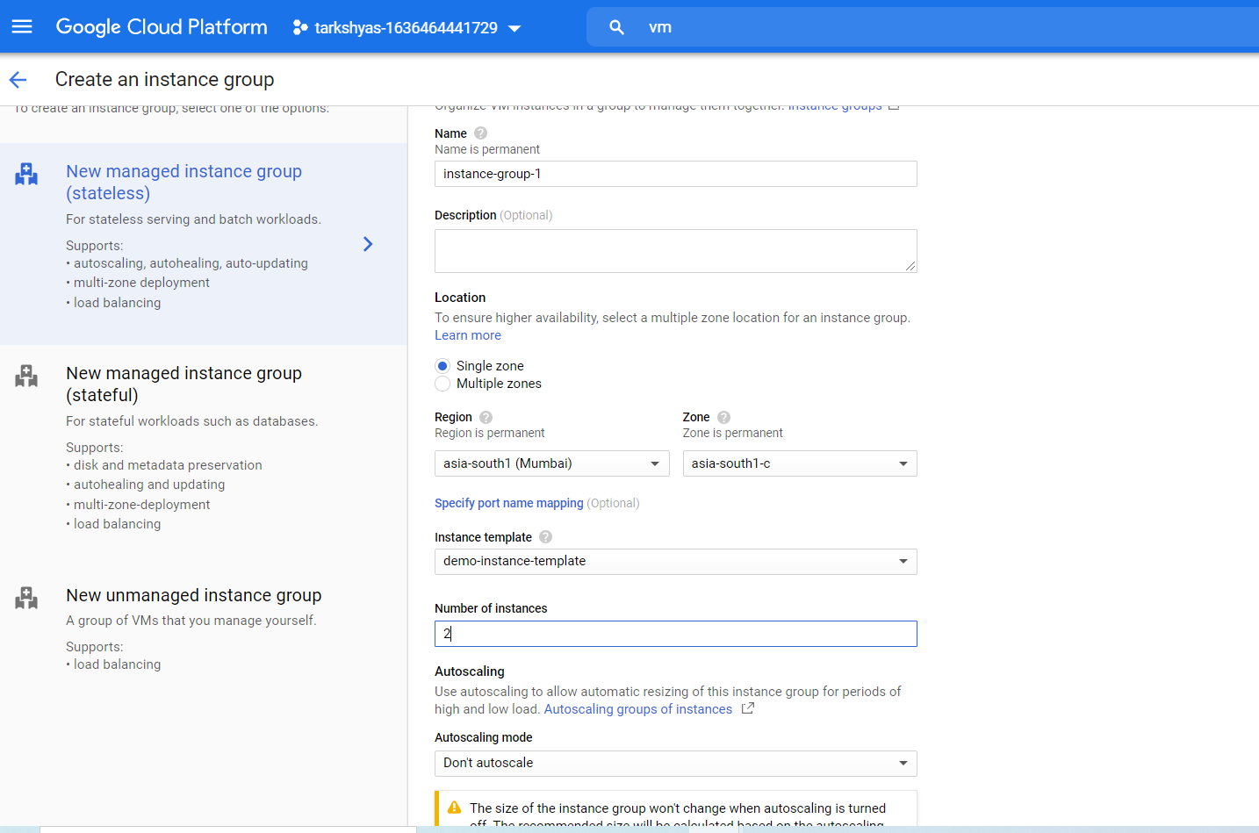

**Health check:**

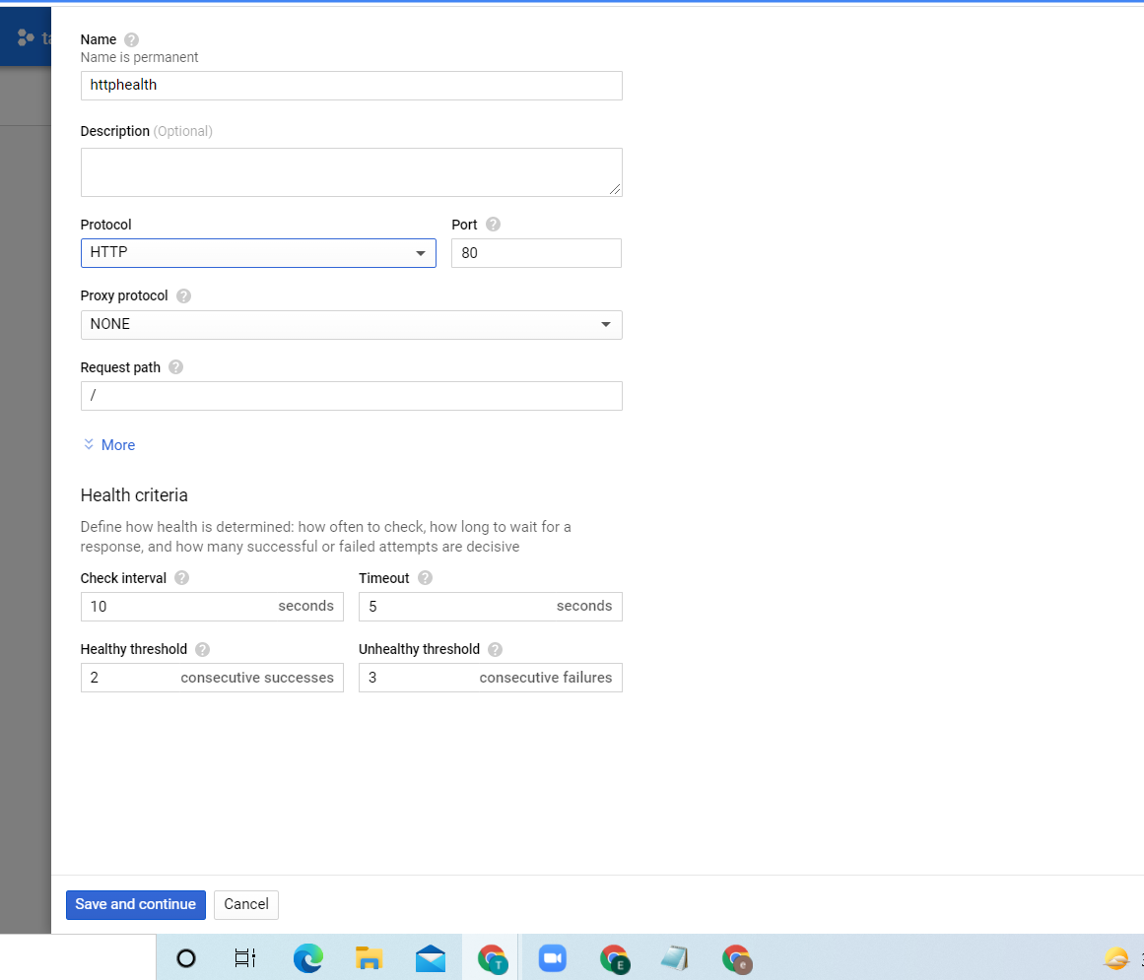

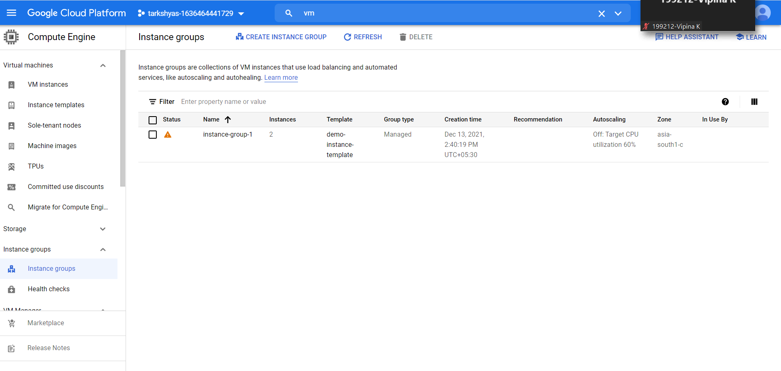

**After creating instance group go to vm instance there we can see the vm instance created from instance group**

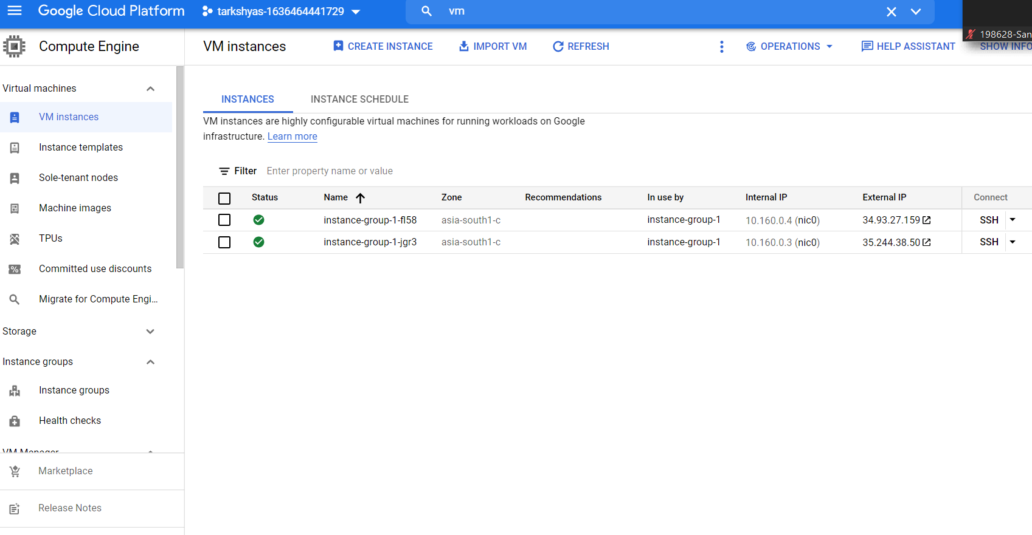

**After that go to load balancing create load balancer**

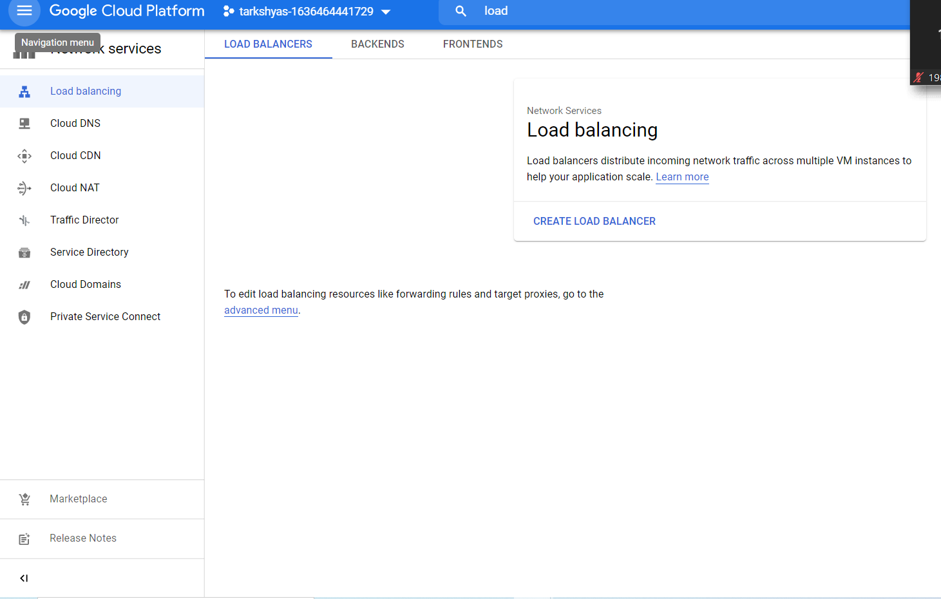

**Select http configuration:**

**Then do the steps:**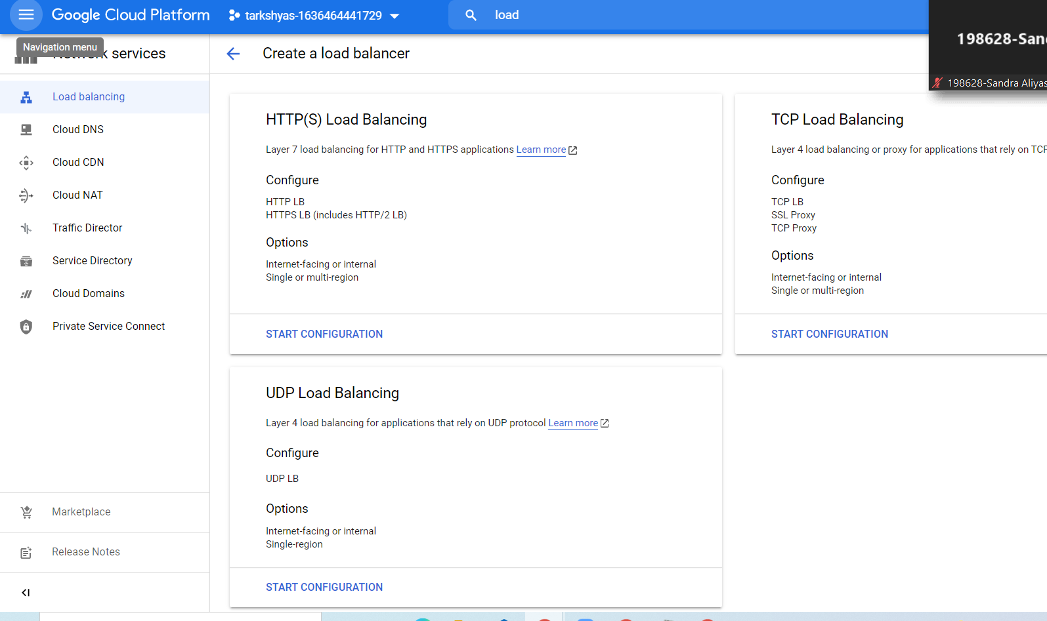

**Backend configration:**

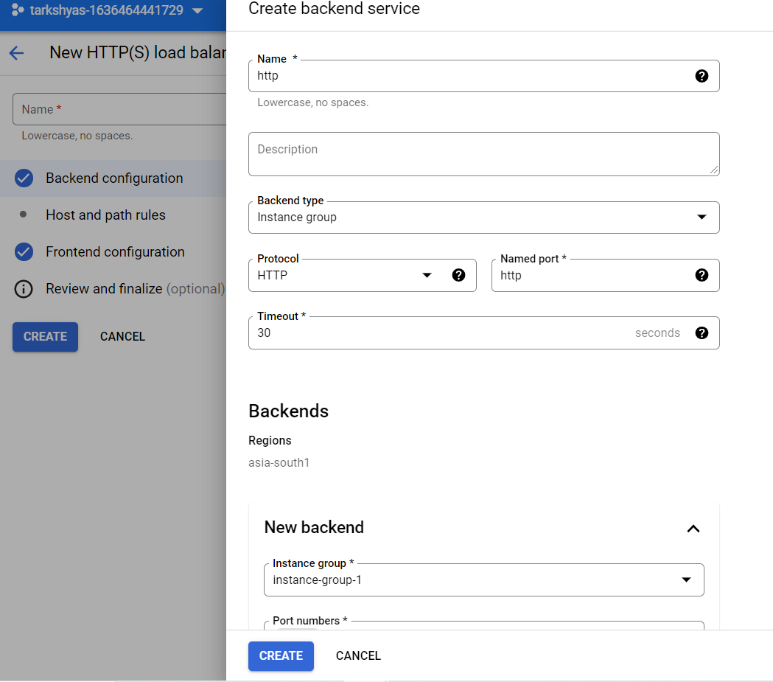

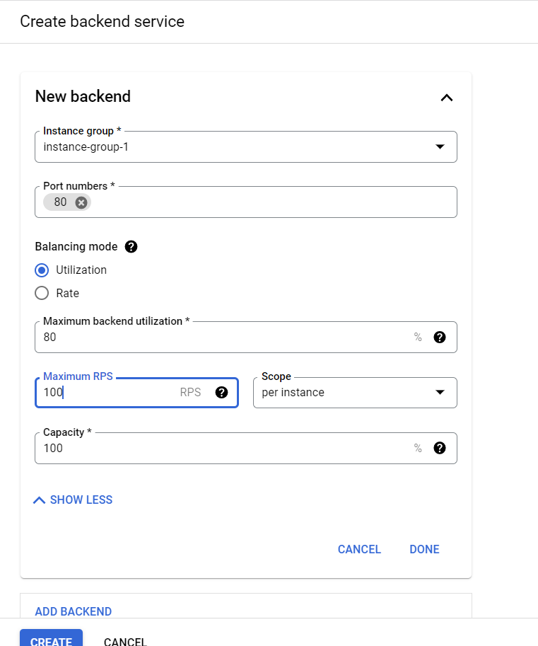

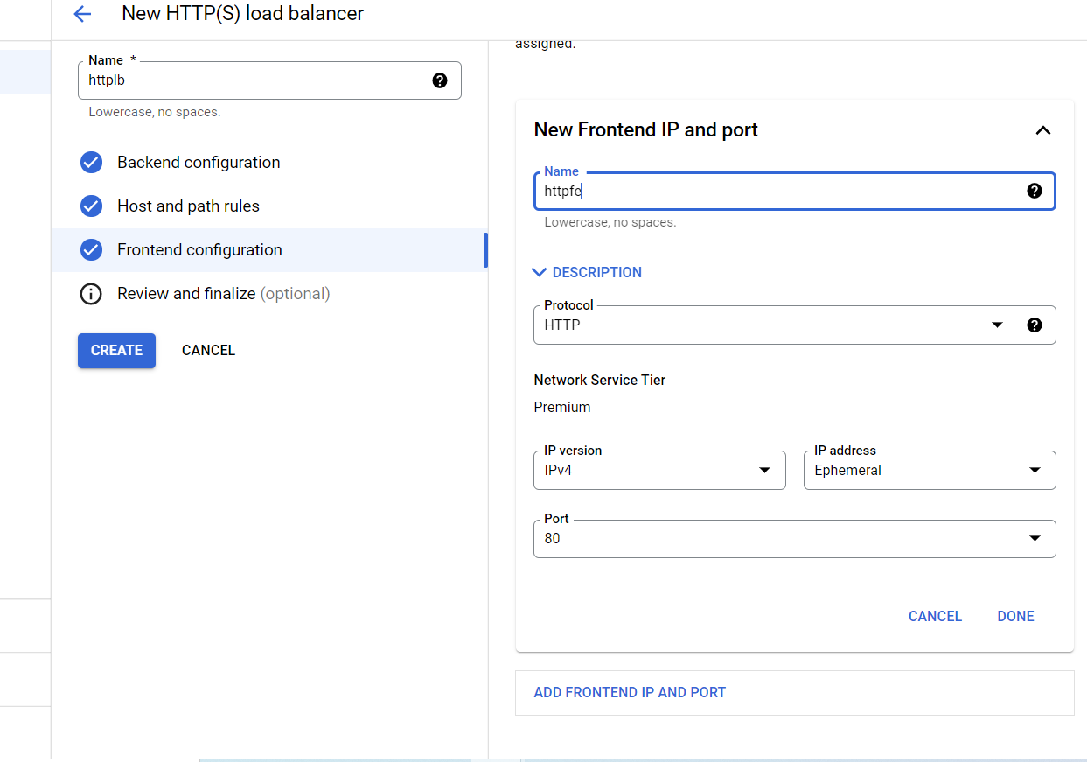

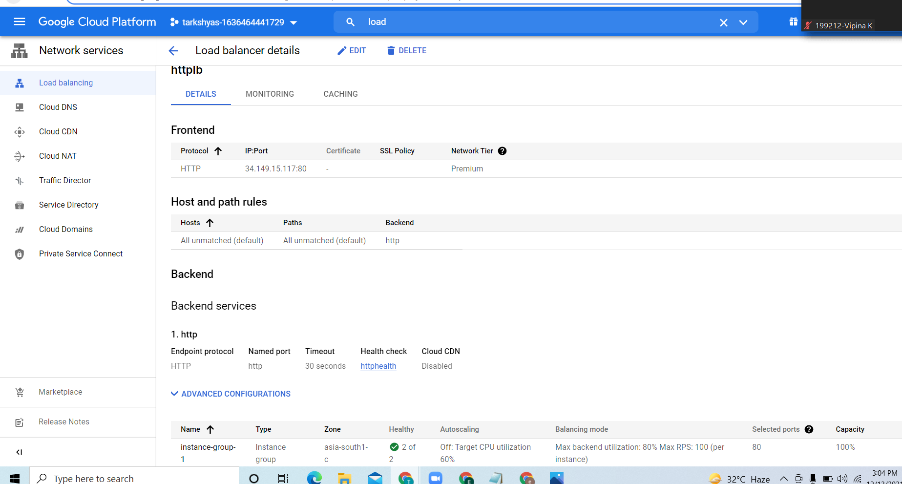

**Copy and paste the ip the we get the webpage:**

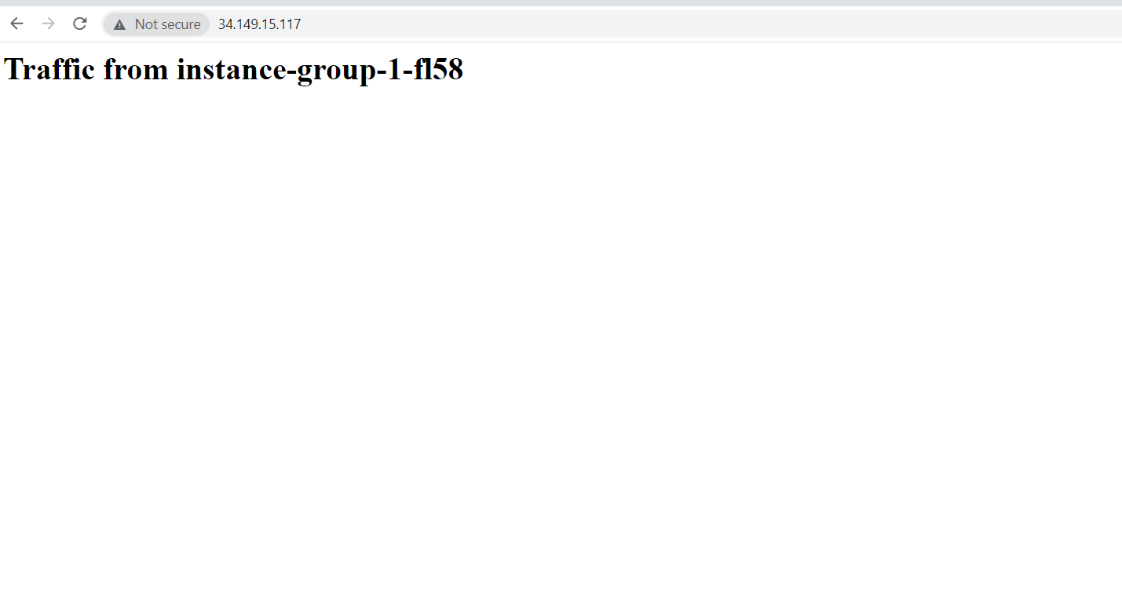

**If the requests coming to the first is high then the loadbalancer direct some requests to the next vm**

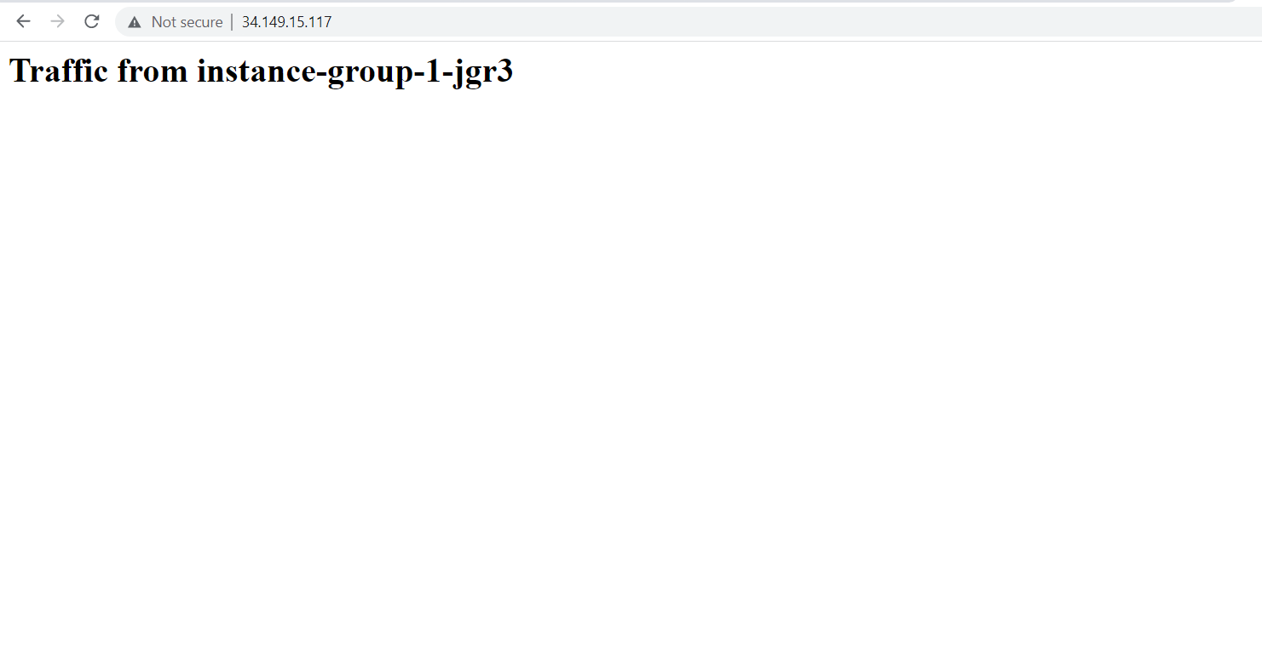

**QUE 5 CLOUD FUNCTION**

**Steps :**

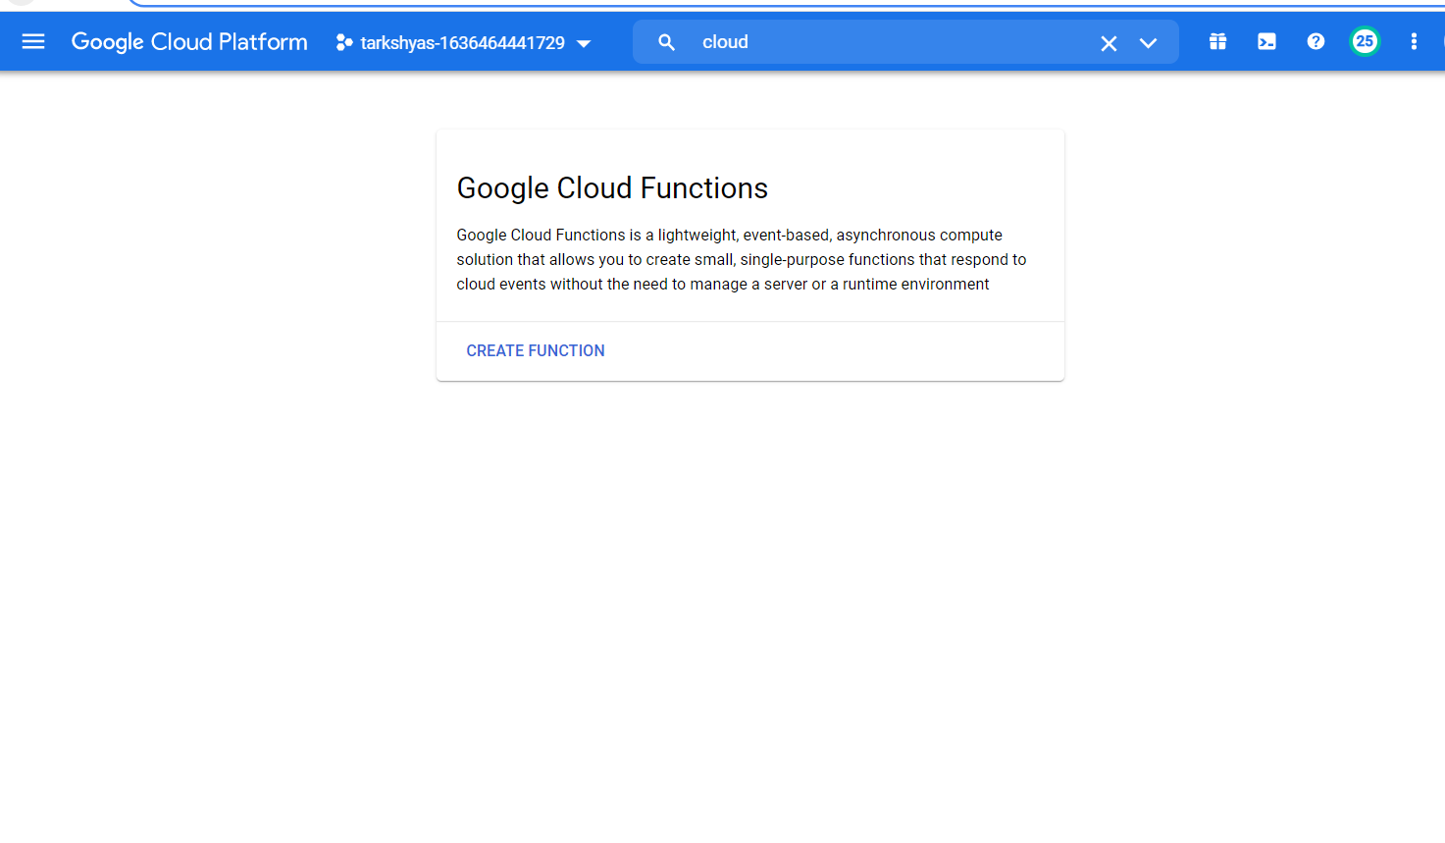

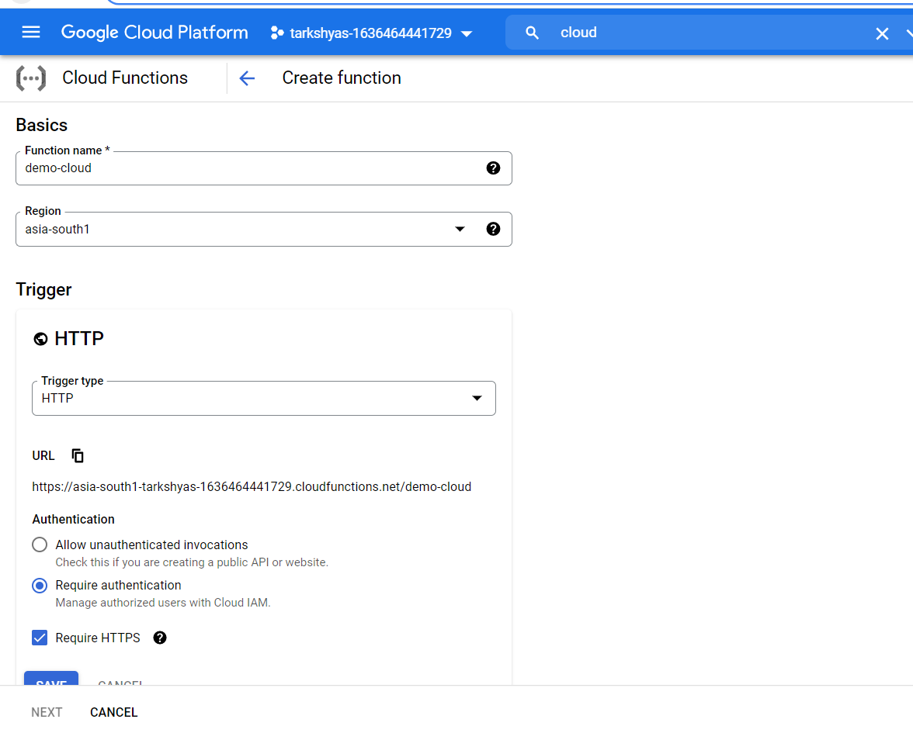

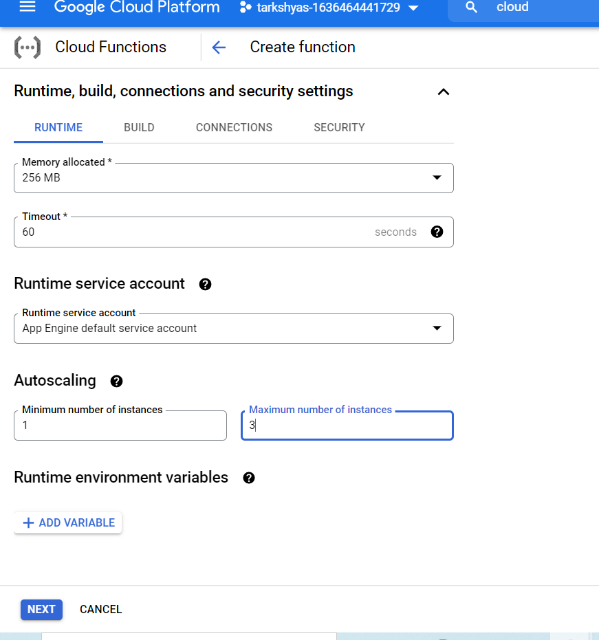

**Click on trigger section where we will get a link to our webpage**

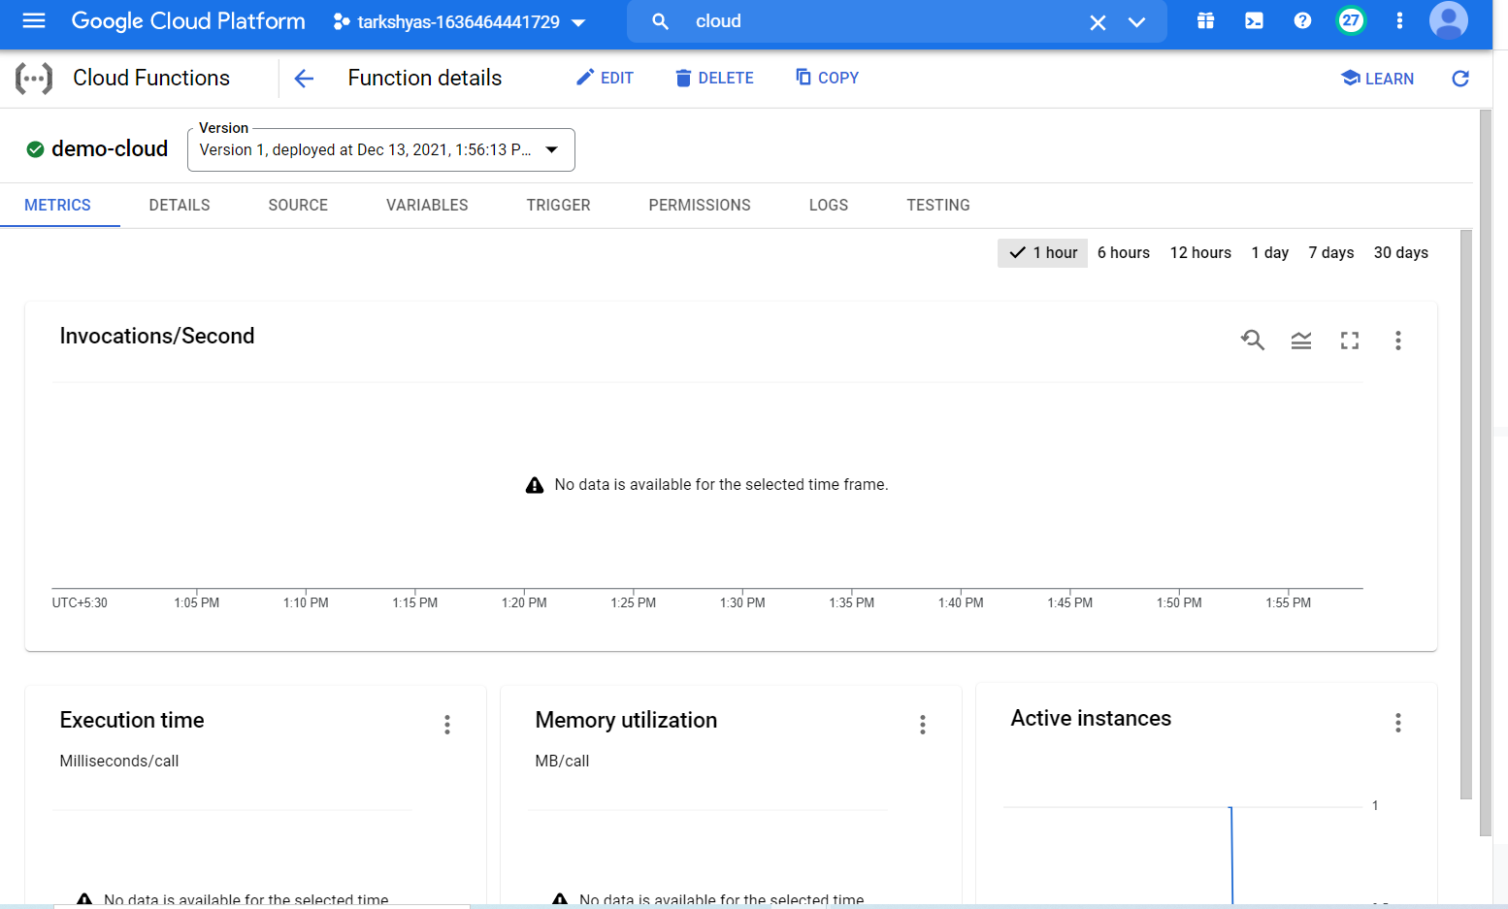

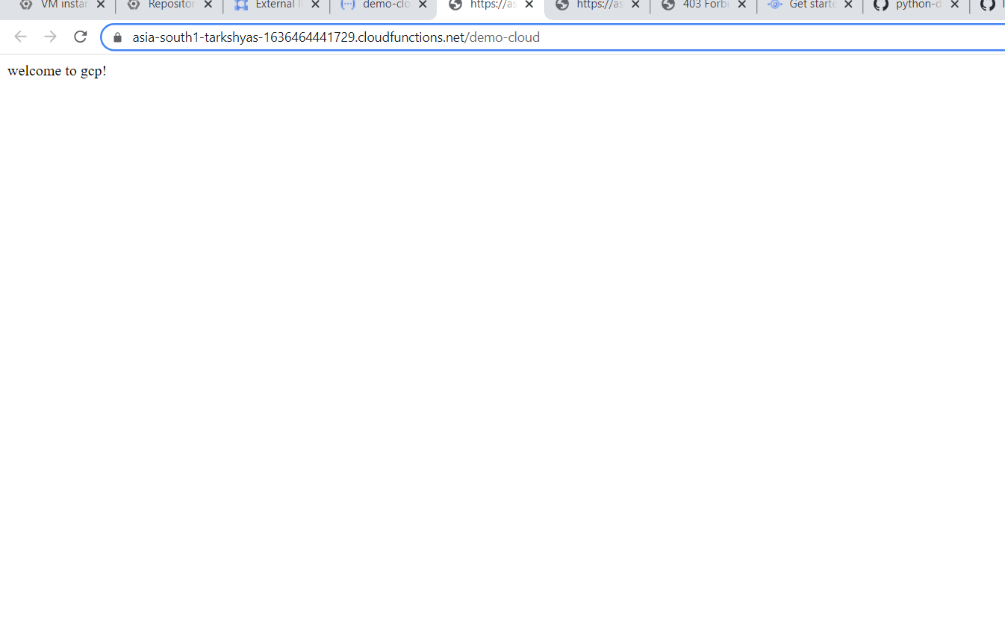

**QUE 11 TERRAFORM AND ANSIBLE**

**TERRAFORM**

**We can create gcp resources using terraform**

**For this we need terraform.exe file, service account with json key,visual studio**

**The command used to create resources :**

**In cmd , 1.gcloud init**

**2.terraform init**

**3.terraform plan**

**4.terraform apply**

**5.terraform destroy**

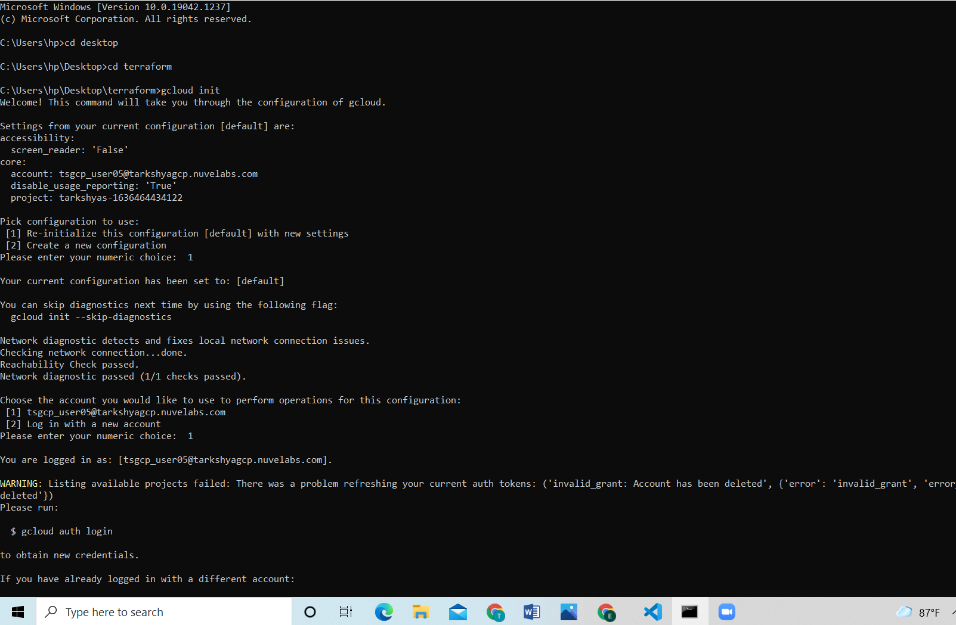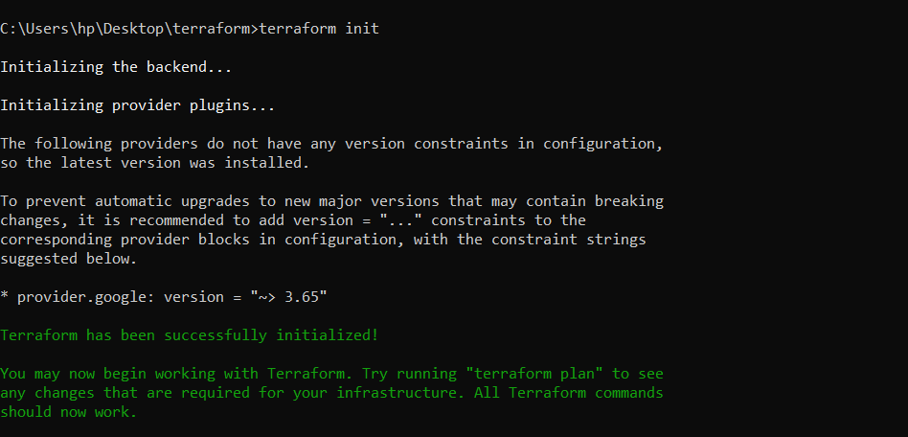

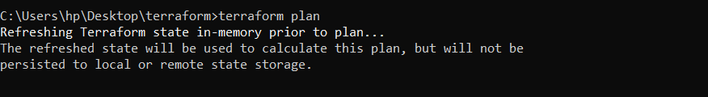

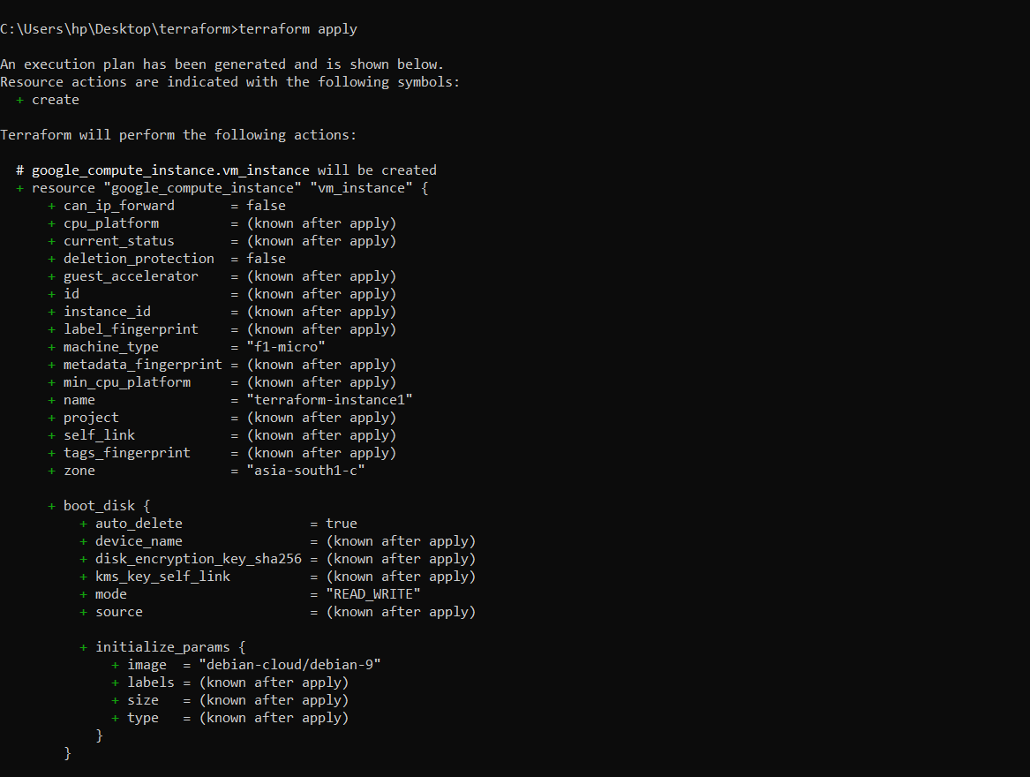

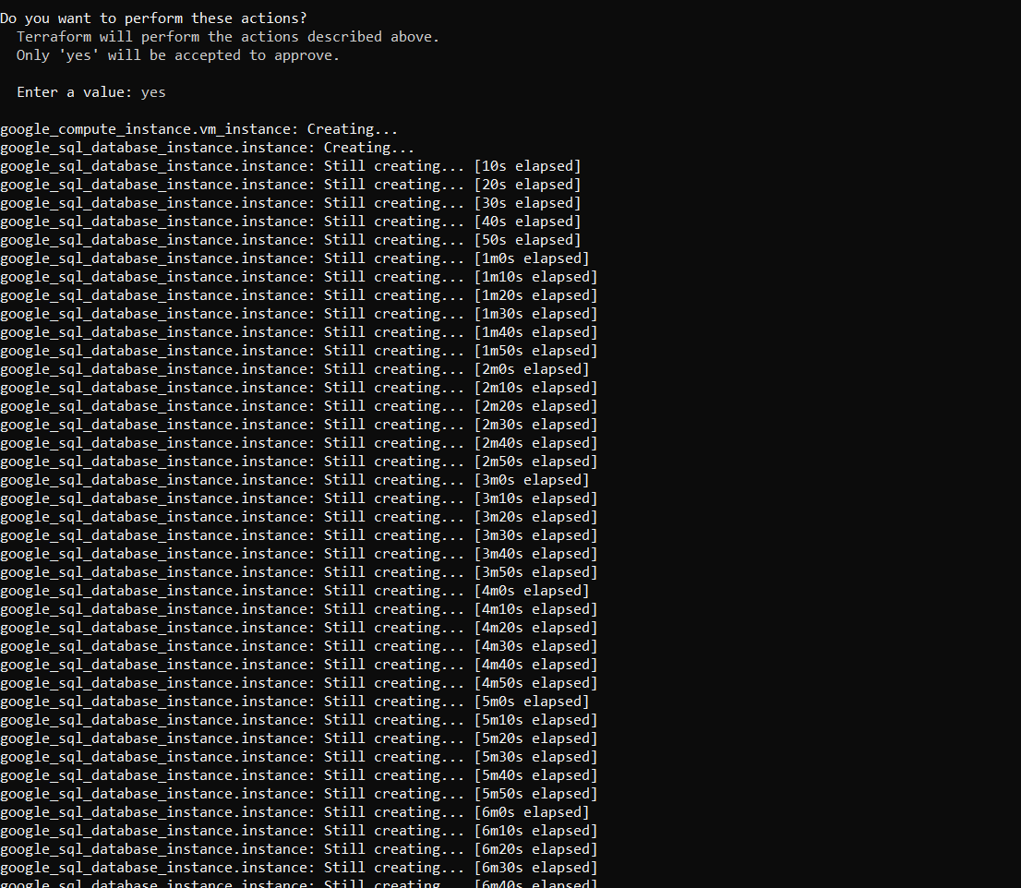

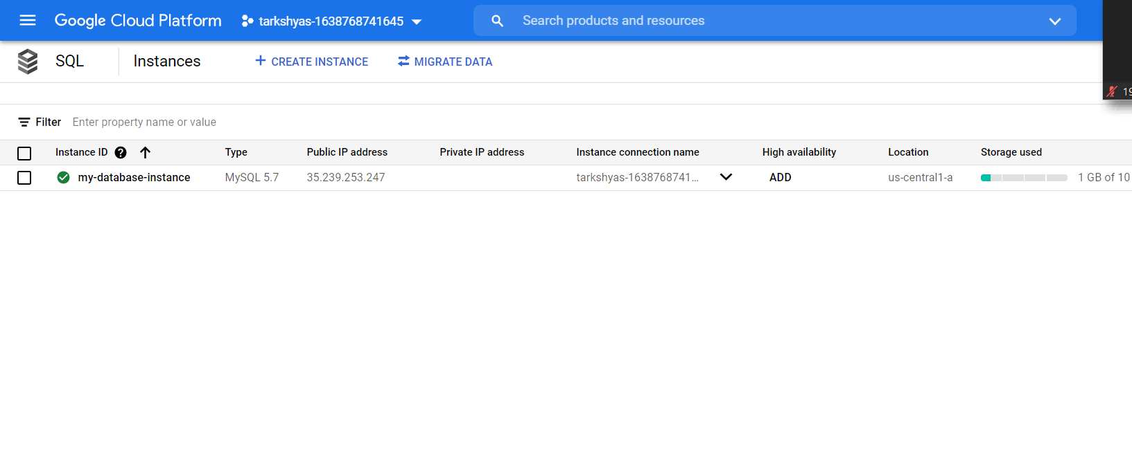

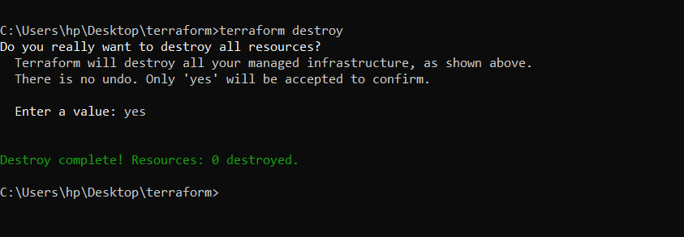

**Code for cloud sql:**

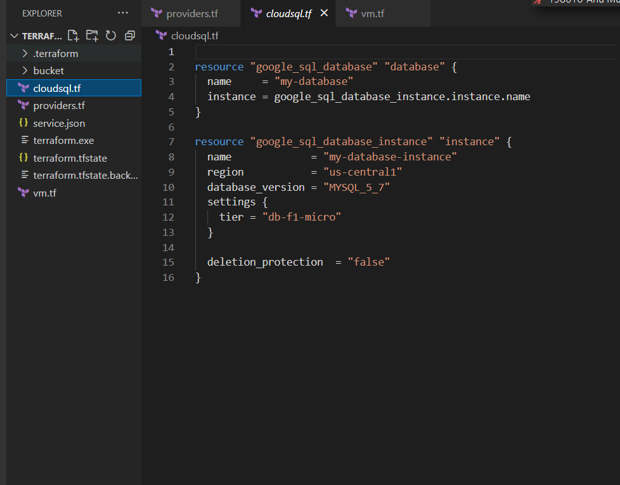

**The steps to create service account**

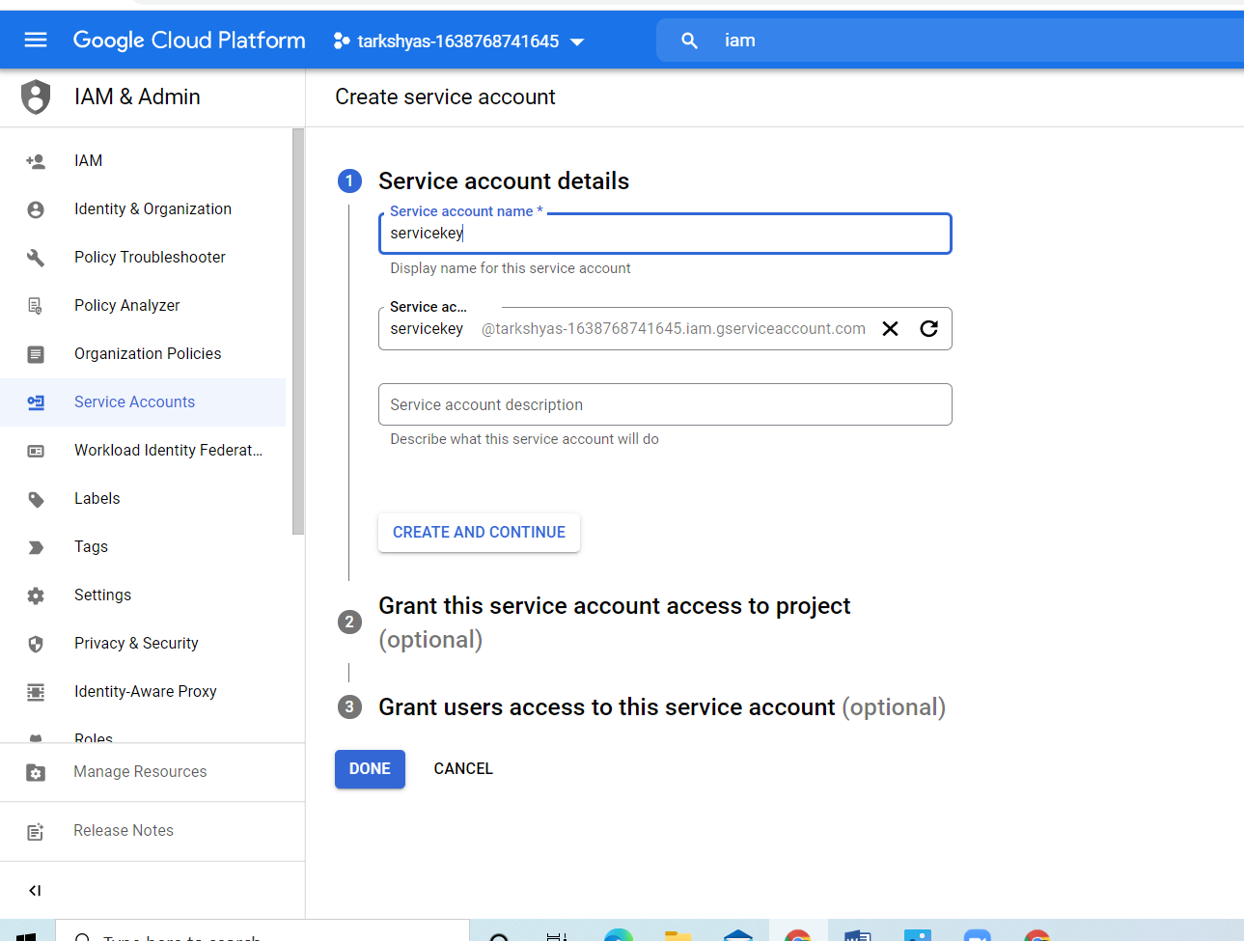

**Grant service account access to project as owner**

**ANSIBLE**

**The commands are:**

**Python –m pip install –user ansible**

**Pip install ansble==2.7.0**

**Upload the json file and code for creating the resources**

**Ansible-playbook filename.yml**

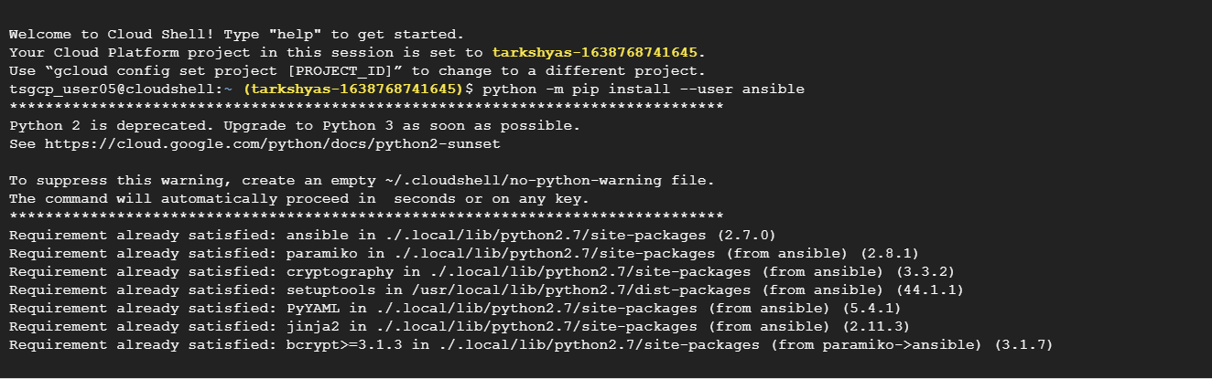

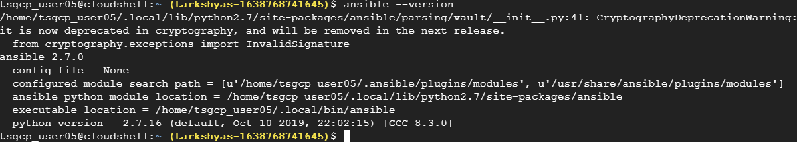

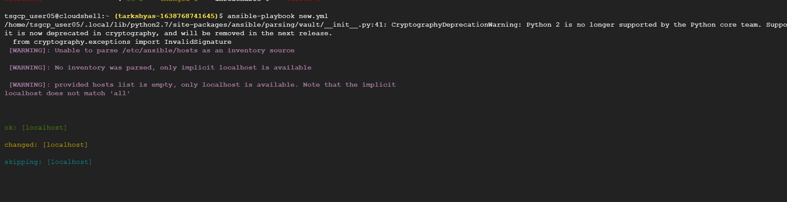

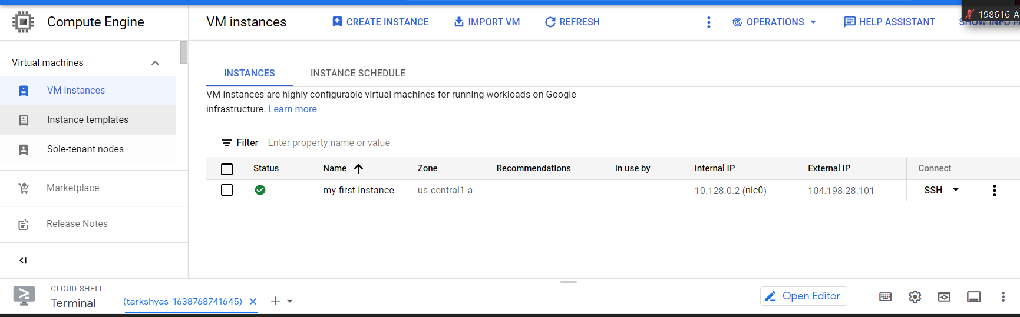

**Code:**

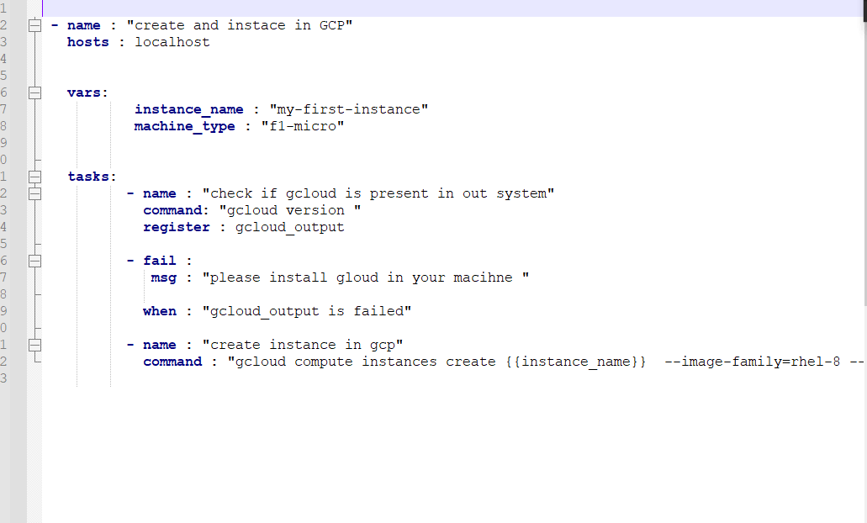

**Que 12 bigquery**

**1.create a dataset**

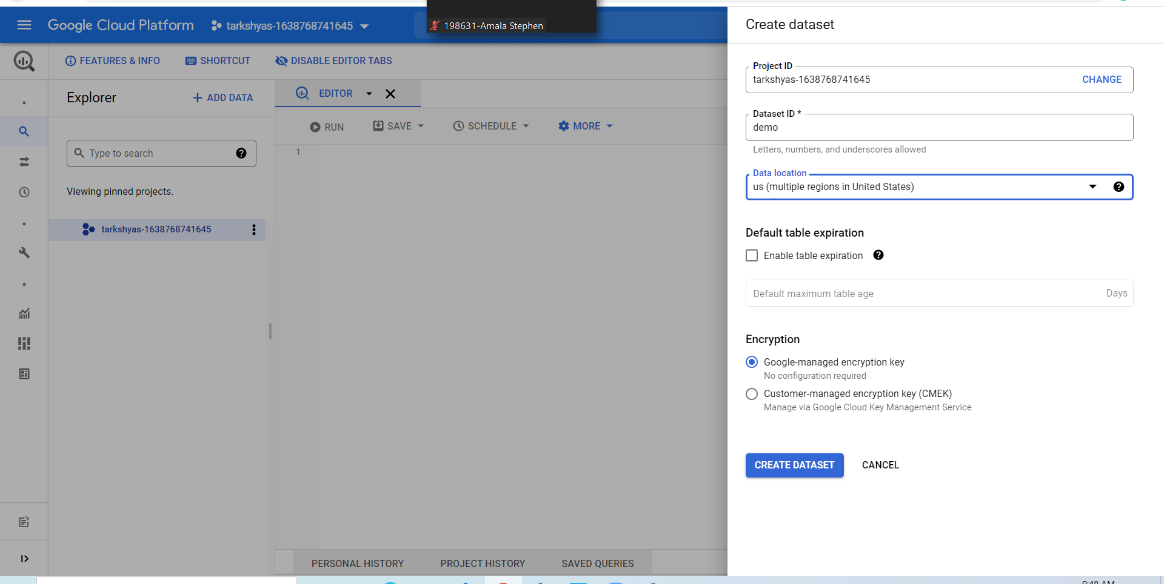

**Create a bucket and upload the files to be imported**

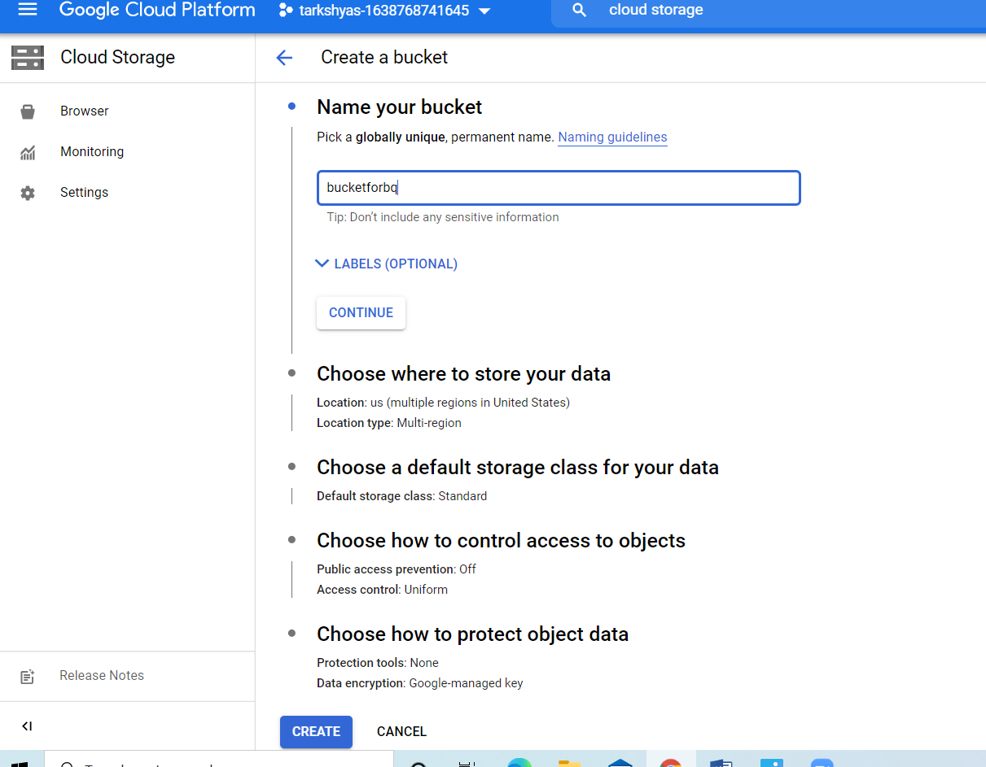

**Bucket and files**

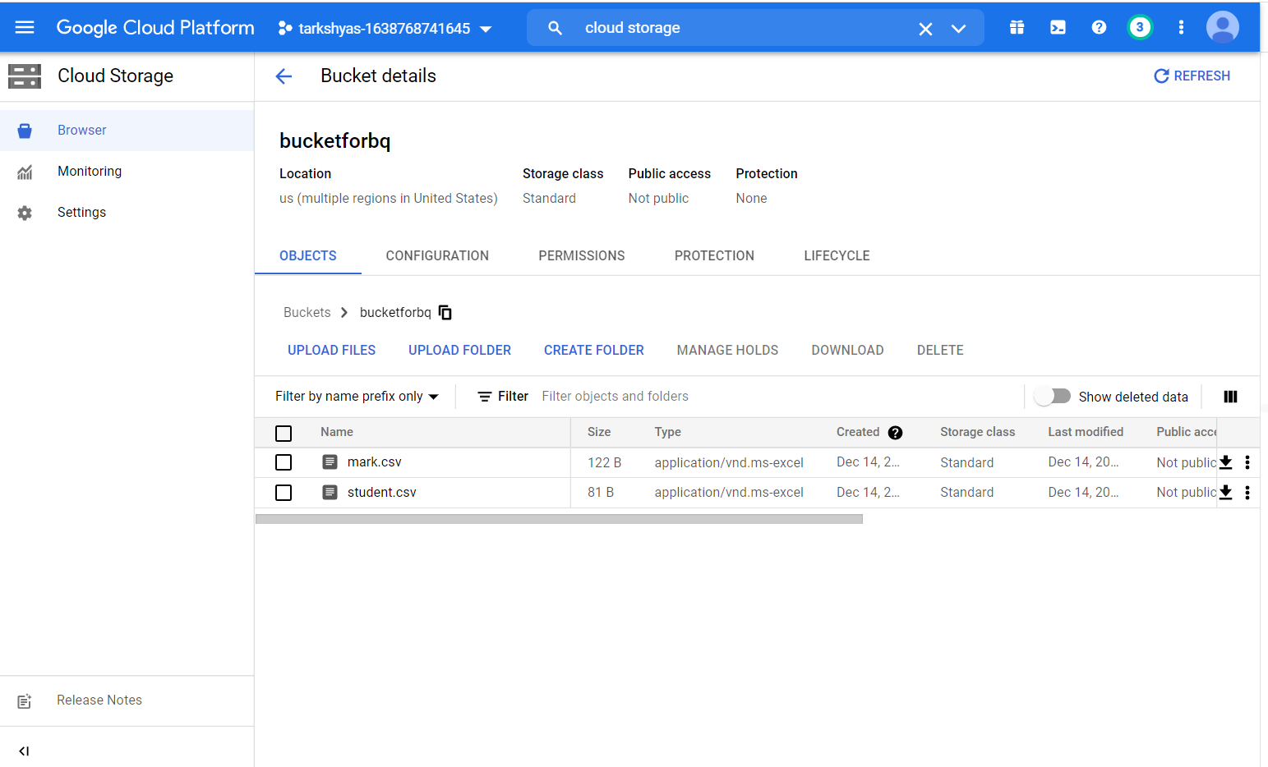

**Table creation :**

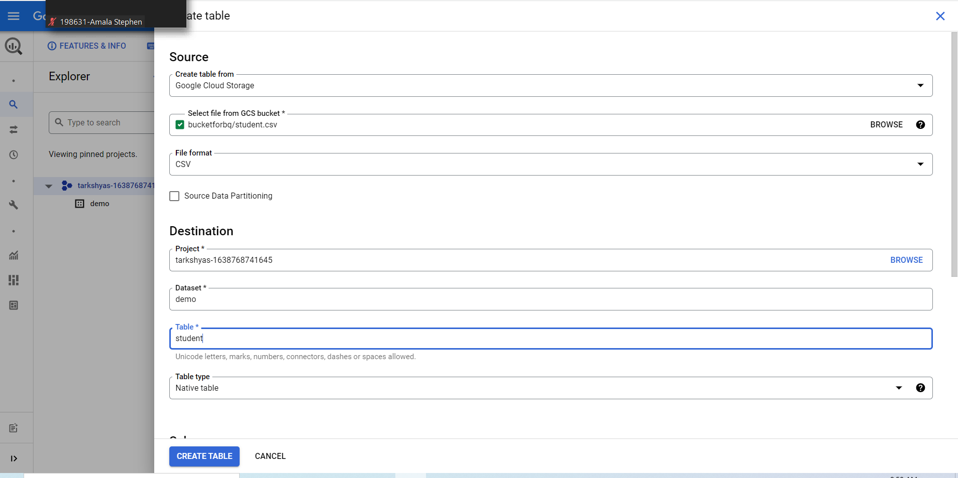

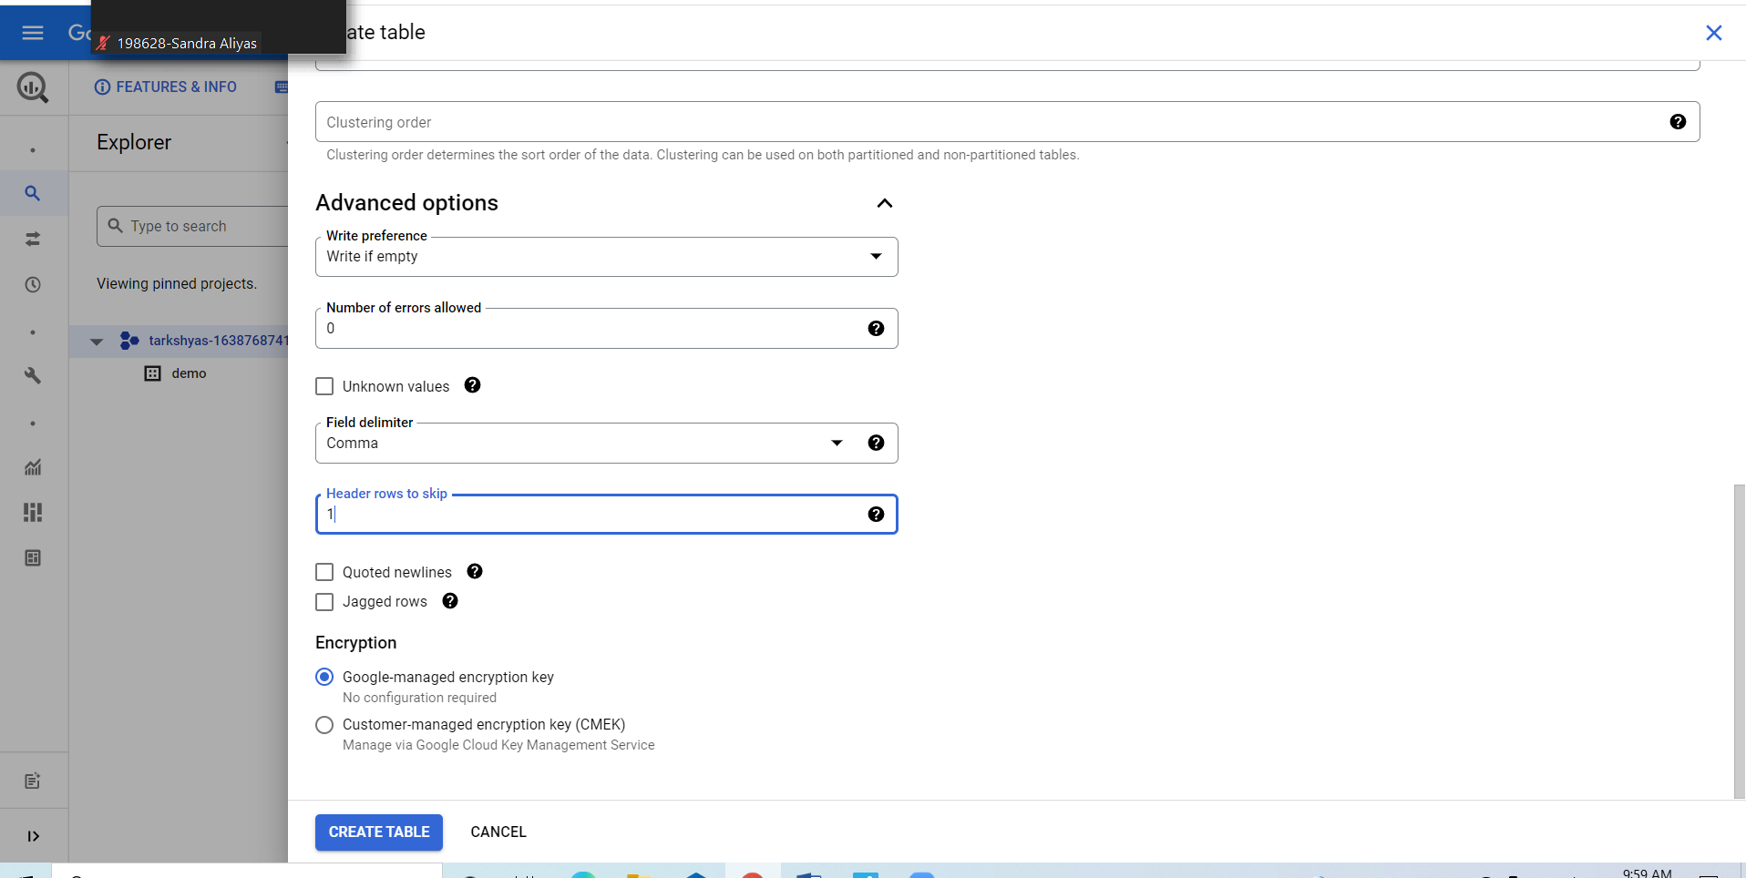

**Creation of another table**

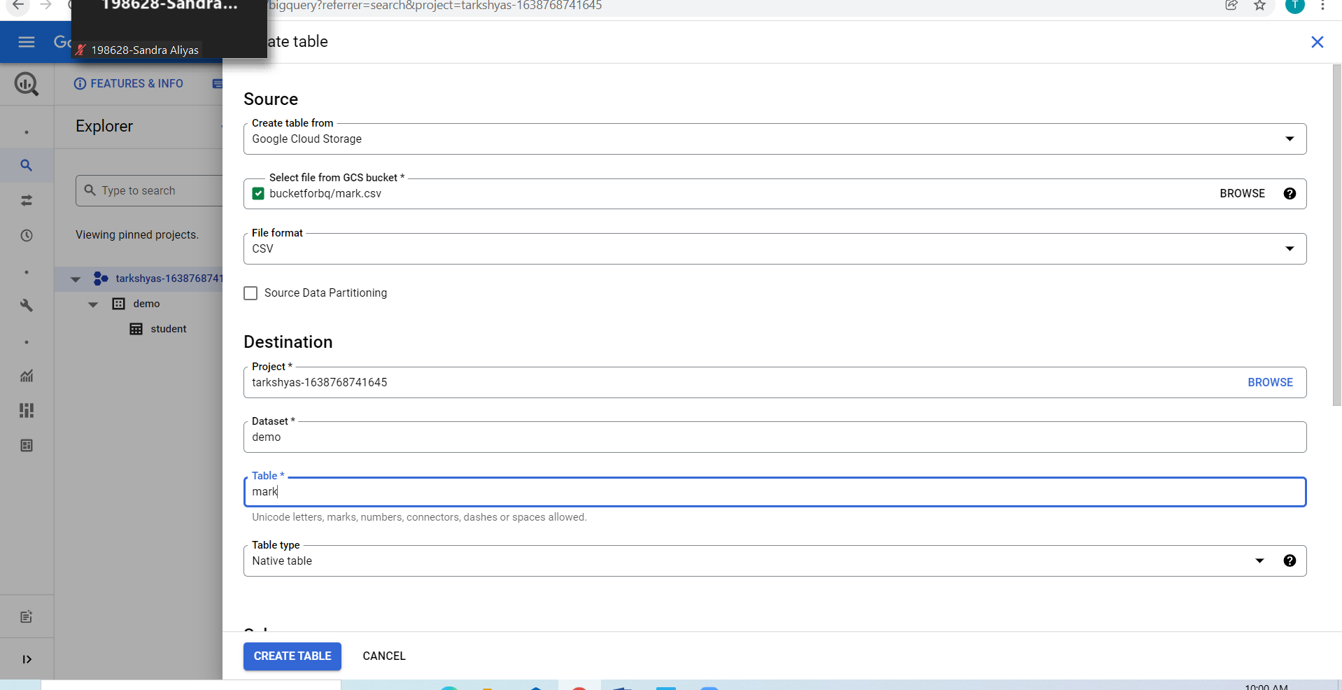

**Sql basics such as where, group by ,order by,join**

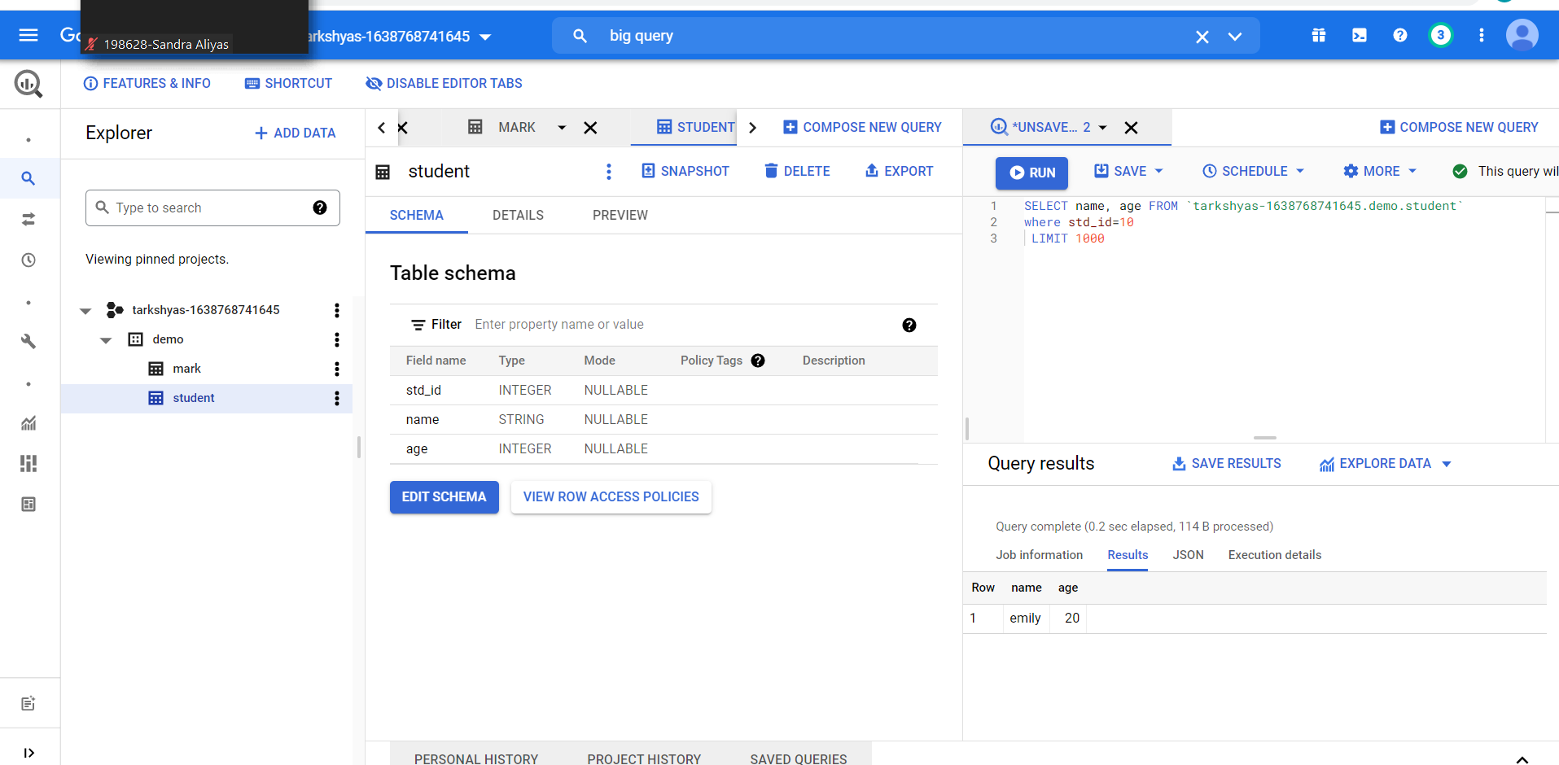

**Order by**

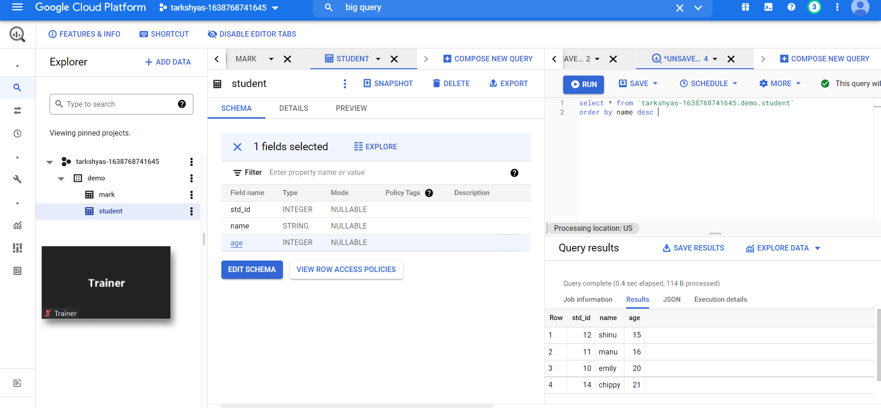

**Group by:**

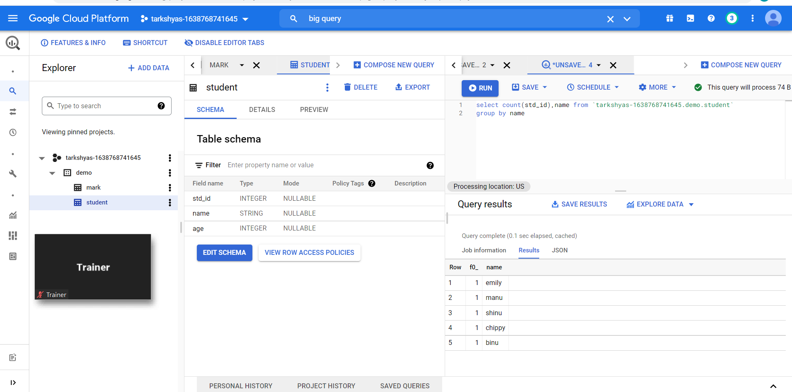

**Join:**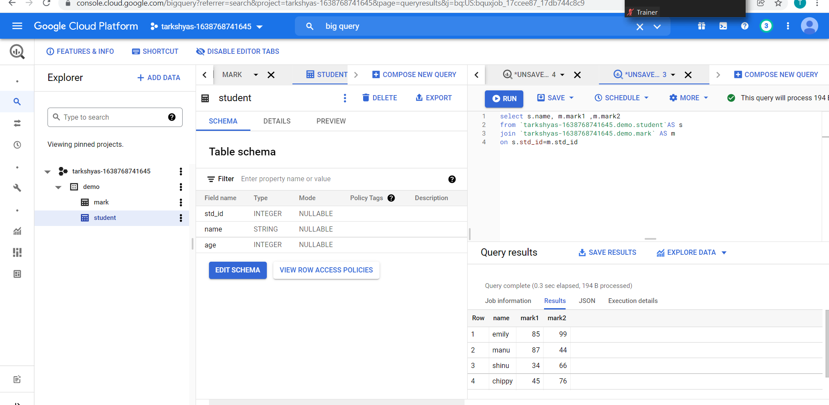

**Clustering and partitioning:**

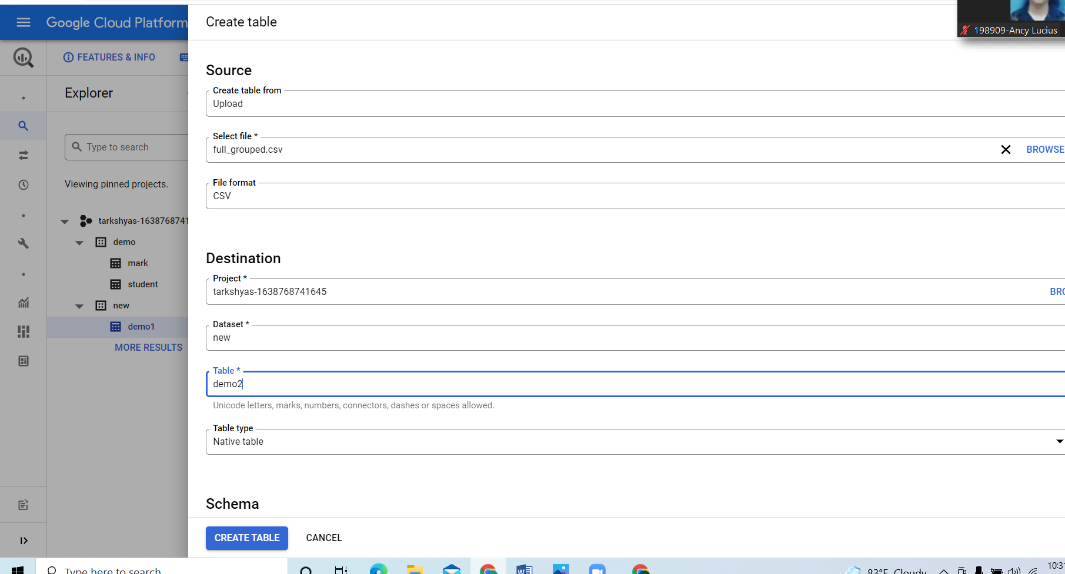

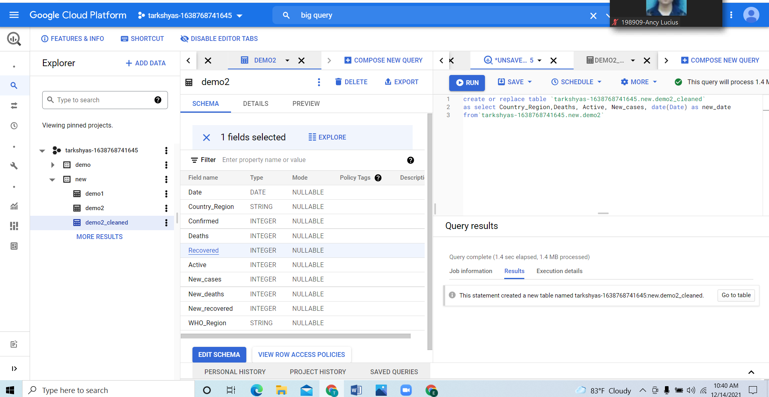

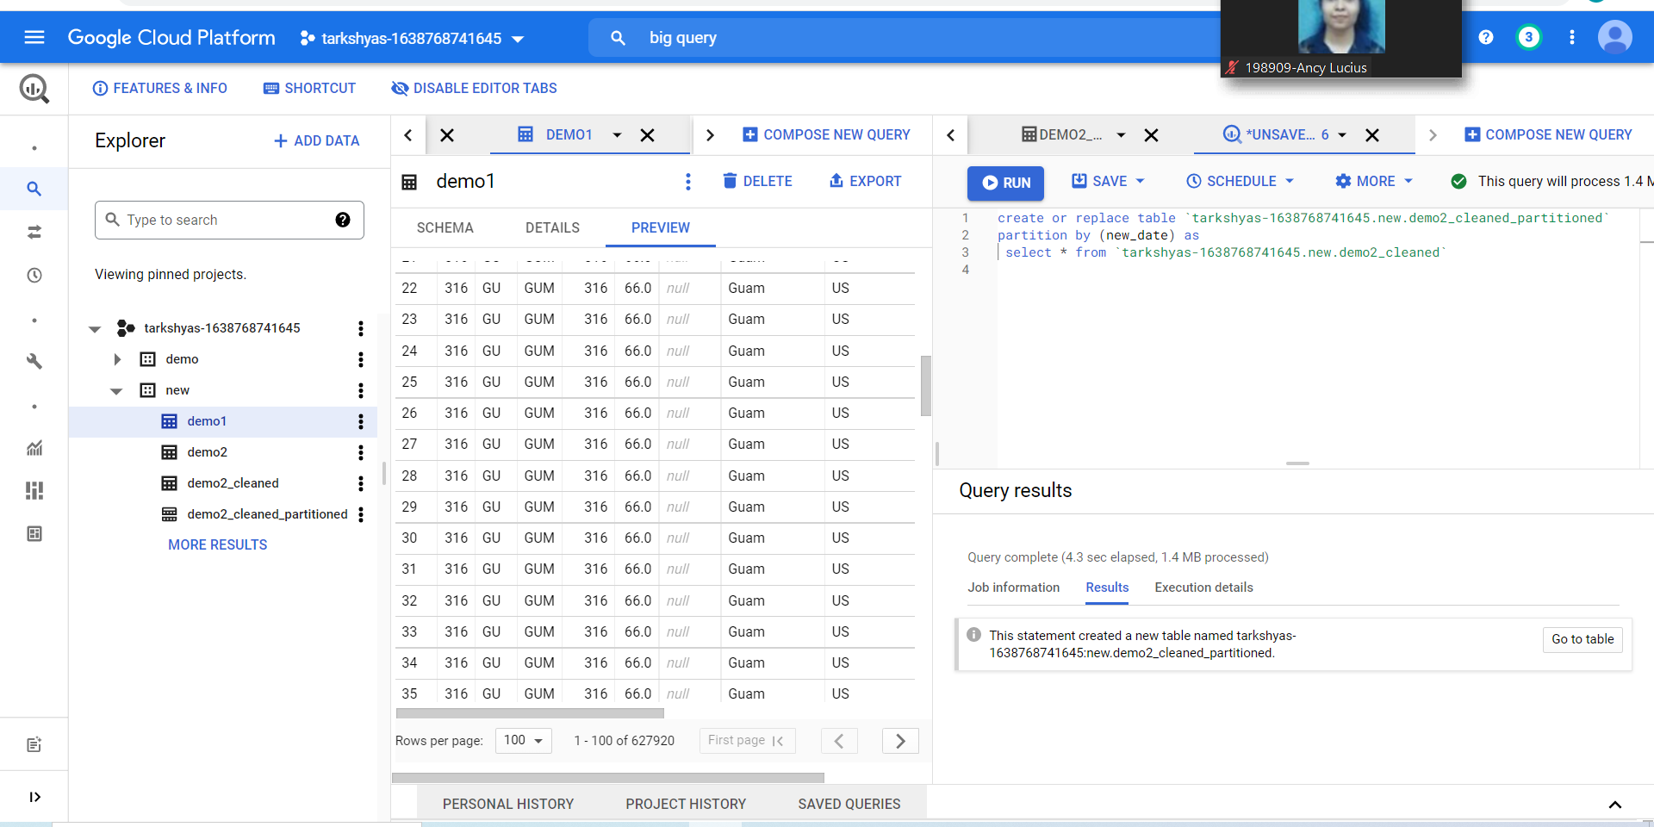

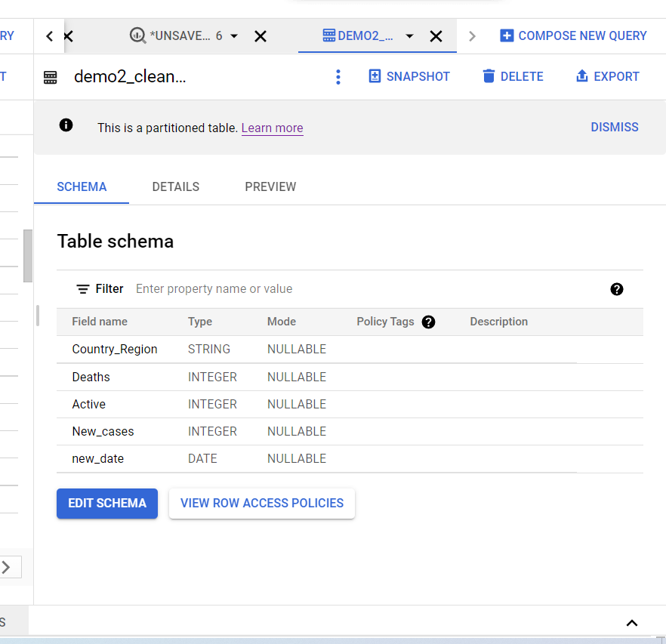

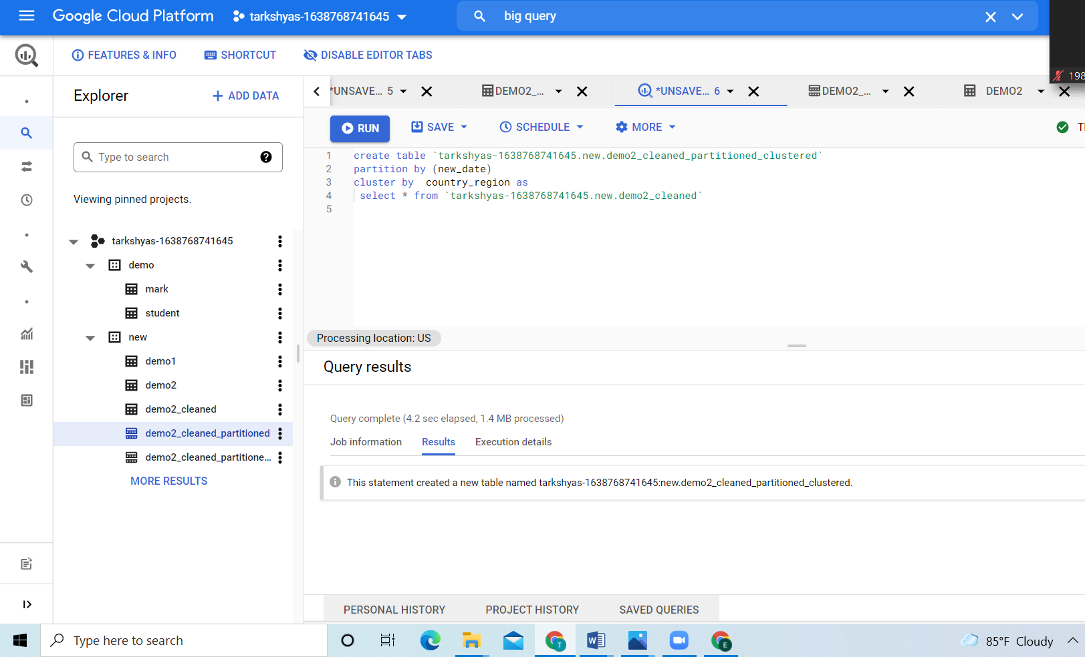

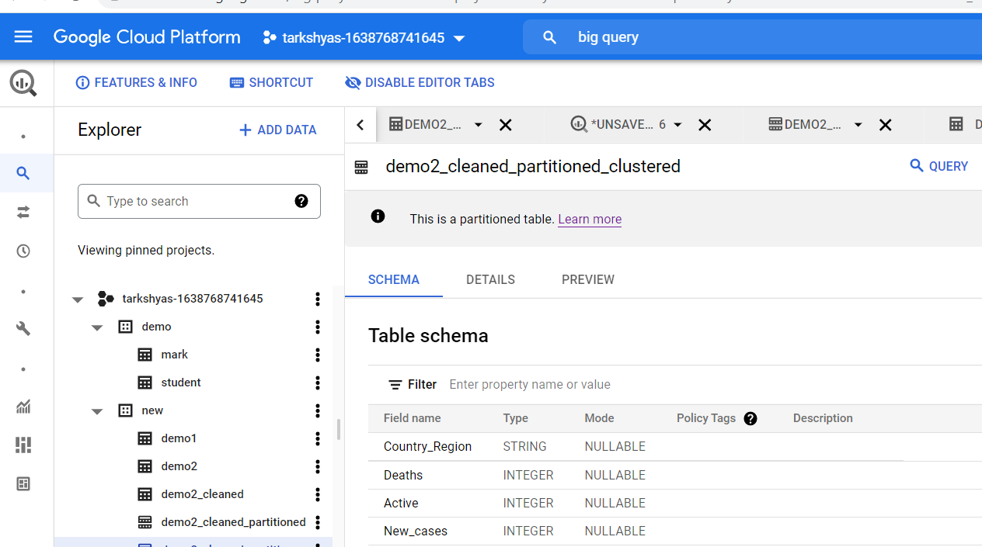

**Big query ML**

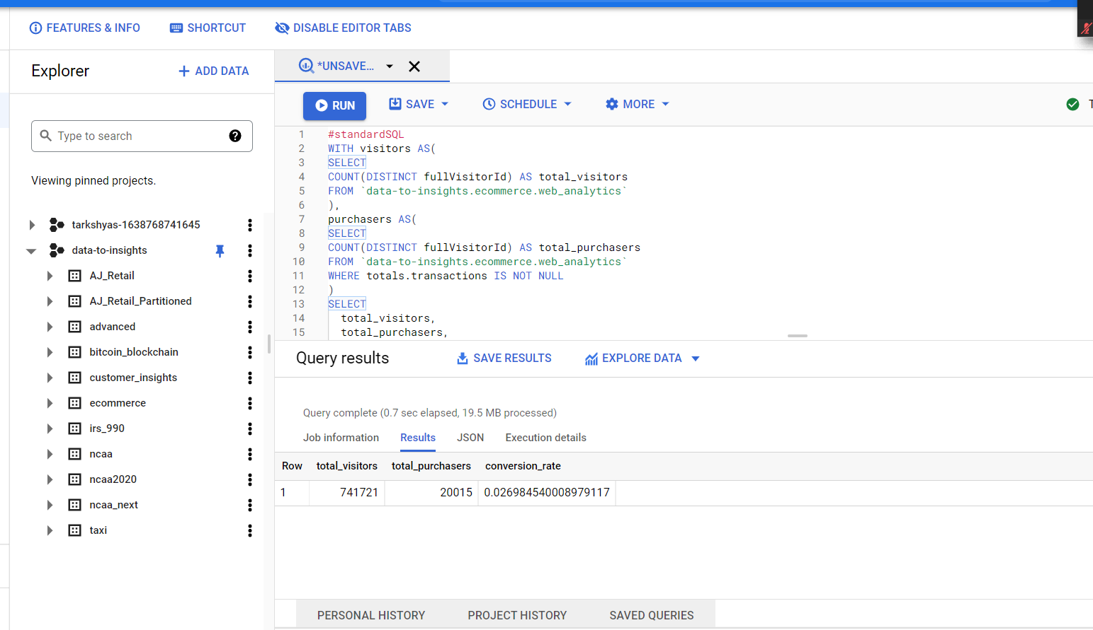

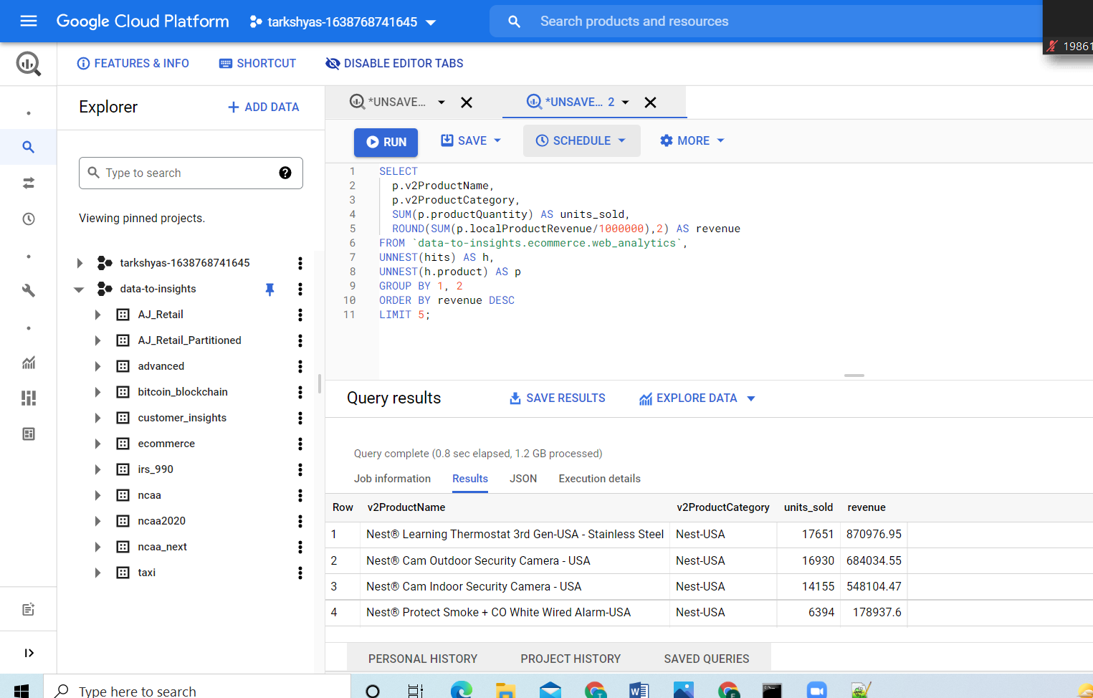

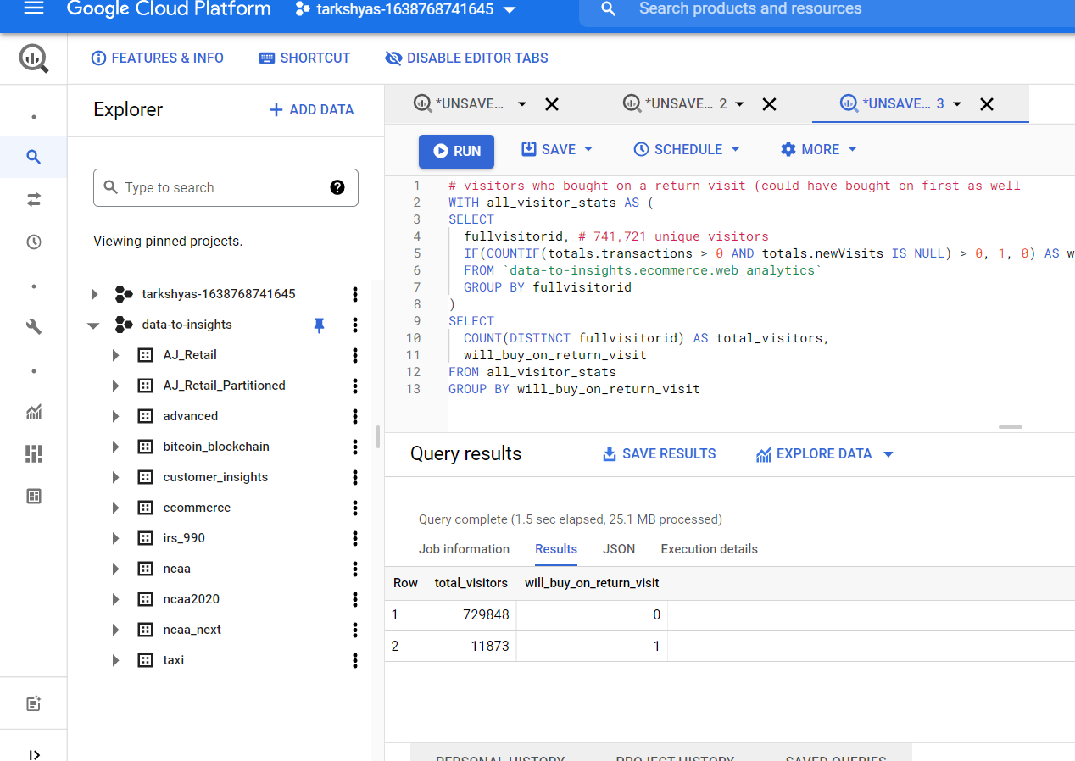

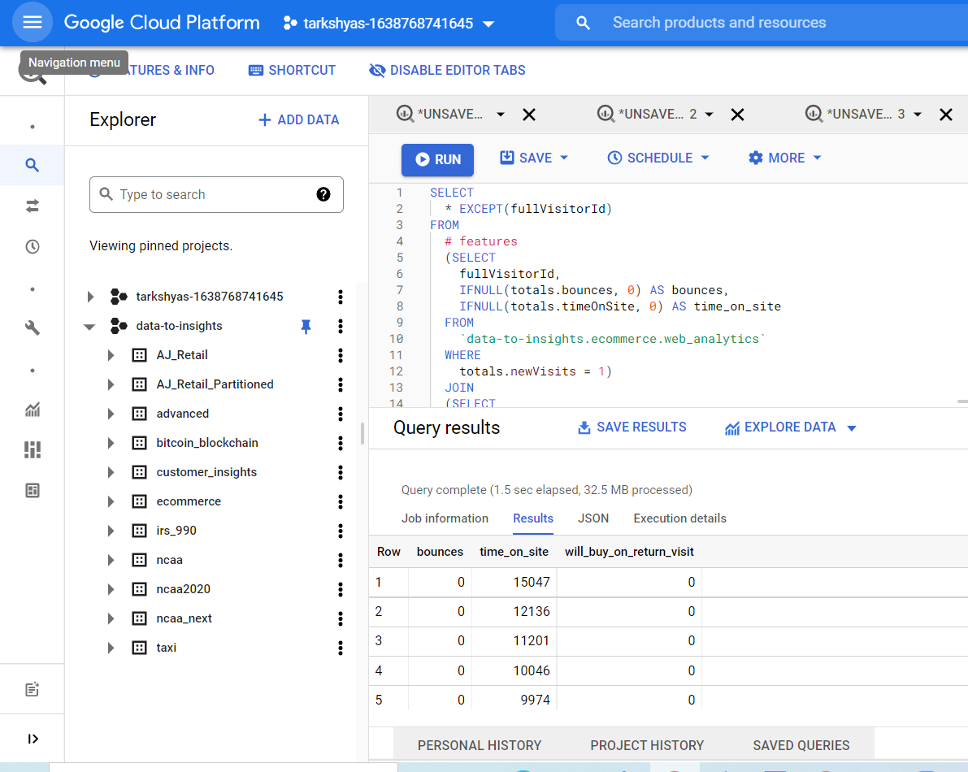

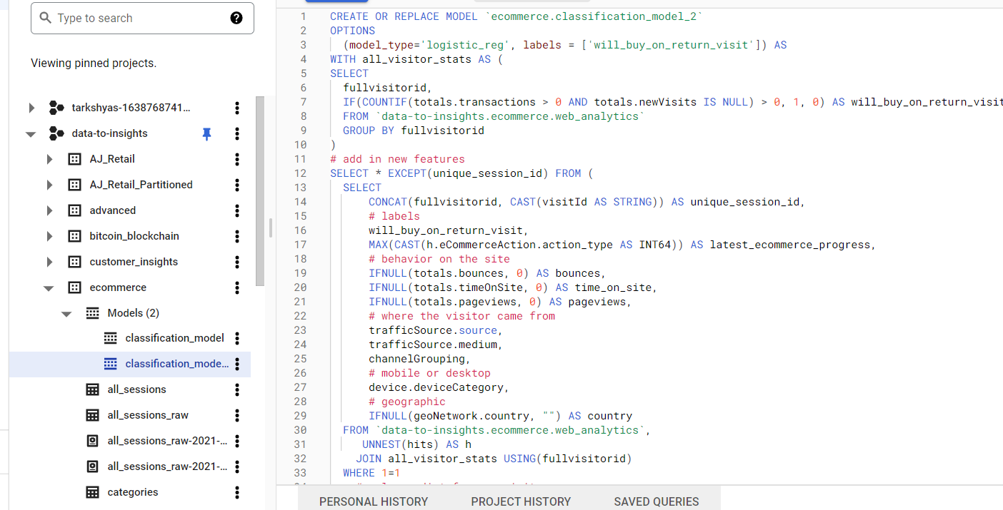

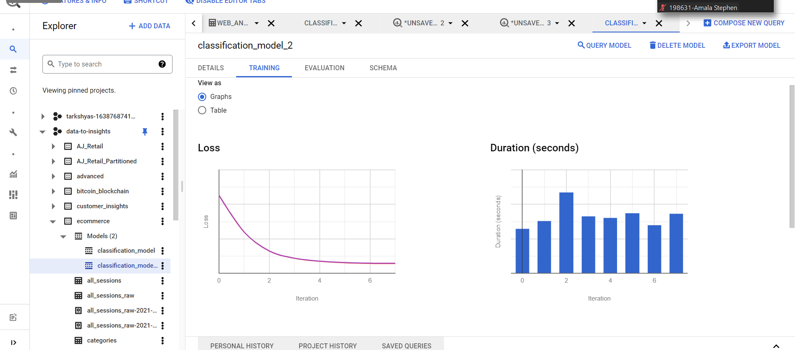

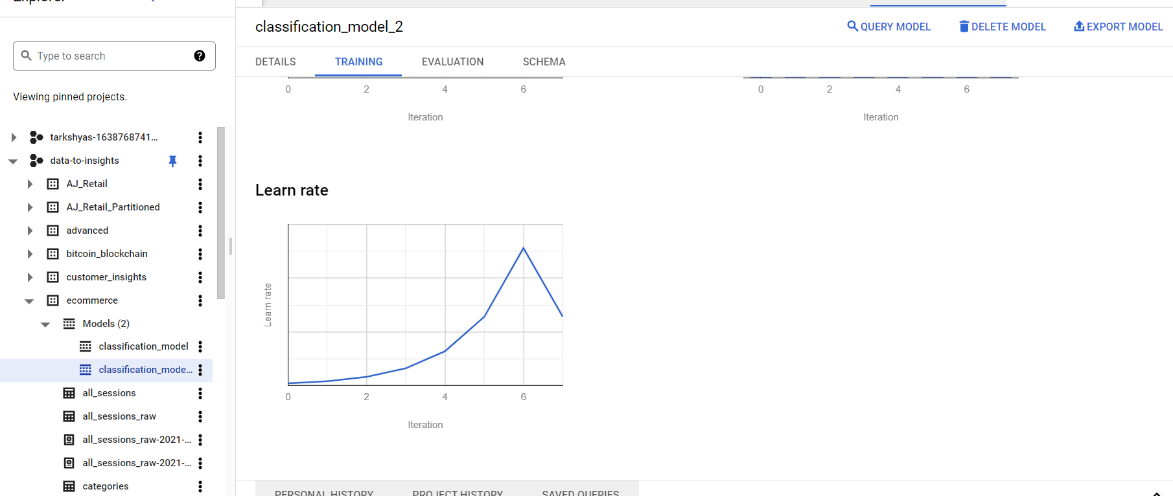

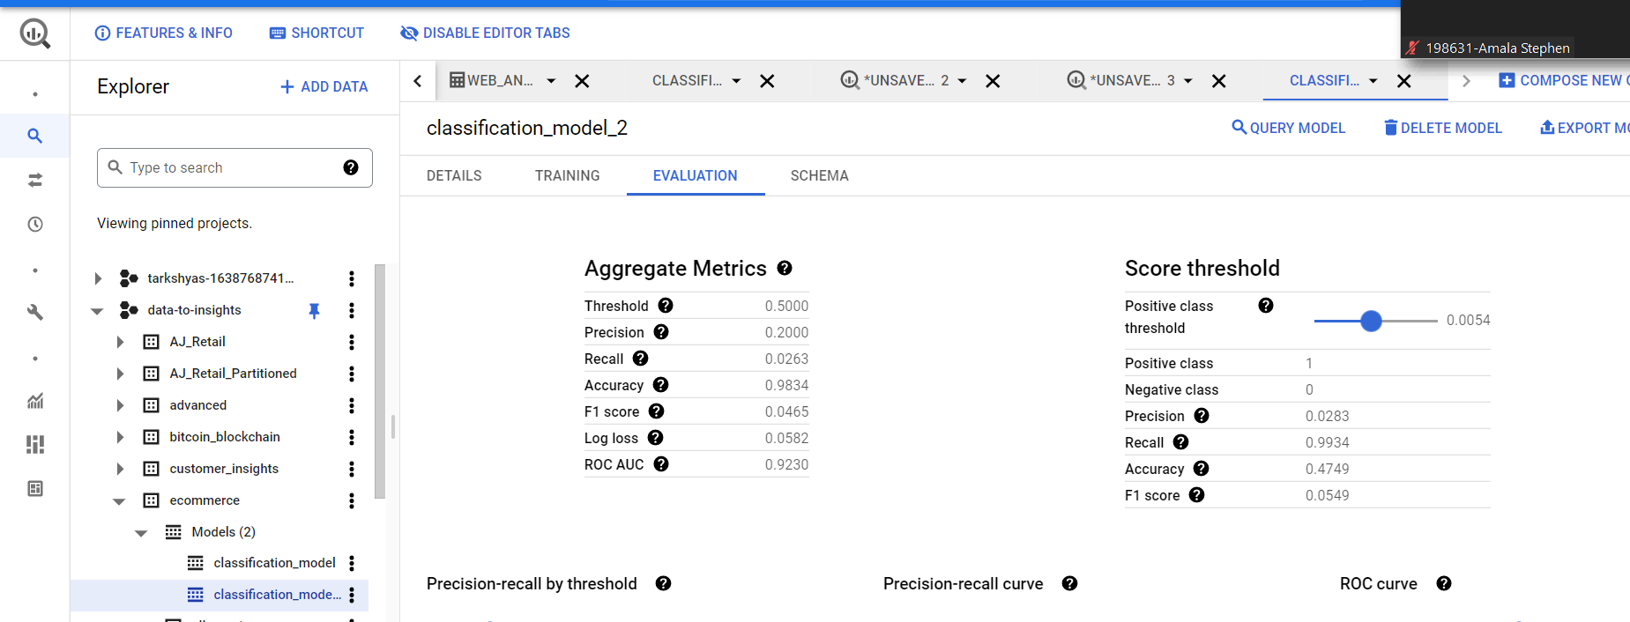

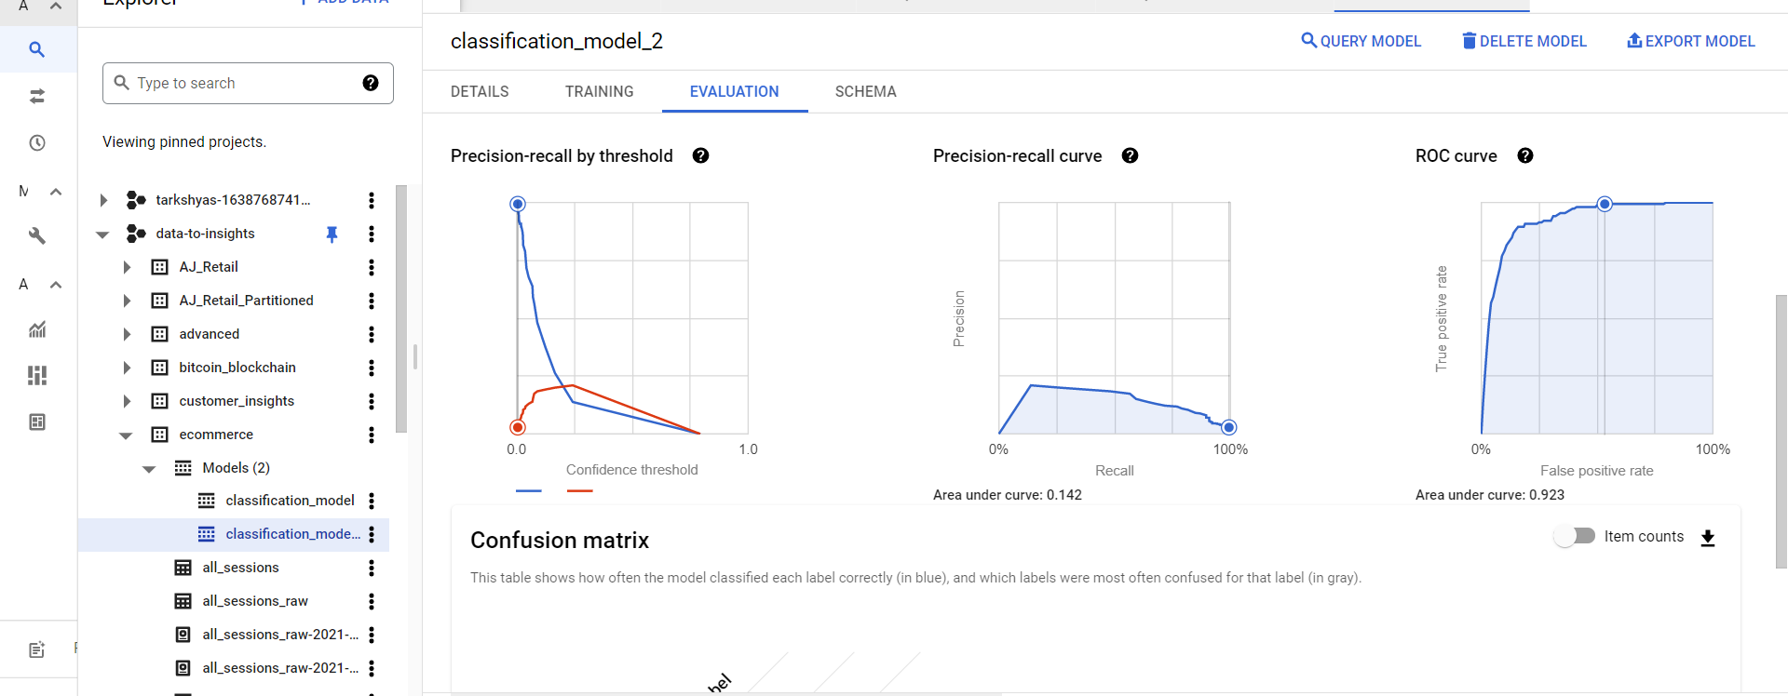

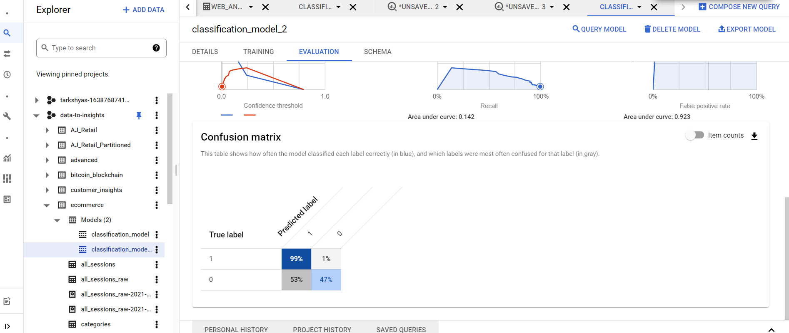

**Que1 vm instance creation and host a website**

**First we need a container and deploy that container in vm instance**

**Steps:**

**git clone** [**https://github.com/learning-zone/website-templates/above-educational-bootstrap-responsive-template**](https://github.com/learning-zone/website-templates/above-educational-bootstrap-responsive-template)

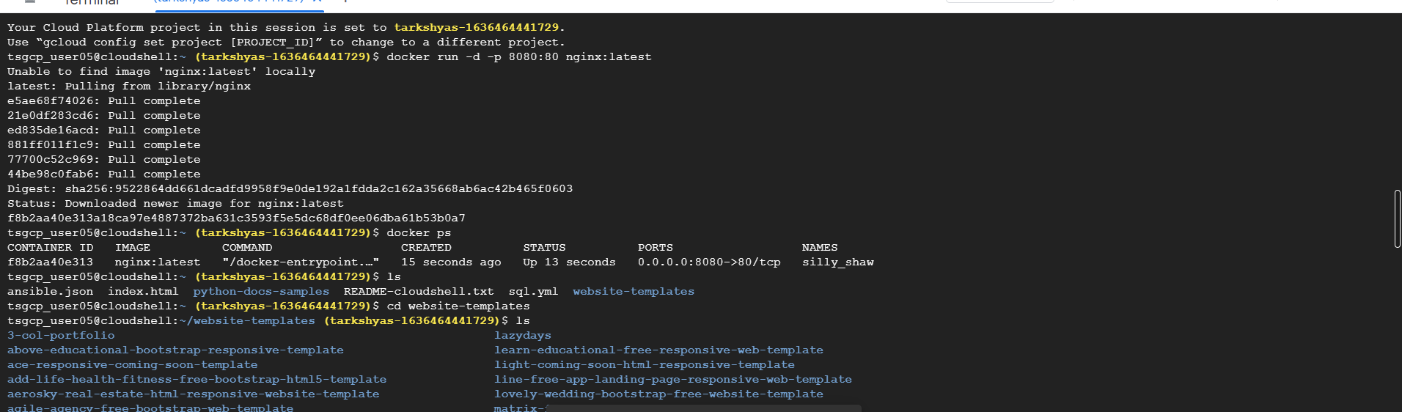

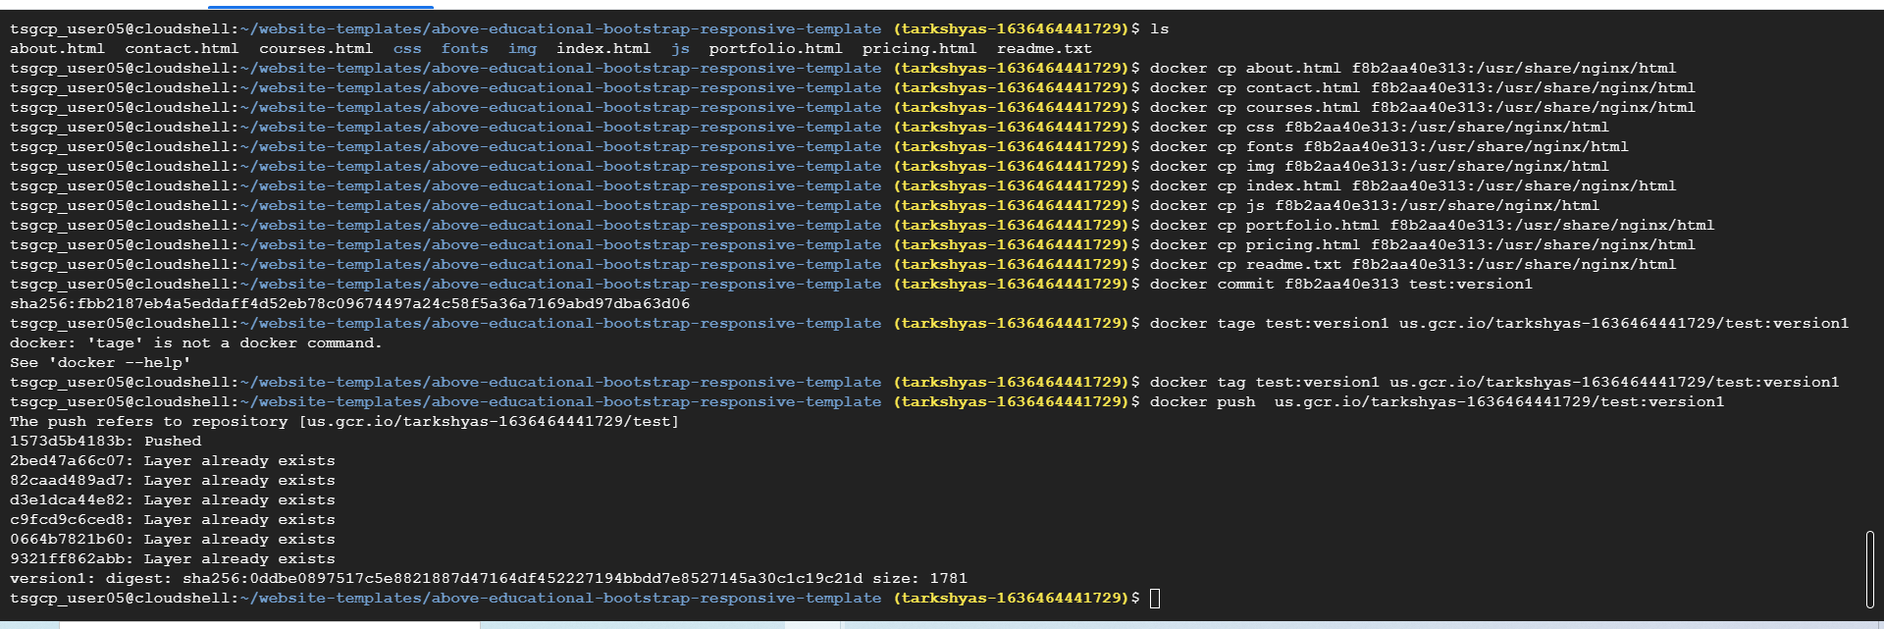

**Vm instance creation:**

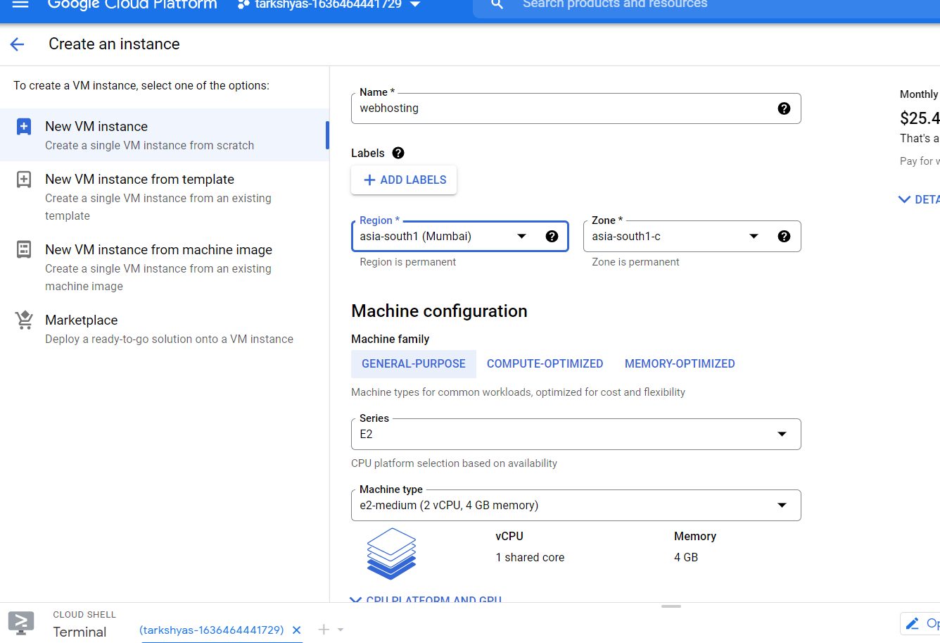

**Deploying container:**

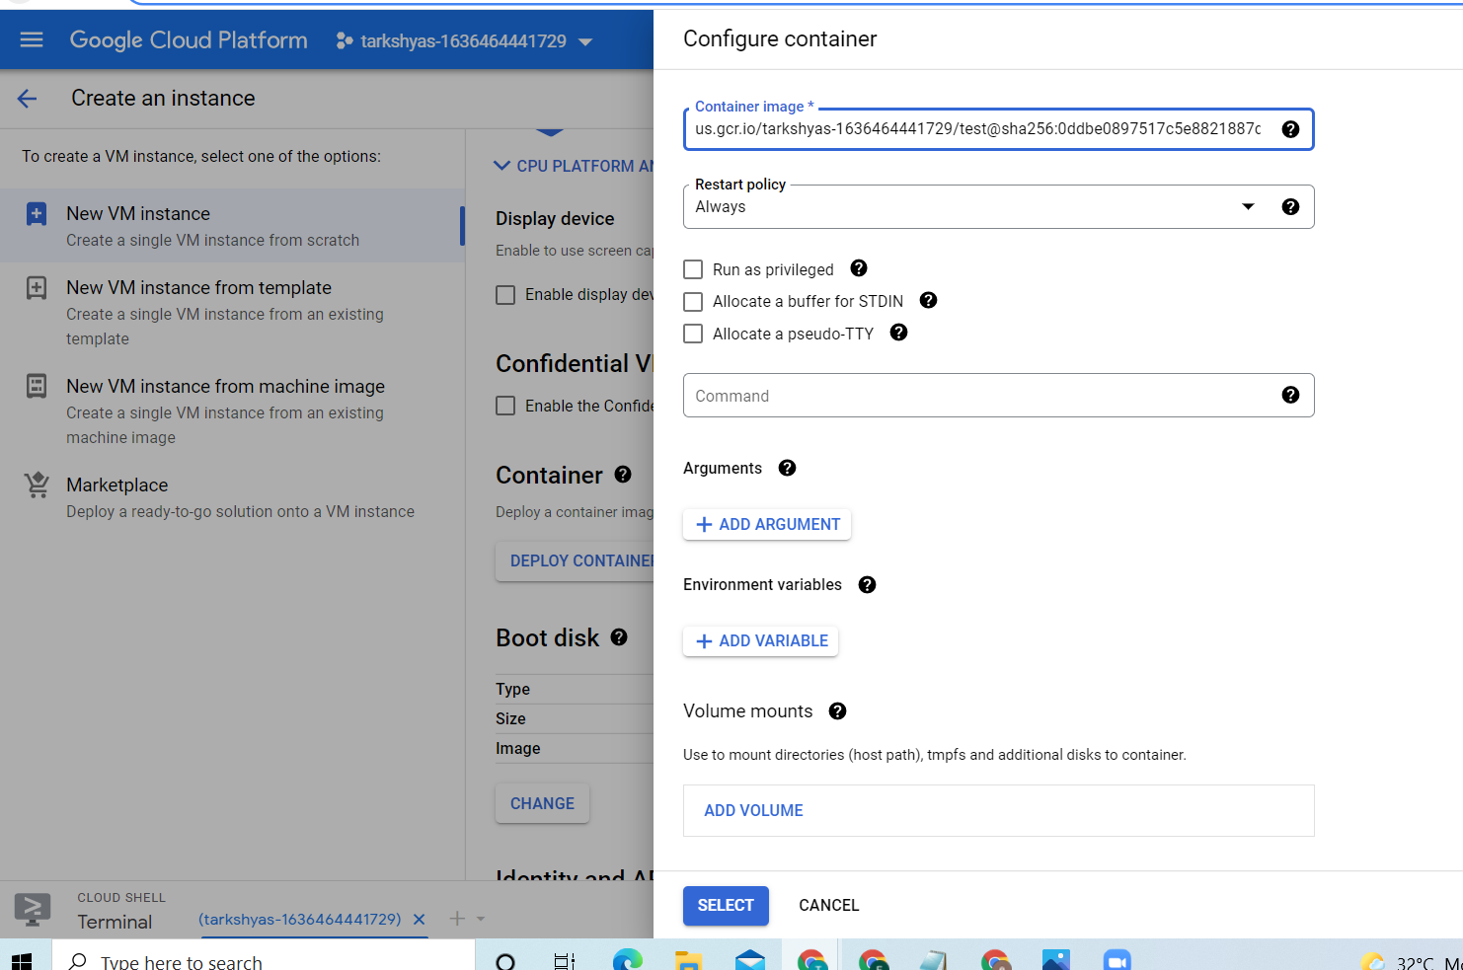

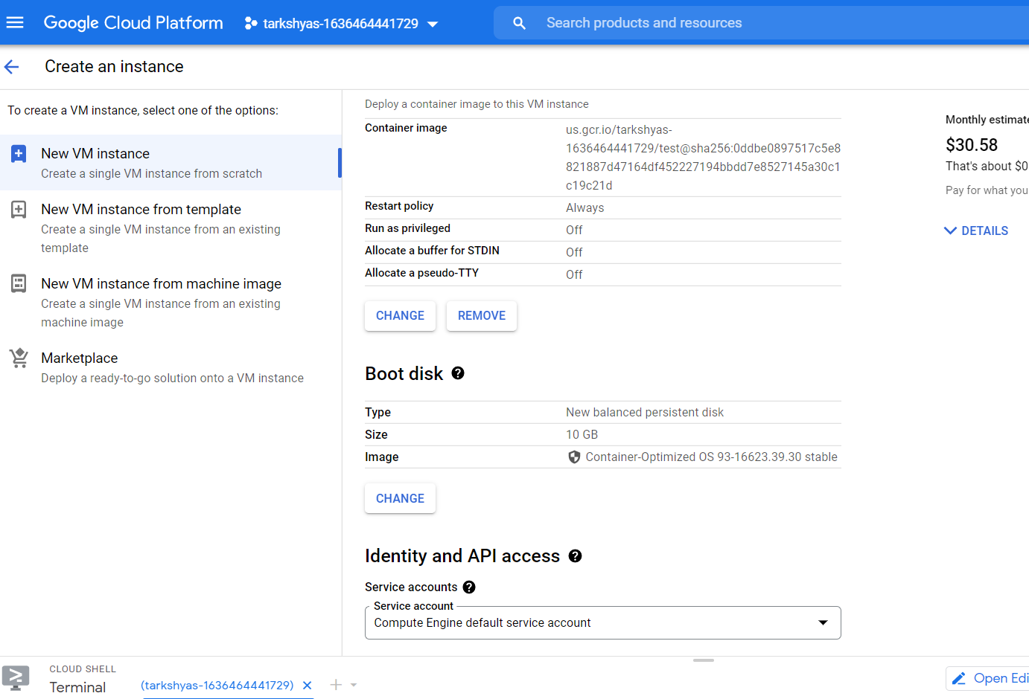

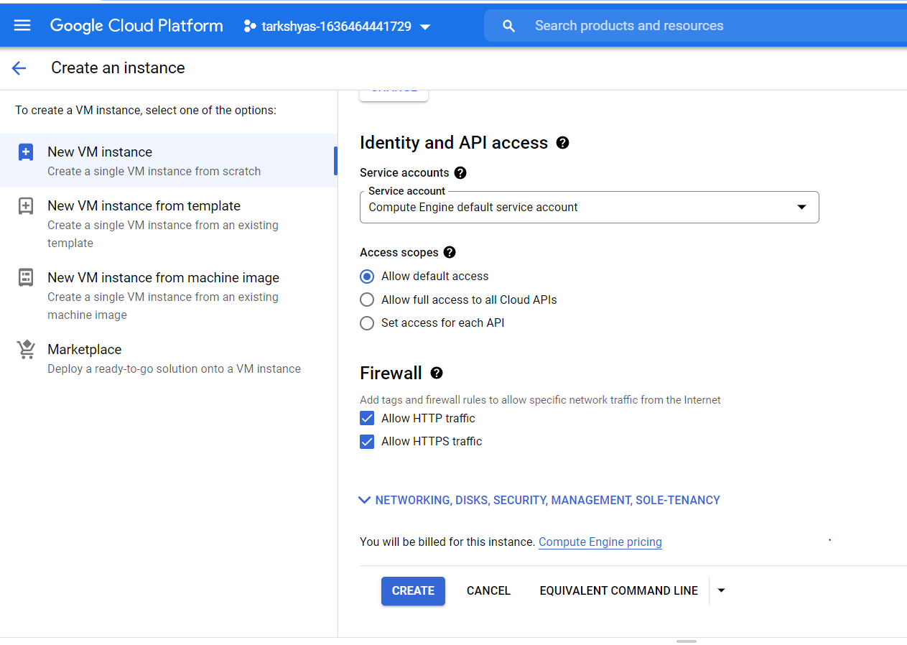

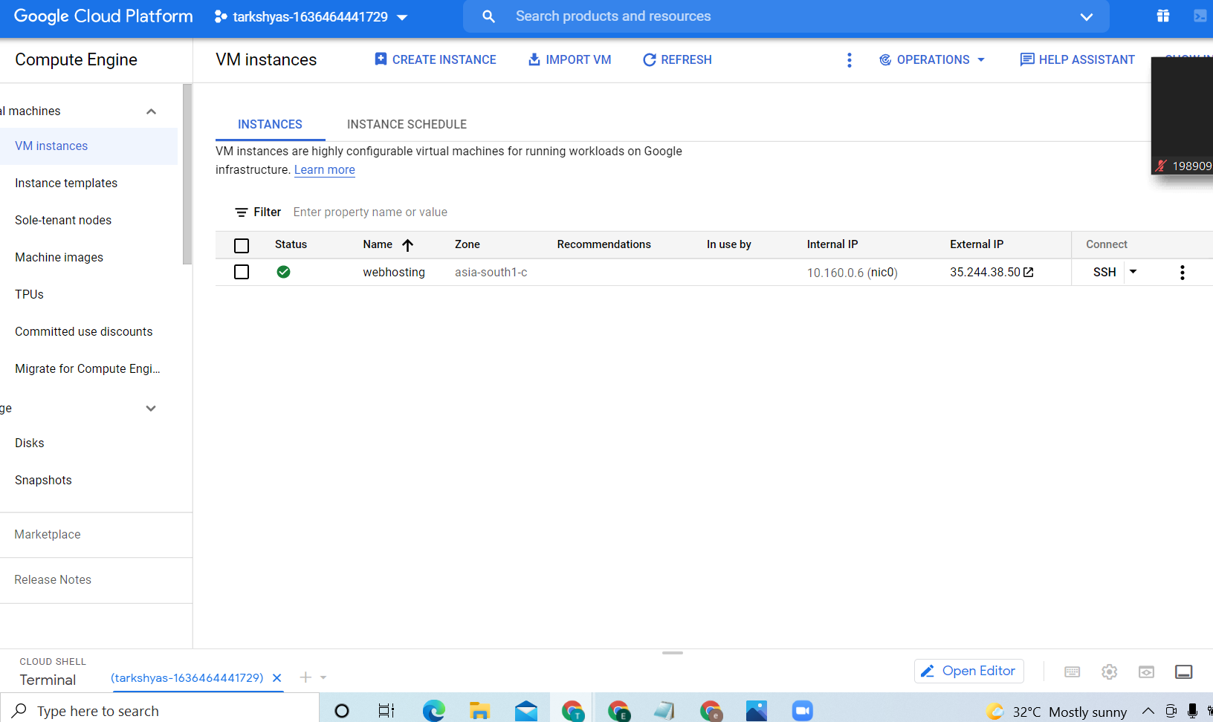

**Click on the external ip then we will get our website**



**QUE 8 CLOUD DNS**

**FOR creating cloud dns we require vm instance and a domain name**

**Creation of vm instance**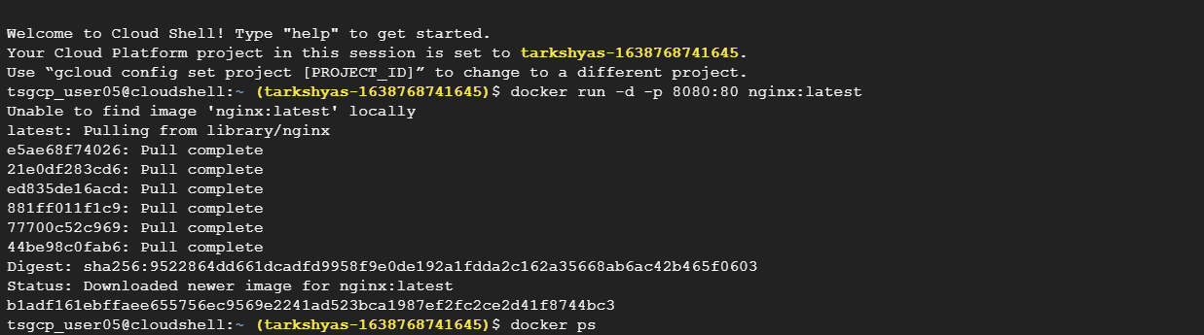

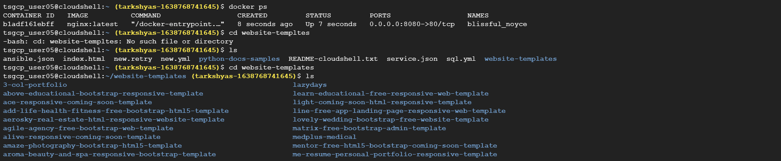

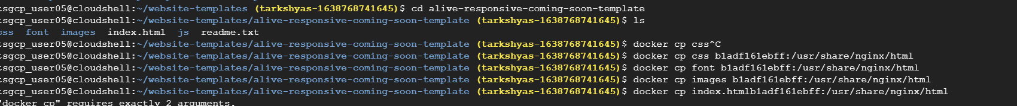

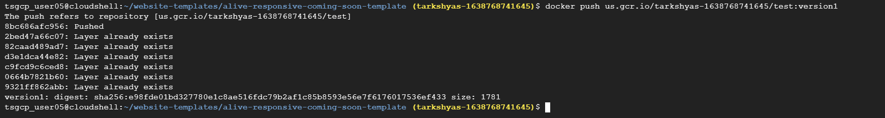

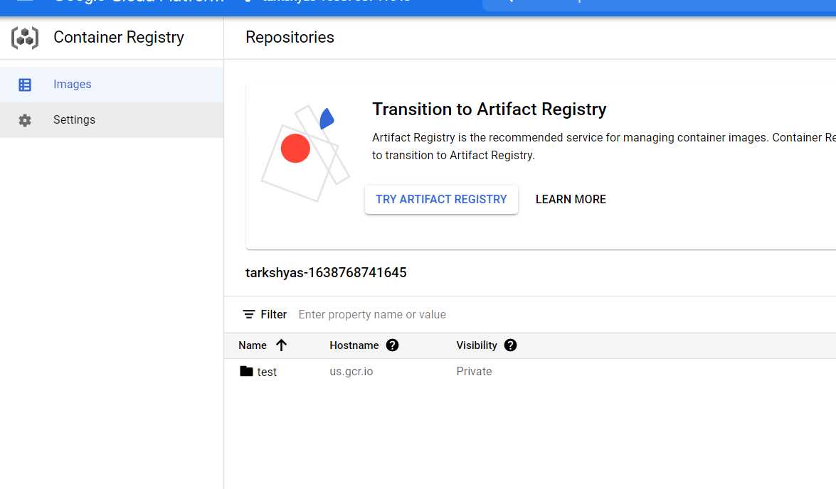

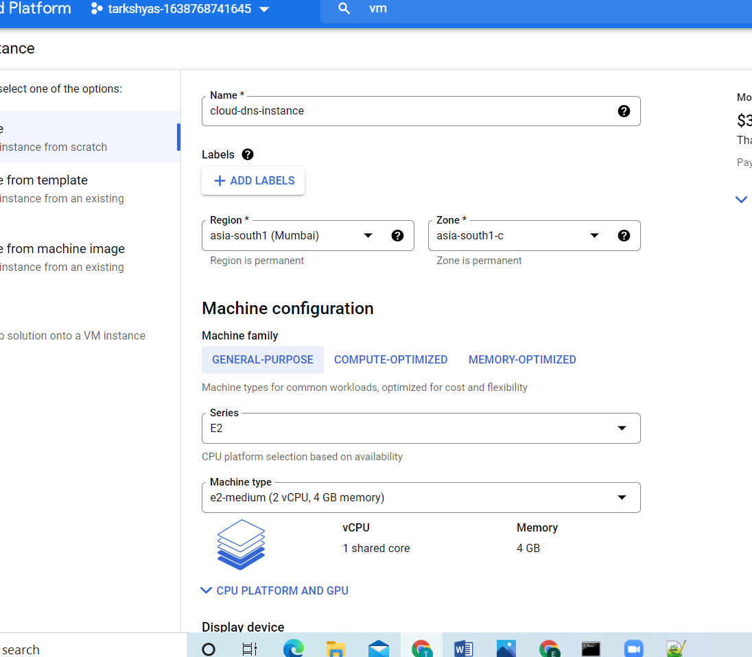

**Deploying the container:**

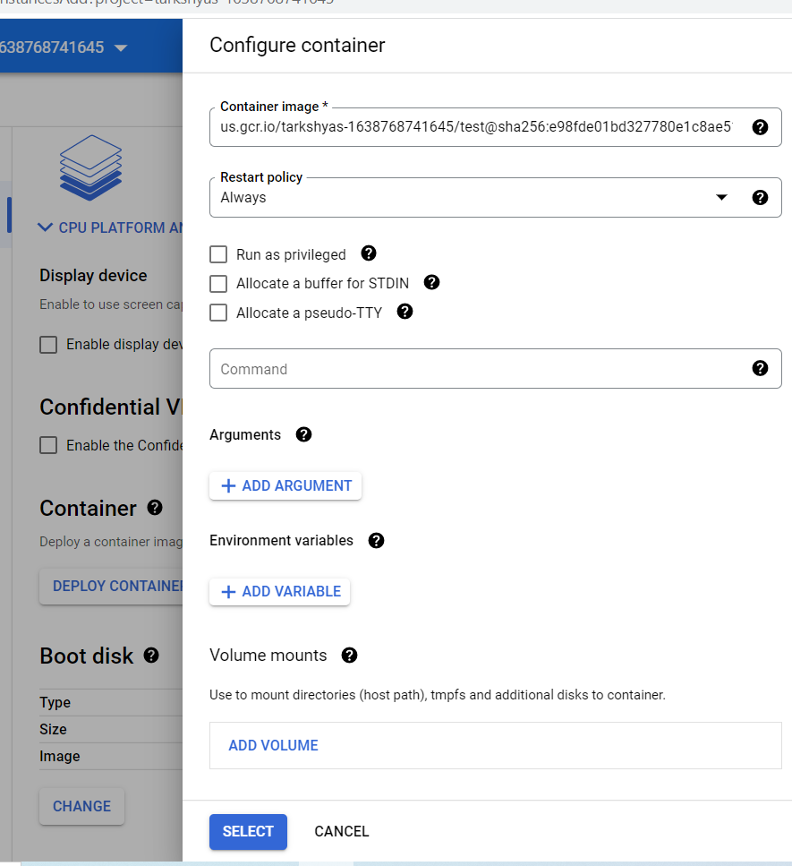

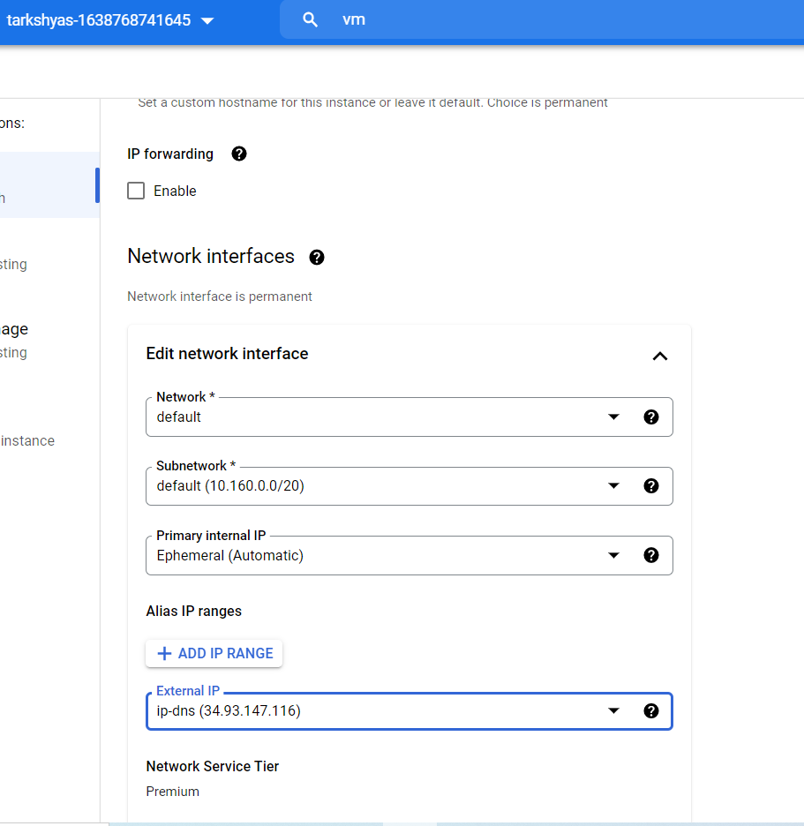

**After that create a zone**

**Add record set such as A and cname**

**In A record add the external ip of vm and in cname add the domain name**

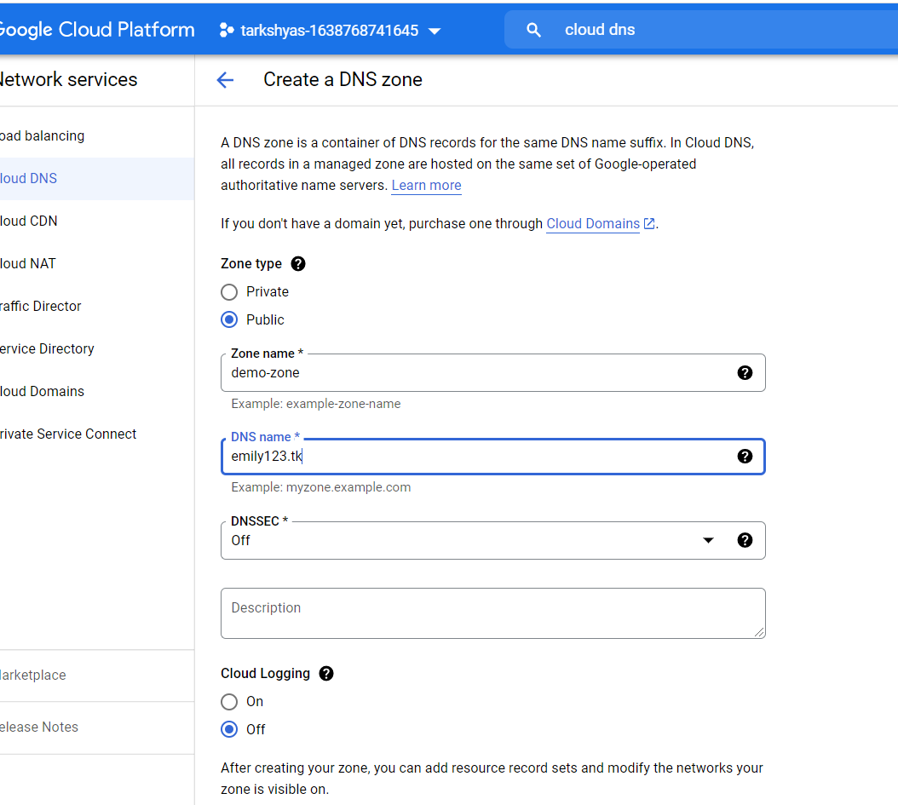

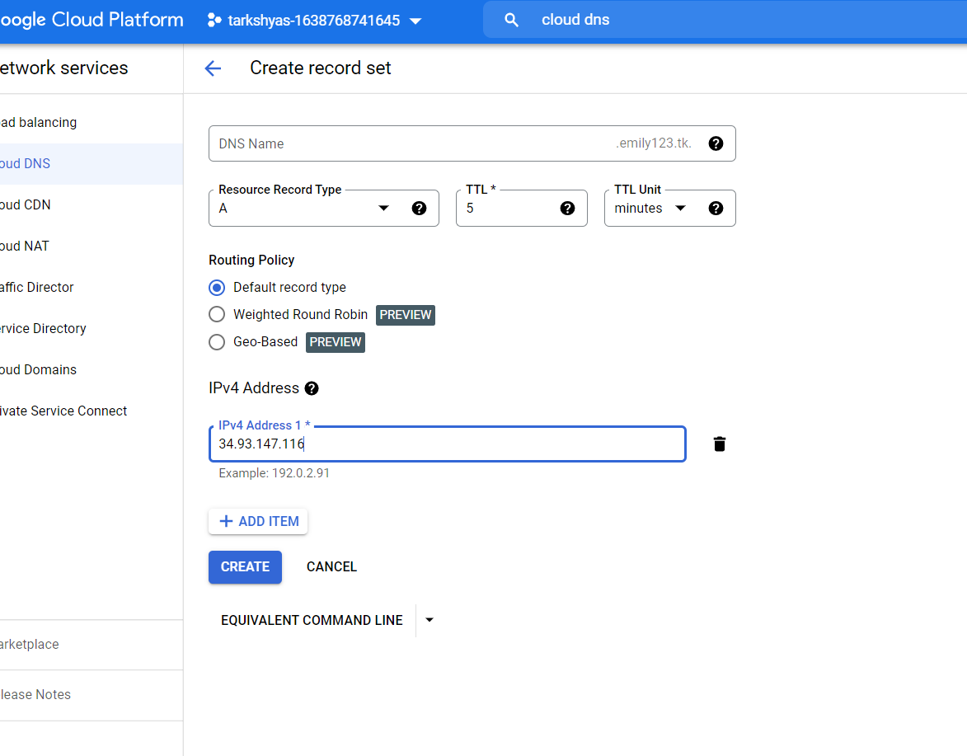

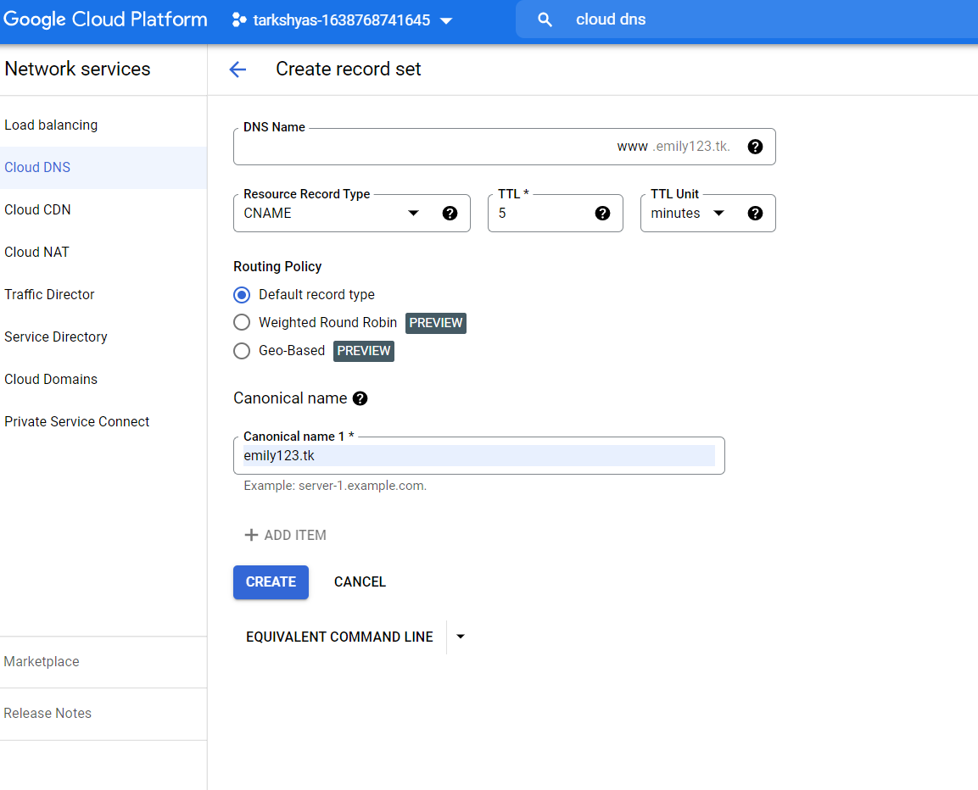

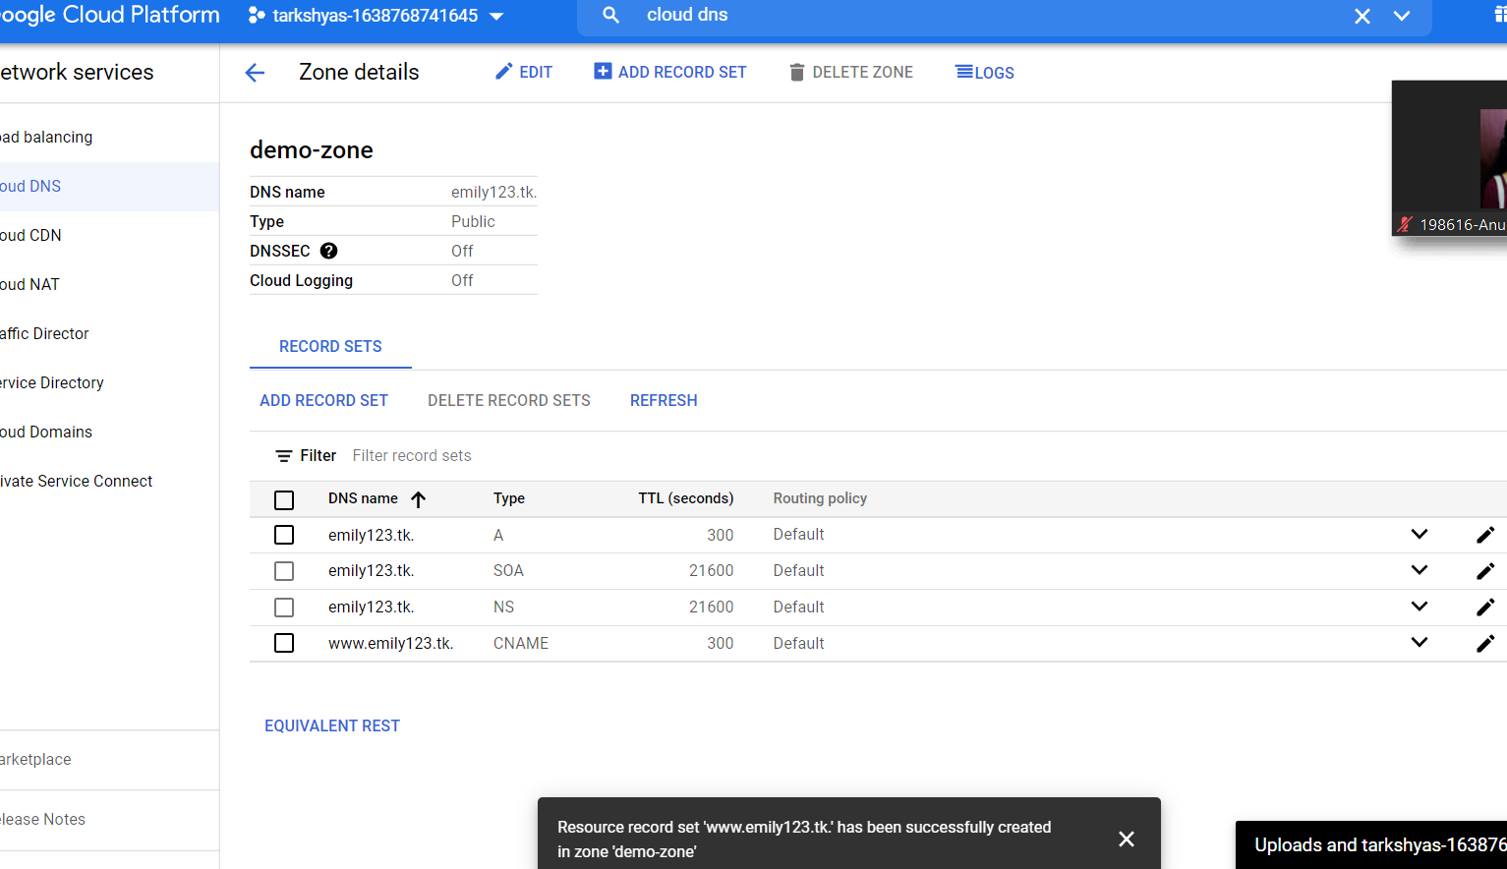

**We can search using our domain or external ip**

[**www.emily123.tk**](http://www.emily123.tk)

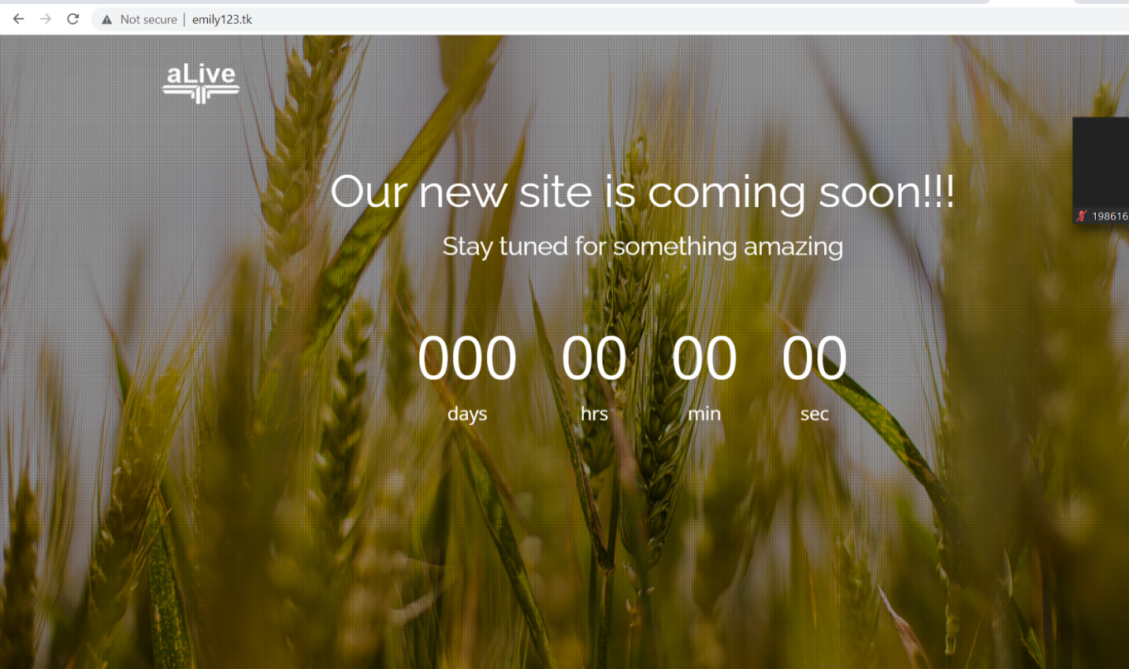

**http://34.93.147.116**

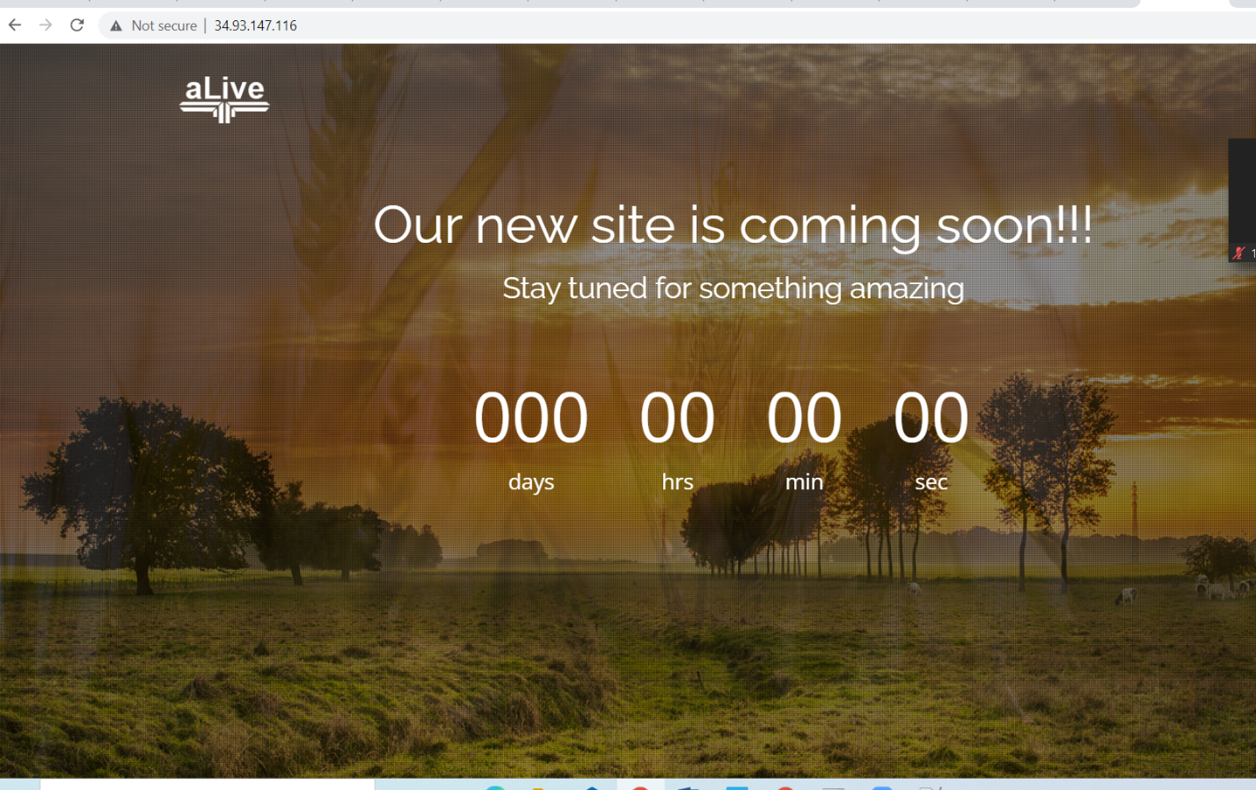

**Que 3 App Engine**

**Commands:**

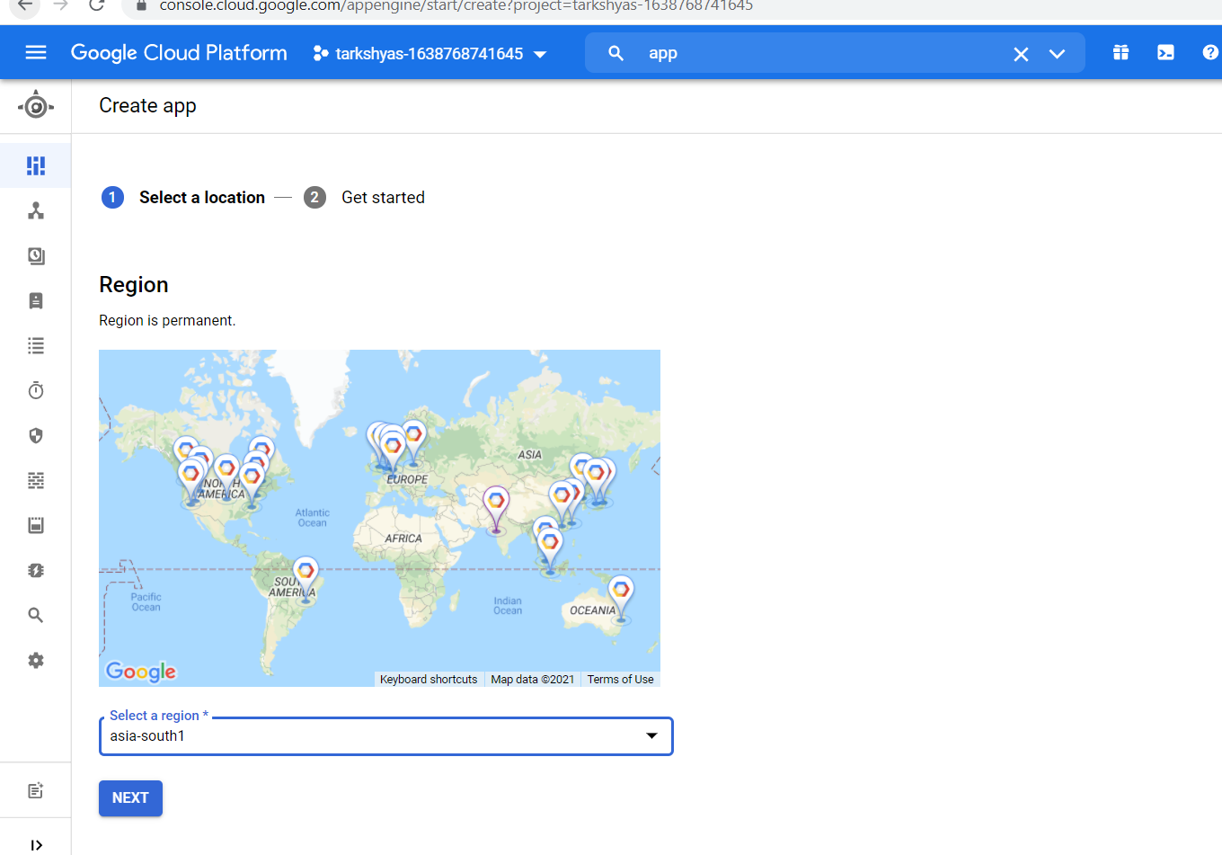

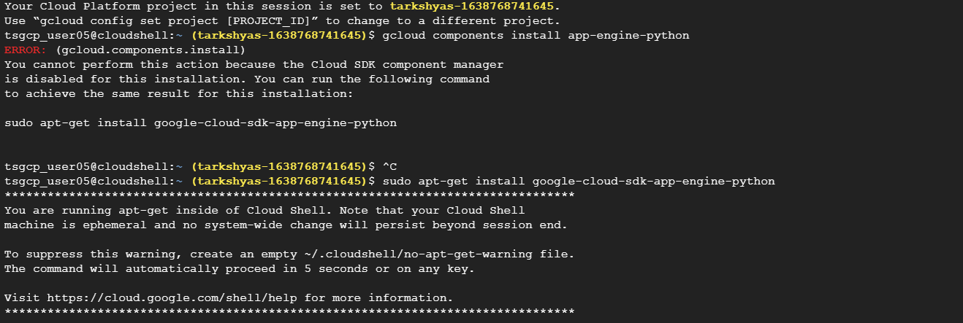

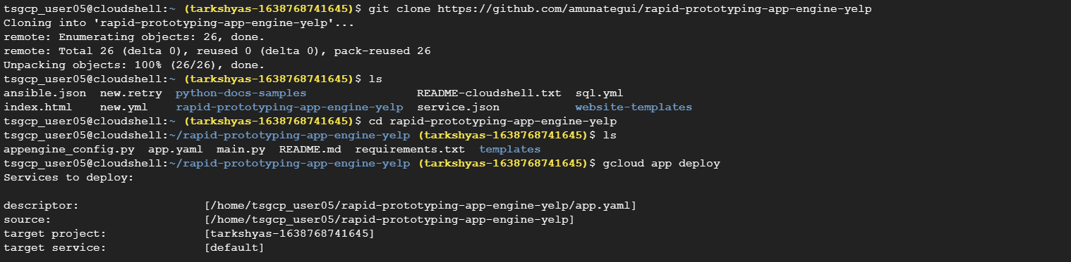

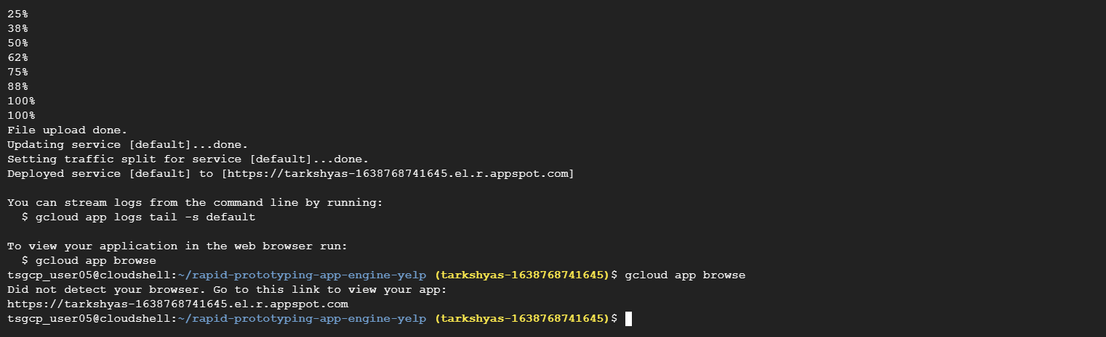

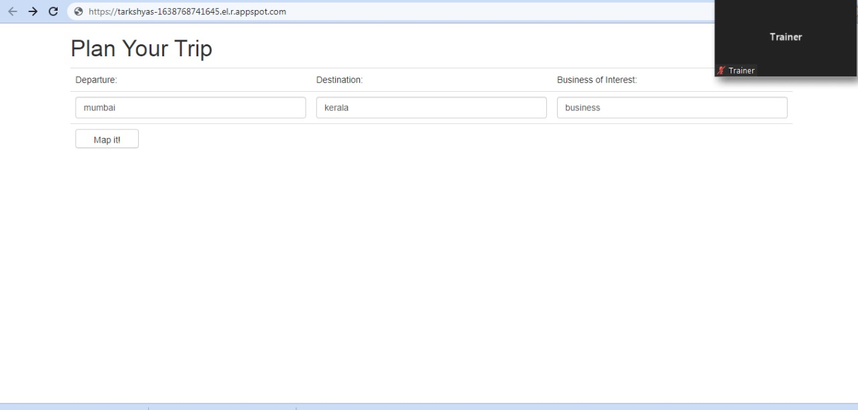

**QN 9. TCP**

**STEPS :**

1. **Create instance template**
2. **Create instance group**
3. **After that configure tcp load balancing**

